Installing Microsoft 365
Step 1:
Log in to your student email account. Once logged in, click the App Launcher icon (located in the upper-left corner of the screen) to open the apps menu.
Select More apps from the list.
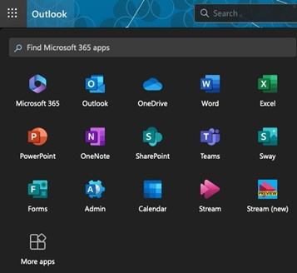
Step 2:
On the right side of the page, select the Install apps menu, then choose Microsoft 365 apps from the dropdown options.
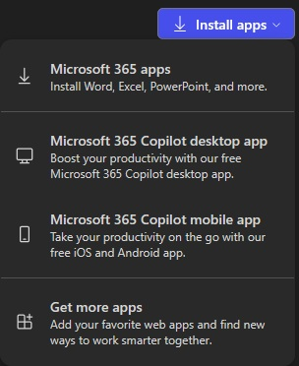

Step 3:
Click the Install Office button to begin the download and installation process.
Follow the on-screen prompts to complete the installation on your device.
