Posting to a Forum
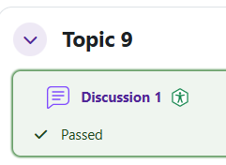
Log in to Moodle and navigate to the course.
Find the forum that you want to post to and click on the link.

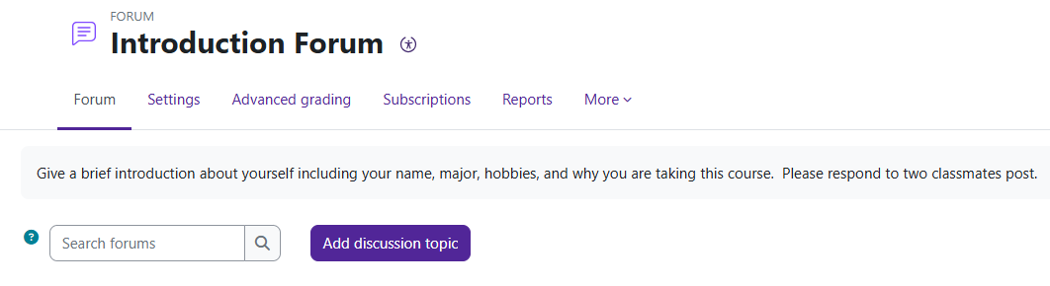
To add a new discussion topic, click on the Add discussion topic button.

Add a Subject and type your message.
When you are ready to submit, click the Post to forum button.
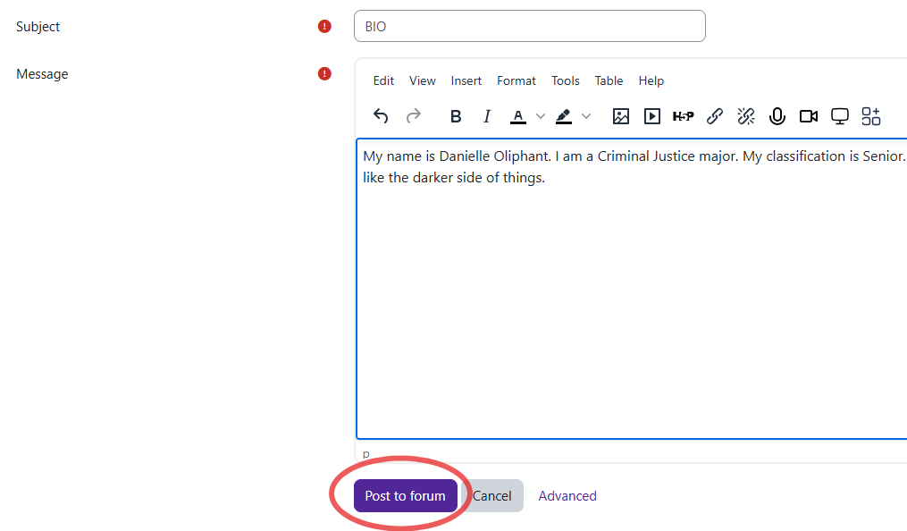

Moodle v. 4.5.7 Updated 03/26

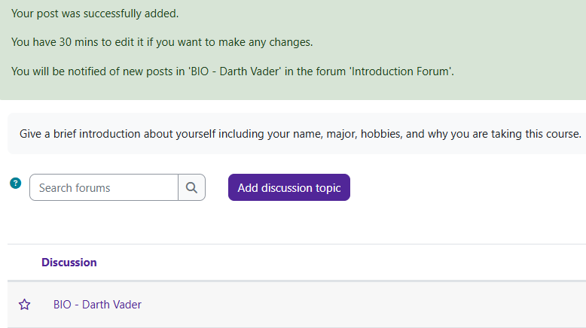
You will have 30 minutes to edit.

When someone replies to your post, their post will be indented.

