Posting to a Forum
Log in to Moodle and navigate to the course.
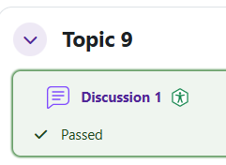
Find the forum that you want to post to and click on the link.

To reply, click on the original post.
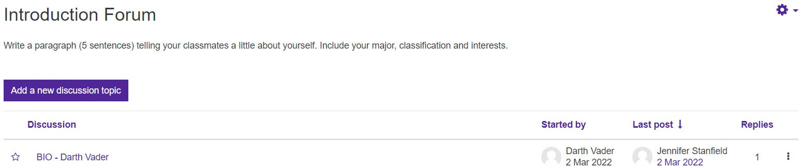

Click on Reply.

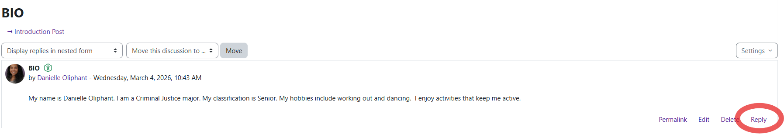

Moodle v. 4.5.7 Updated 03/26

Type your message.
When you are ready to submit, click on Post to forum.
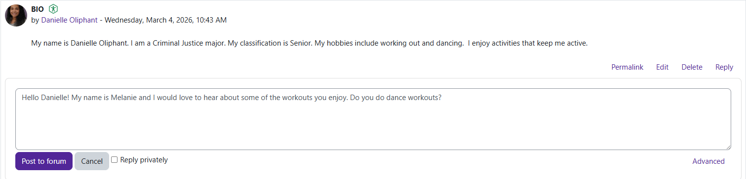

You have successfully replied to a forum. You will have 30 minutes to edit.
