Creating Categories in Question Bank
In Moodle, questions can be organized into categories. A new course starts out with one category
named “Default for (course name).” To make it easier to find questions and to facilitate the use of ran- dom questions, organize your questions into additional categories. A hierarchy of categories can be
created by building subcategories inside parent categories. If you organize your question categories during the initial setup of your course, it will make it easier to reuse questions in the future when cre- ating exams.

To create a question category:
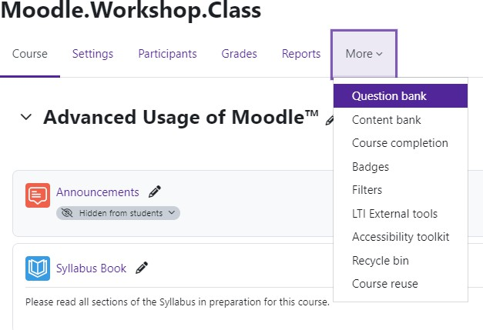
Log in to Moodle and navigate to the course. Under the course name, click on More.
Once clicked, select Question Bank.

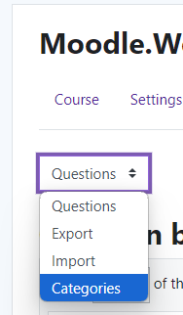

Once in the Question Bank, click on the dropdown located at the top right corner.
Change from Questions to Categories.



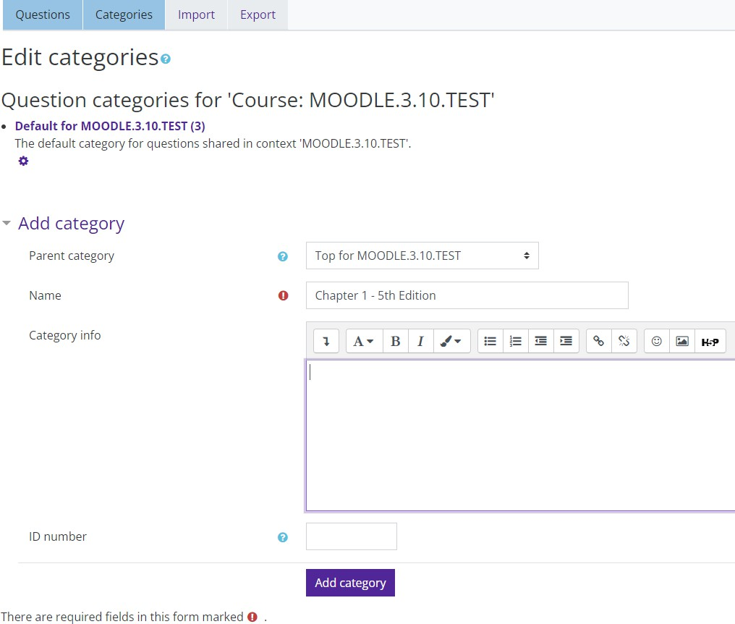

The new question category will appear on the Question categories page. From this page, you can delete, edit
or indent a category by using the configuration icons next to each category.
Now, you can add questions to that category.
On the Categories page, click Add category.

Under Add category, define the new category that you want to add:
- Parent Category (optional) - select a Parent category for the new category. (By default, the new category will be added as a sub- category of the default category.)
- Name—enter a name for the new category.
- Category info (optional)—enter a description for the new category. (i.e. Textbook name, edition)
Click Add category.



