Submitting an Assignment—File Upload Submission
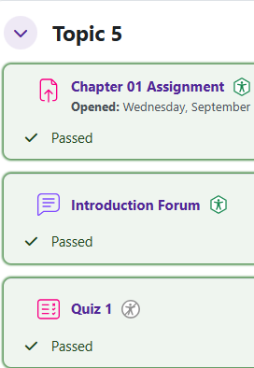
Log in to Moodle and go to your course. Find the assignment and click on the link.

The submission status shows important information about the assignment. To add your file, click the Add submission button.
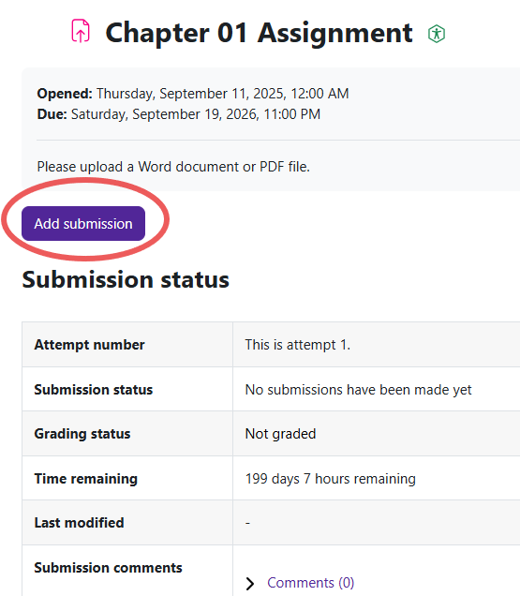
Moodle v. 4.5.7 Updated 03/26

There are two ways to add a file in the file submission box.
- Drag and drop your file into the designated area.
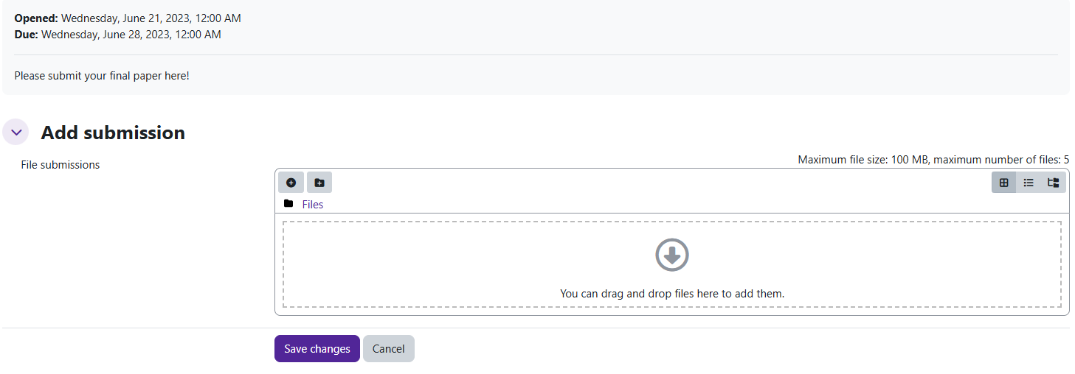
- Use the Add button.

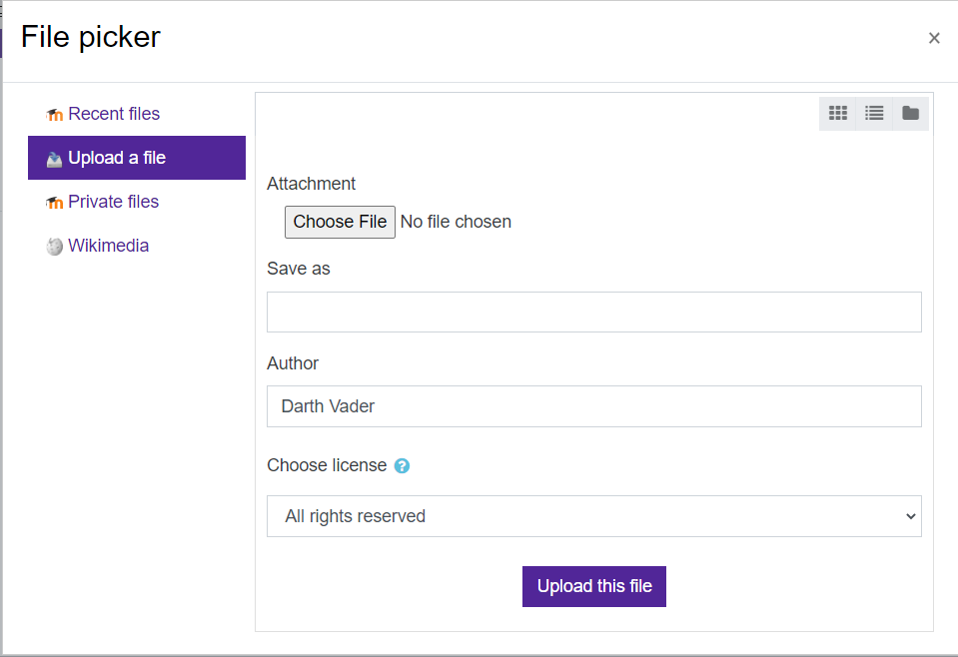
The file picker window will appear. Click on the Choose File button.
Locate the file on your computer. Highlight and click on Open.

Once the file is loaded in the file picker, you should see the name of the file net to the Choose File button.


Click on Upload this file.

Your file should now show in the file submission box. Click Save Changes.
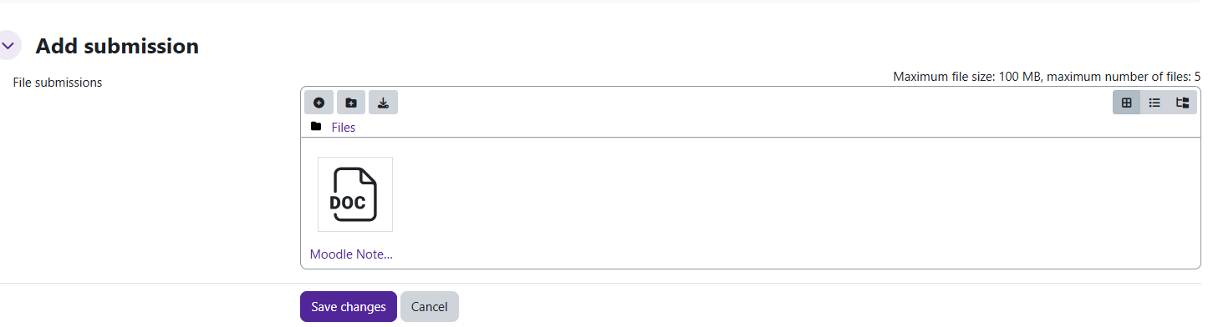

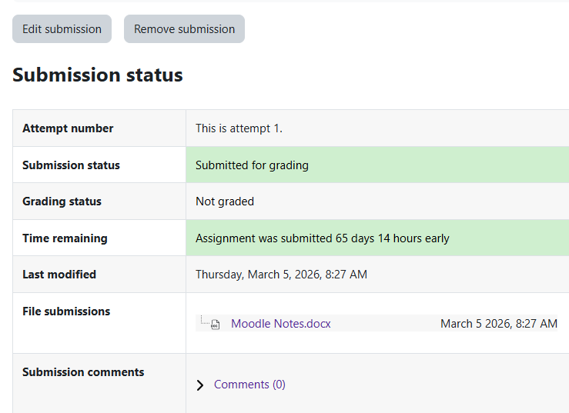
The submission status page will show that your file has been submitted.

