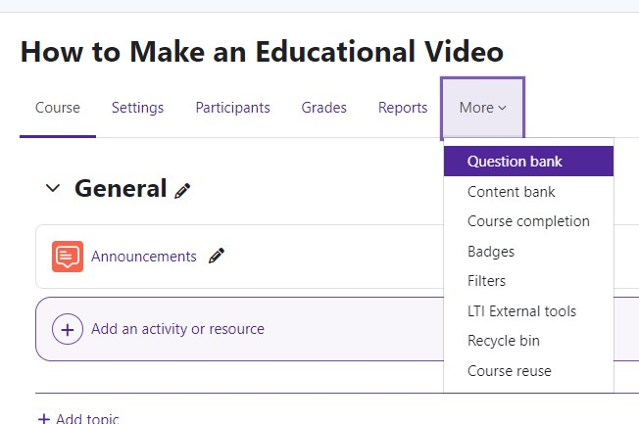
Creating Questions in the Question Bank
You may add a variety of question types in the Quiz module.
To start creating/adding questions:
Log in to Moodle and navigate to the course.
Under the course name, Click on More.. Under More, select Question bank.

On the Question bank page, Click on Create a new

question.
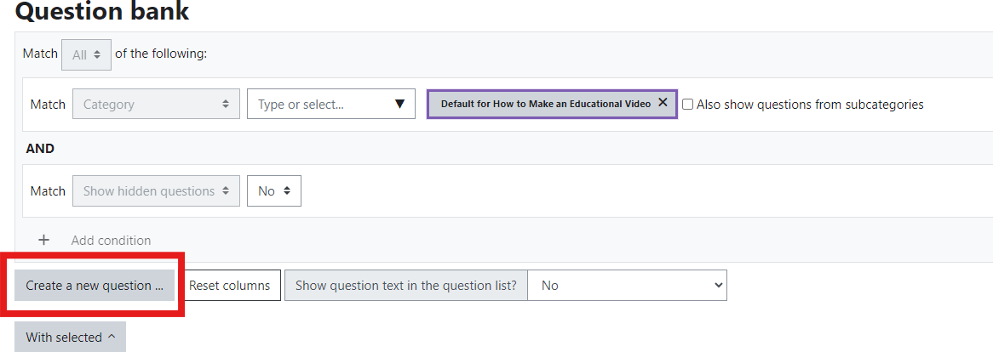

The Choose a question type to add menu will appear. Moodle offers a wide selection of question types. The three most commonly used question types are true/false, multiple choice and essay. We will focus on these.
Moodle v. 4.5.7 Updated 3/26

Adding Questions
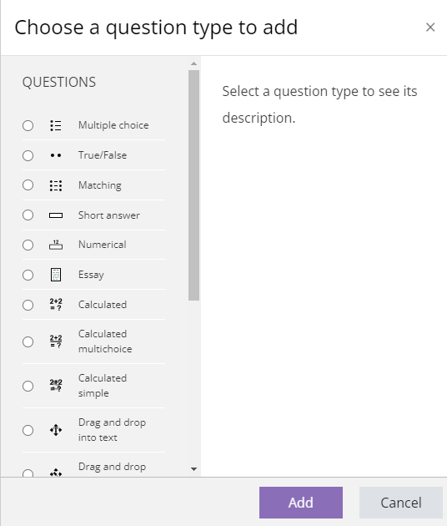
To add a question, click on the question type.
To the right of the question types, there is a help screen that will describe the type of question chosen.

Click the Add button.

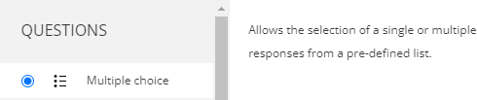

Adding a True/False Question
Make sure that you have the correct Category selected.
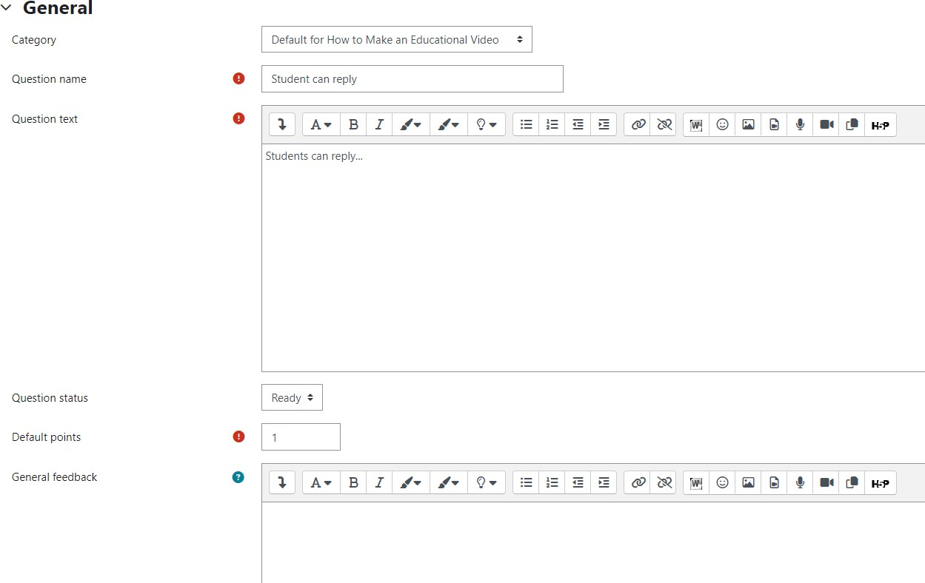
Question name—give the question a descriptive name. This makes it easy to identify it in the question bank list. The question name is not visi- ble to students.
Question Text - enter the actual question here.
Images, audio and video can also be inserted into
this field using the HTML editor toolbar.
Default Mark - can be set by entering a numerical value (i.e. the maximum number of marks for this question).
General feedback— shown to the student after they have completed the question.

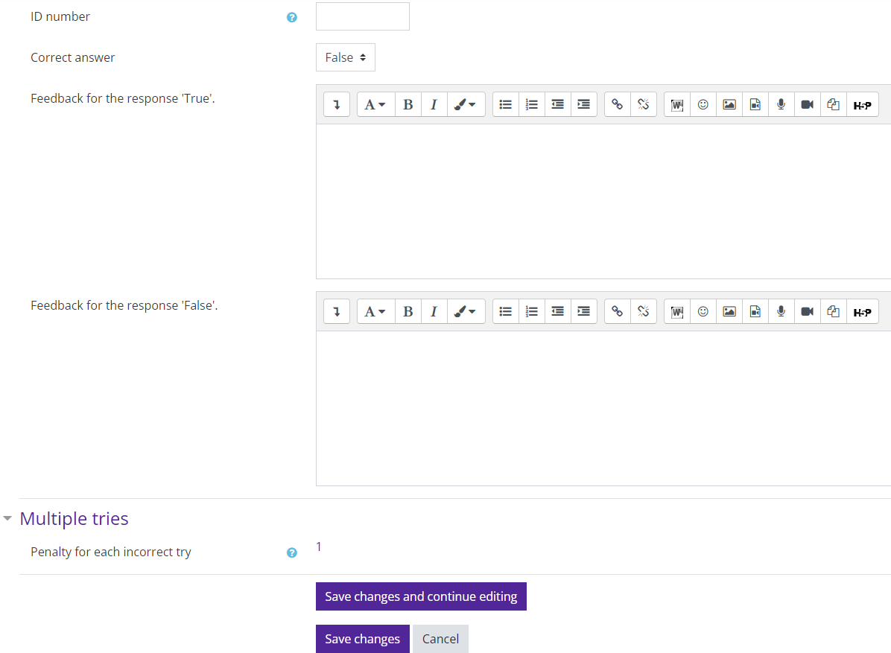
ID Number—if used, the ID number must be unique within each question category. It provides another way of identifying a question which is
sometimes useful, but can usually be left blank.
Correct answer—use the drop down menu and select true or false.
If you would like to add feedback for the “True” response or the “False “ response, Moodle pro- vides a textbox for this information.

Save changes.

Moodle will take you back to the Question bank page. The question you created is now visible along with creation information.
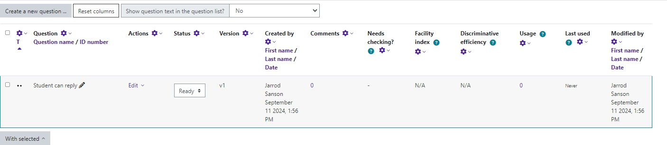

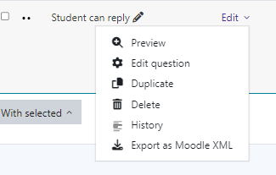
The Edit drop down menu gives you the opportunity to edit, duplicate, preview, review the history, delete, or export.

Adding a Multiple Choice Question
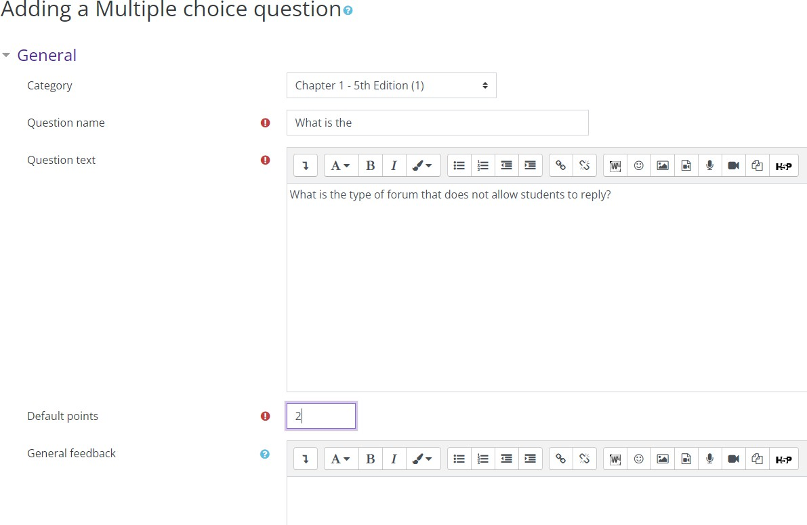
Make sure that you have the correct Category selected.
Question a name—give the question a descriptive name. This makes it easy to identify it in the question bank list. The question name is not visi- ble to students.
Question Text - enter the actual question here.
Images, audio and video can also be inserted into this field using the HTML editor toolbar.
Default Mark - can be set by entering a numerical value (i.e. the maximum number of marks for this question).
General feedback— shown to the student after they have completed the question.

ID Number—if used, the ID number must be unique within each question category. It provides another way of identifying a question which is sometimes useful, but can usually be left blank.
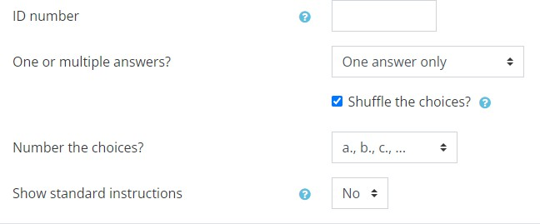
One or multiple answers—do you want to have one correct answer or more than one? Use the drop down menu and select the number of correct answers you want.
Shuffle the choices—if enabled, the order of the answers is randomly shuffled for each attempt. Tip: if you have “all of the above” or “none of the above” answers, select “No.”
Number the choices—this allows you to decide how your answers are numbered.
Show standard instructions—if enabled, you can choose whether Moodle shows the instructions
“Select one” or “Select one or more” before multi- ple choice answers.

Answers
Moodle gives the option of 5 answers. However, you can add or subtract to suit your needs.
Choice 1 text box—type in an answer. Use the editing toolbar to customize your text. Images, audio and video can be added as well.
If the answer is correct, select 100% from the Grade drop down menu. If it is incorrect, leave the “Grade”
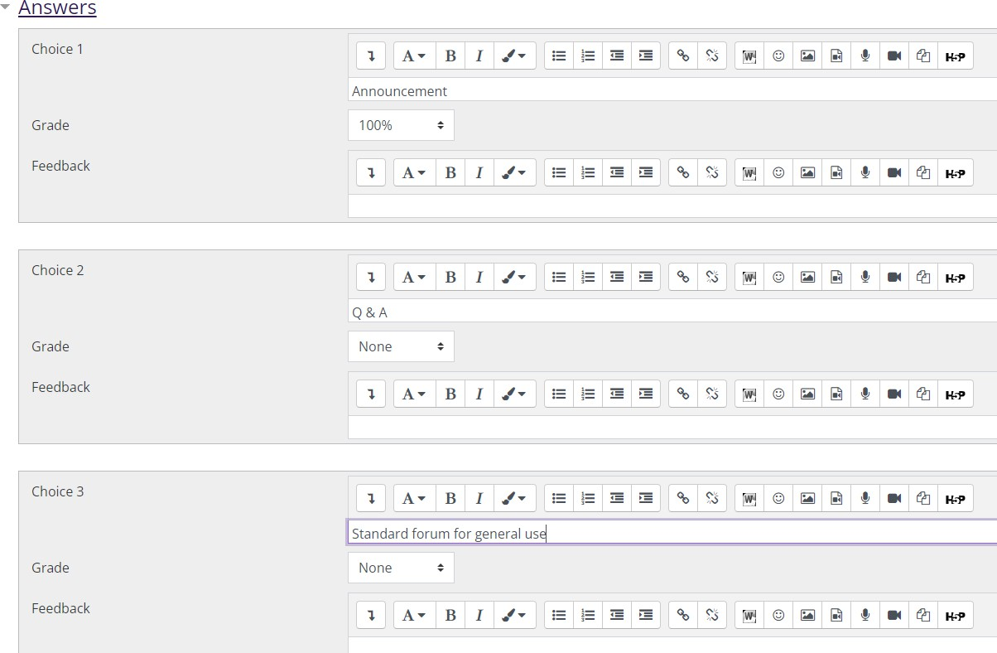
set at None.
Feedback—add feedback if desired. Follow this procedure for all choices.

You must provide a correct answer or Moodle will not allow you to save your questions.

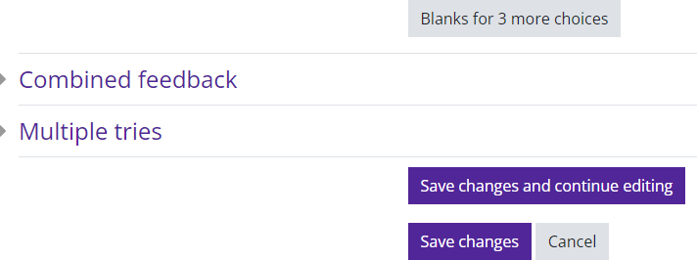
Blanks for 3 more choices—more choices can be added 3 at a time if needed.

Save changes.

There are now 2 questions in the question bank.
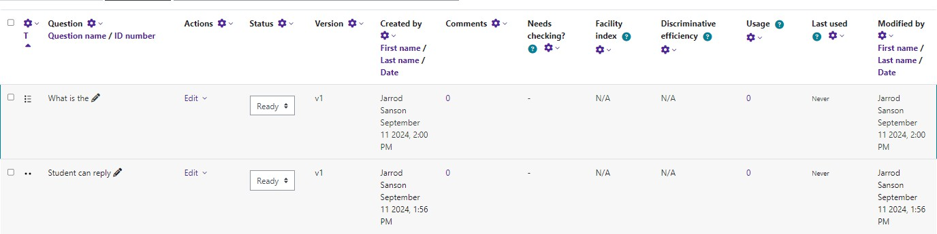

Adding an Essay Question
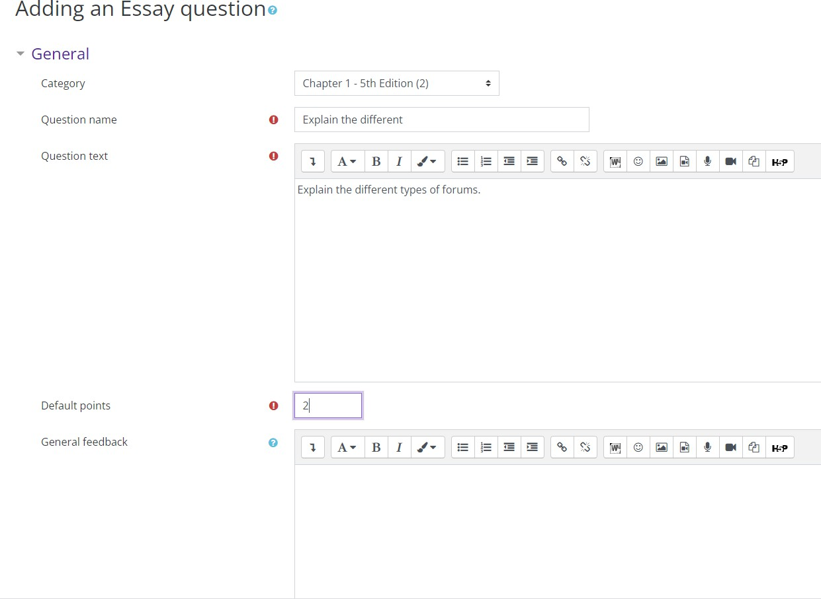
Make sure that you have the correct Category selected.
Question a name—give the question a descriptive name. This makes it easy to identify it in the question bank list. The question name is not visi- ble to students.
Question Text - enter the actual question here.
Images, audio and video can also be inserted into this field using the HTML editor toolbar.
Default Mark - can be set by entering a numerical value (i.e. the maximum number of marks for this question).
General feedback— shown to the student after they have completed the question.

Response Options
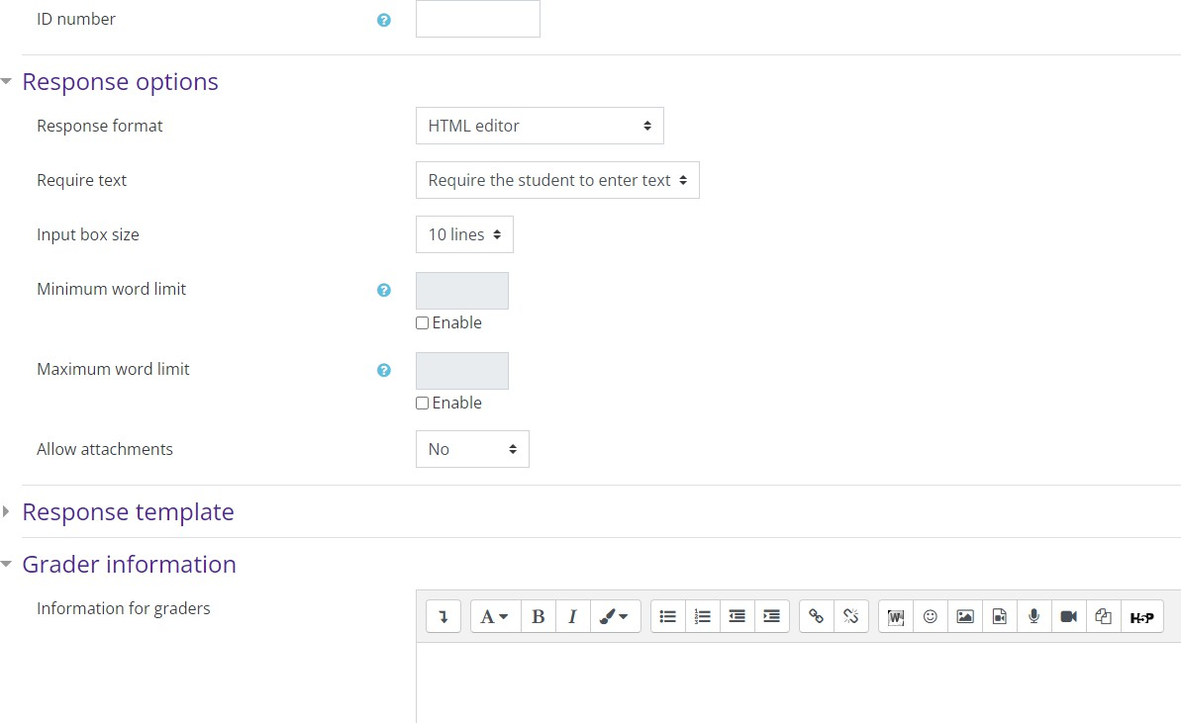
Response format—allows you to choose what is available for the students when typing their es- says. HTML editor is recommended.
Required text— allows you to decide whether or not students must add text into the text editor when they do the question. If you only want
them to upload a word-processed file as an essay, then you can set this to “Text input is optional.”
Input box size—dictates how many lines are in the text box.
Minimum/Maximum word limit— set a minimum and/or maximum word count for the essay ques- tions.
Allow attachments—if you want students to attach files, choose the number of files you want to allow.

Response Template
Any text entered here will be displayed in the response input box when a new attempt at the question starts.
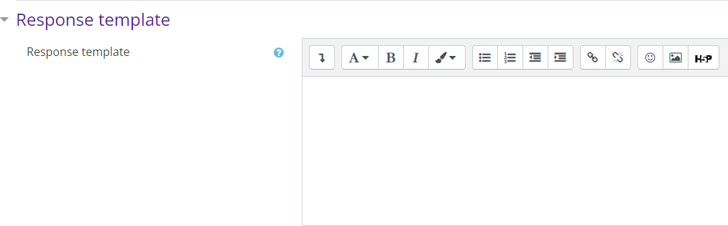

Save changes.

You now have 3 questions in the Chapter 1 question bank.
Note: Moodle will not automatically grade Essay questions. You will have to manually grade these questions.
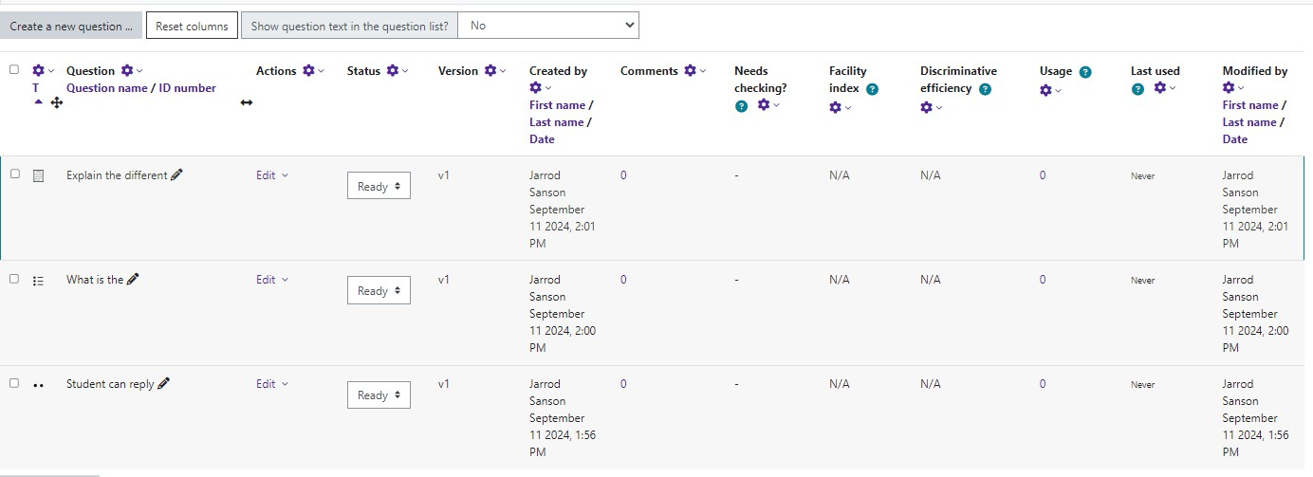

Once all your questions have been created, you can create your quiz.

