Submitting an Assignment—Text Submission
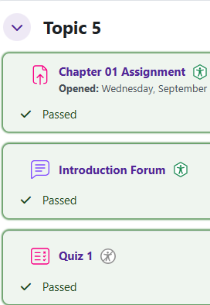
Log in to Moodle and go to your course. Find the assignment and click on the link.

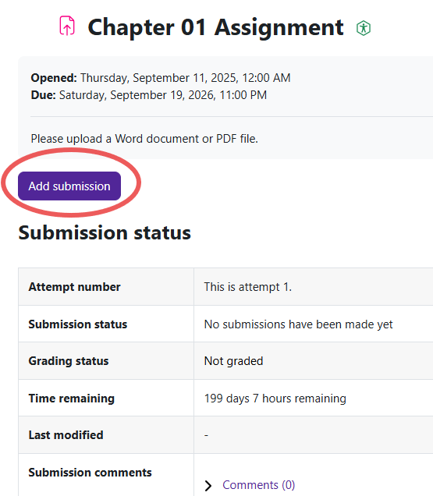
The submission status shows important information about the assignment. To add your text information, click the Add submission button.
Moodle v. 4.5.7 Updated 03/26

Moodle will provide a text box for you. Type your information in the text box.
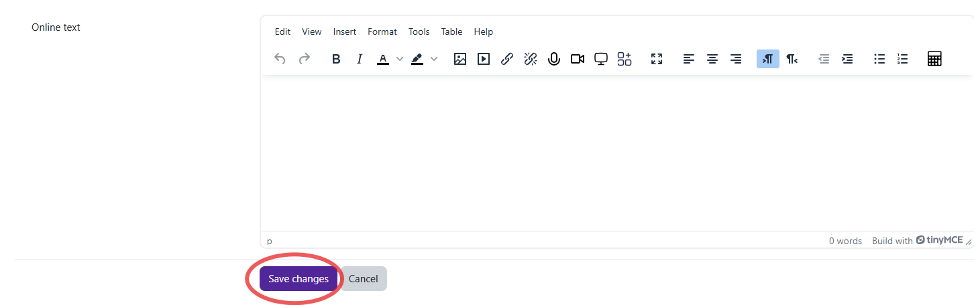
When you are ready to submit, click on the Save changes button.

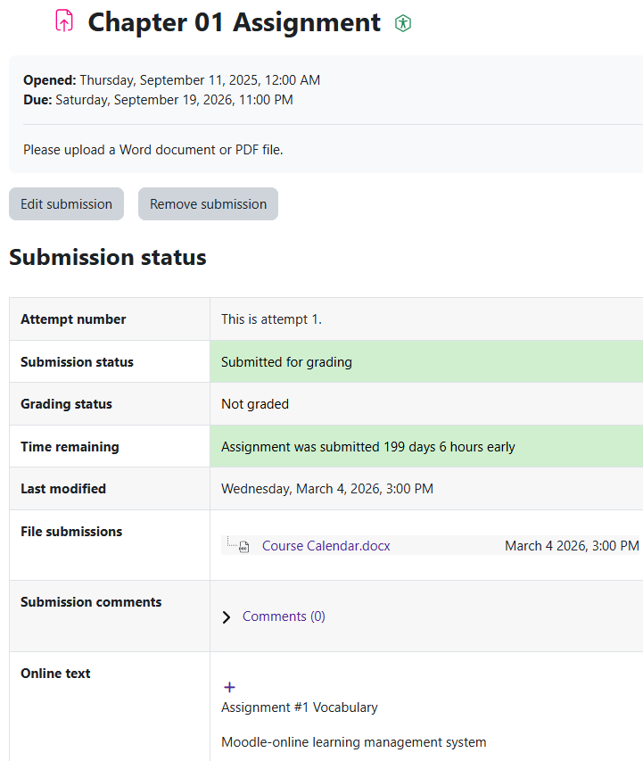
The submission status page will show that your Online text assignment has been submitted.

