Creating a Quiz

Quiz Settings
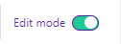
Log in to Moodle and navigate to the course. Turn editing on.
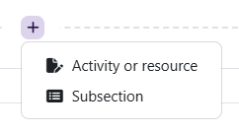
Within a topic, click on the plus and select activity or resource.

The Add an activity or resource picker will open.
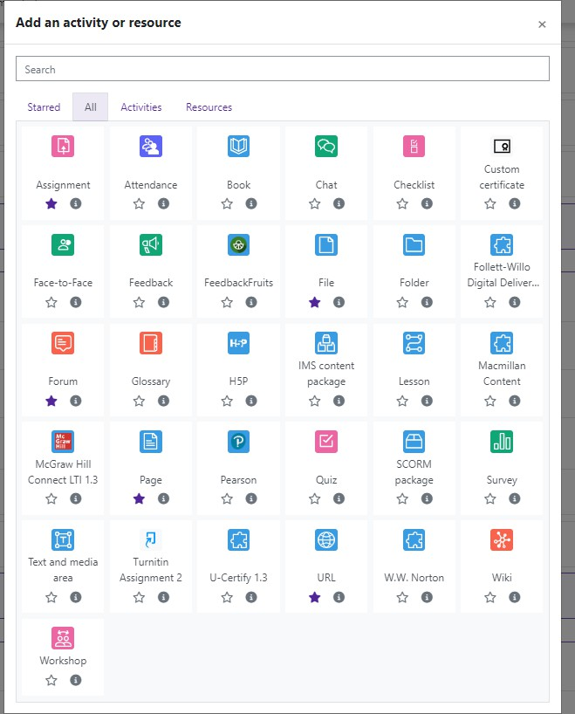
Moodle v. 4.5.7 Updated 03/26

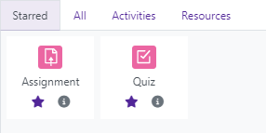
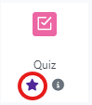
Underneath the quiz name, the star icon will allow instructors to “star” an activity or resource that is used most frequently.
The activity or resource picker also allows toggling between Starred, All, Activities, and Resources.

Clicking on the “I” —information icon—will open a window that gives more information about the activity or resource.
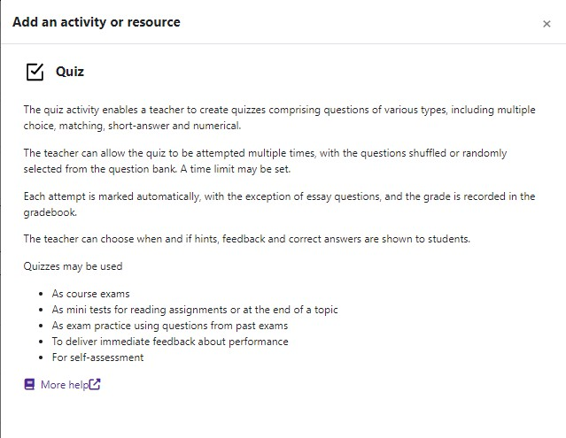
For additional help, click on “More help” to navigate to the Moodle Docs site.

Choose Quiz.

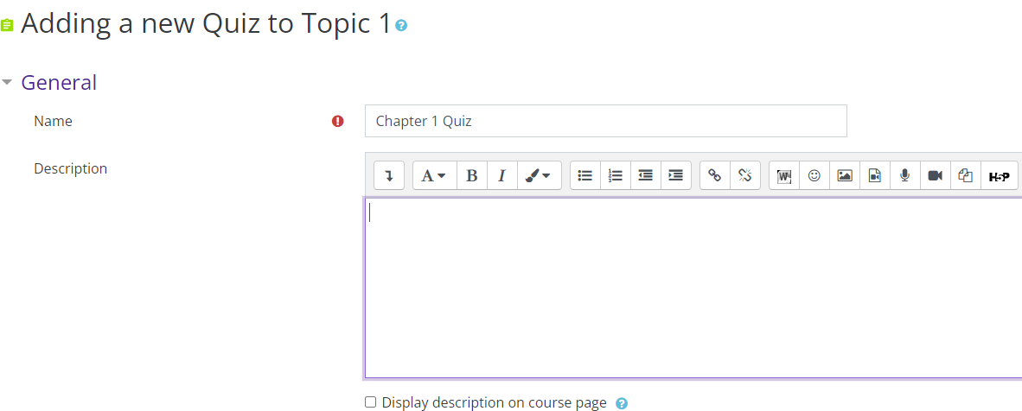
Moodle will open the Adding a new quiz page.

Name—give the quiz a name.

Description—a description of the quiz is optional. This is a good place to explain what will be covered in the quiz as well as the time limit and total points if applicable.

Timing

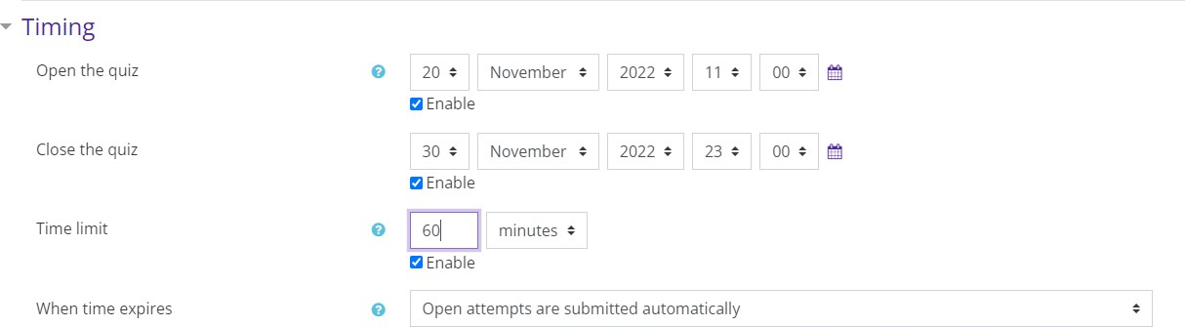
Open/Close the quiz—if enabled, students can only start their attempt after the opening time and they must complete their attempts before the close of time.

Time limit—if enabled, the time limit is stated on the initial quiz page and a countdown timer is displayed above the quiz navigation block.

When Time Expires—this setting controls what happens if the student fails to submit their quiz attempt before time expires. We recommend “open attempts are submitted automatically.”:

Grade

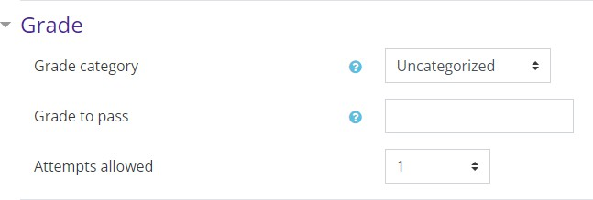
Grade category—if you created categories in the gradebook, they would be available in the drop down menu.

Grade to pass—this setting determines the mini- mum grade required to pass. The value is used in activity and course completion, and in the gradebook, where pass grades are highlighted in green and fail grades in red.

Attempts allowed—you can choose to allow stu- dents to take the quiz multiple times.

Layout

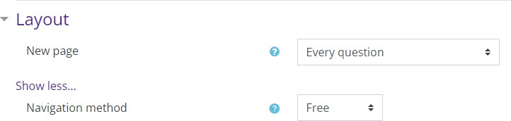
New page—designates how many questions ap- pear on each page. We recommend no more than 5 for multiple choice or true/false and 1 question per page for essay questions.

Navigation method—when sequential navigation is enabled, a student must progress through the quiz in order and may not return to previous pages nor skip ahead. Free navigation lets stu- dents return to a previous page or skip ahead.

Question behavior

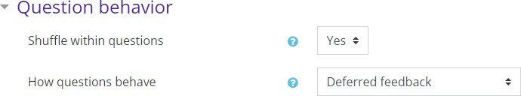
Shuffle within questions—if enabled, the answers to each question will be randomly shuffled each time a student attempts the quiz, provided the op- tion is also enabled in the question settings. This
setting only applies to the questions that have multiple parts such as multiple choice or matching.

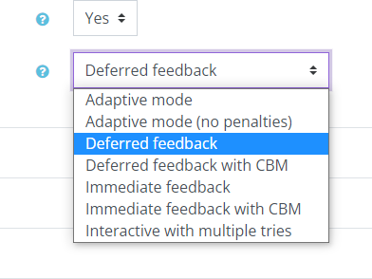
How questions behave—students can interact with questions in the quiz in various ways. For example, you may wish the students to enter an answer to each question and then submit the entire quiz, be- fore anything is graded or they get any feedback.
This would be “deferred feedback” mode. This is the most commonly used mode of behavior.

Adaptive mode can be used if you would like to give the student the opportunity to be allowed multiple responses to a question even within the same attempt of the quiz.
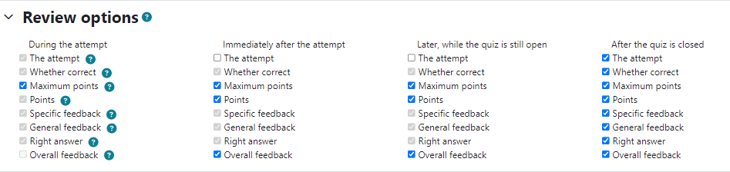

Review options

These options control what information students can see when they review a quiz attempt or look at the quiz reports. We recommend only showing MAXIMUM POINTS & POINTS until after the quiz is closed, as seen above.
During the attempt—settings are only relevant for some behaviors such as adaptive mode.

Immediately after the attempt—settings apply for the first two minutes after Submit all and finish is clicked.

Later, while the quiz is still open—settings apply after this, and before the quiz close date.

After the quiz is closed—settings apply after the quiz close date has passed. If the quiz does not have a close date, this state is never reached.

Appearance

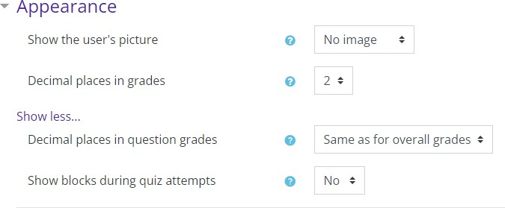
Show the user’s picture—if enabled, the student’s name and picture will be shown on-screen during the attempt, and on the review screen, making it easier to check that the student is logged in as themselves in a proctored exam.

Decimal places in grades—this setting specifies the number of digits shown after the decimal point when displaying grades.

Decimal places in question grades—this setting specifies the number of digits shown after the dec- imal point when displaying the grades for individu- al questions.

Show blocks during quiz attempts—if set to yes, then normal blocks will be shown during quiz attempts.

Extra restrictions on attempt

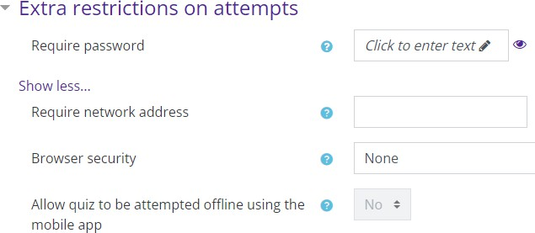
Require password—if a password is specified, a student must enter it in order to attempt the quiz. Click the pencil icon to type in password.

Require network address—leave blank.

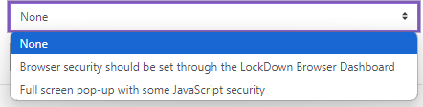

Note: If using the offline option, remember that it is not possible for a quiz to be attempted
offline if it has a time limit, or requires a network address, or uses any question behavior other
than deferred feedback (with or without CBM).
Browser security—this activates security measures that necessitate having a JavaScript- enabled web browser to attempt the quiz, view the quiz in a full-screen popup window covers all the other windows and has no navigation controls, and disable facilities like copy and
paste. Respondus LockDown Browser is anoth- er option. Respondus LockDown Browser is set up through the Respondus LockDown Browser Navigation Block, not through this setting.

Allow quiz to be attempted offline using the mobile app—if enabled, a mobile app user can download the quiz and attempt it offline.

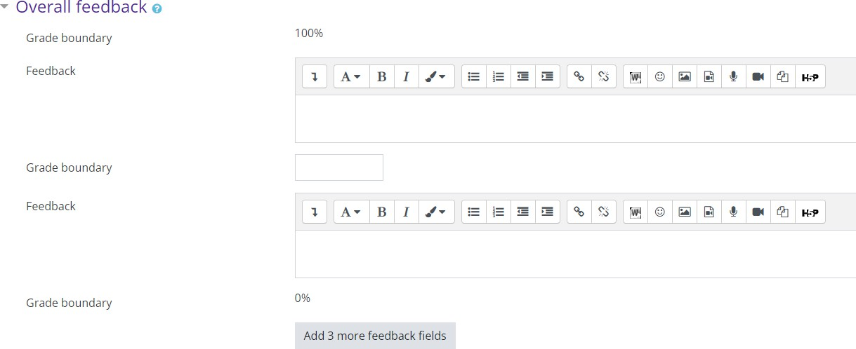
Overall feedback

Overall feedback is text that is shown after a quiz has been attempted. By specifying additional grade boundaries (as a percentage or as a number), the text shown can depend on the grade obtained.

More feedback fields can be added in increments of 3 if needed. Audio and video files can be added to feedback files by using the text editor.

Restrict Access

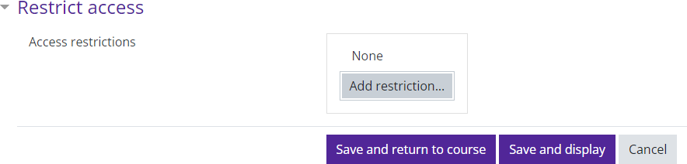
This is used to restrict access to the assignment based upon activity completion, date, grade, the group or grouping the student is in or even user profile fields. Restriction set allows for more com- plex criteria requiring nested conditions.

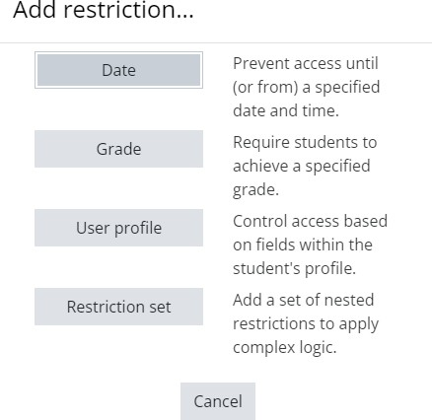
Do not use this function to set the availability of the quiz.

Instructors can choose one or more restrictions. Click on Add Restriction.

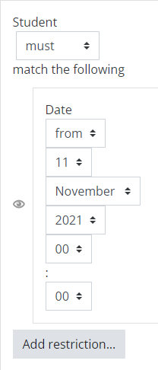
Select the restrictions needed.

Example of Date restriction.

Save and display to save the settings of the quiz.

