Completing a Quiz/Exam
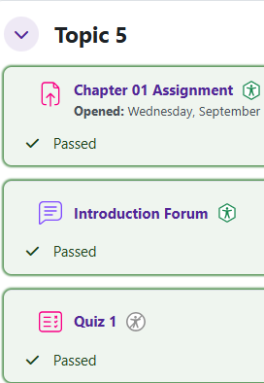
Log in to Moodle and go to your course. Find the quiz and click on the link.

Make sure to read any directions the instructor posts.
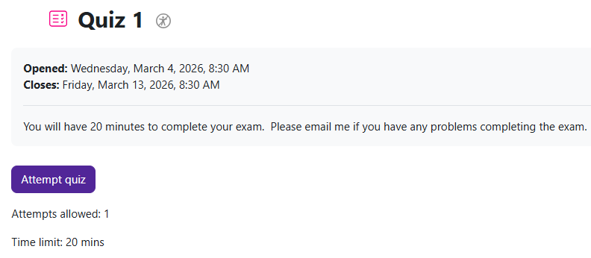
When you are ready to take the quiz, click on Attempt quiz now.

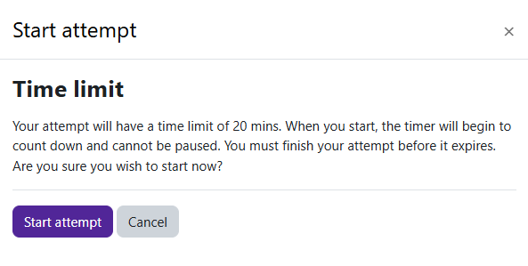
If the quiz is timed, the Time limit warning will appear.
Click on Start attempt.

Moodle v. 4.5.7 Updated 03/26

The Quiz navigation block will show you how many pages there are in the quiz. If the quiz is timed, the timer will be found there as well.
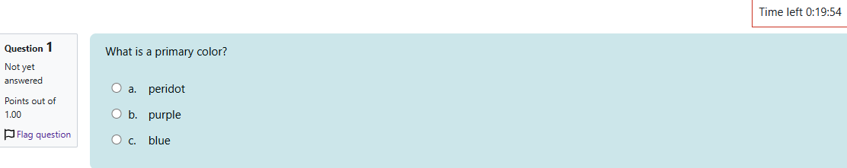

Click on the next page button to proceed to the next set of questions.


Click on Finish attempt to complete the quiz.

The Summary of attempt page will appear.
You can return to the attempt or submit all and finish.
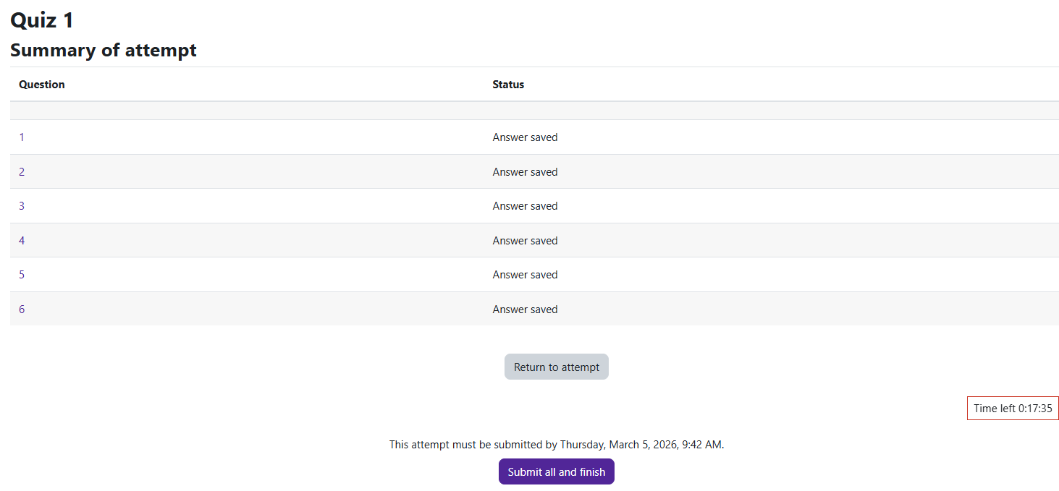

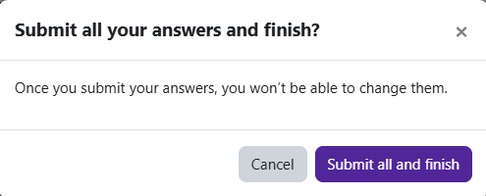
A confirmation window will open. Click on Submit all and finish.

You have successfully submitted your quiz.
This screen may vary depending on the instructor’s settings.

