Viewing Grades
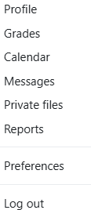
Log in to Moodle.
In the top, right of the screen, locate your name and profile picture. Using the dropdown menu beside your name, click on Grades.

Select the name of the course.
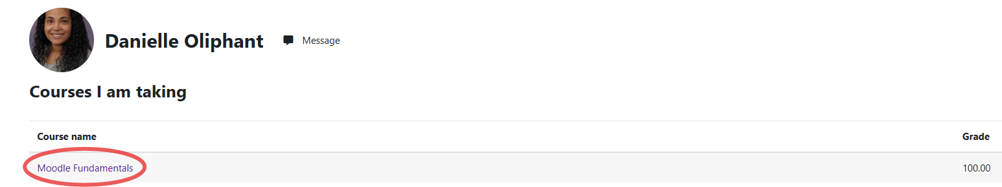

Moodle will load the grades for the course.

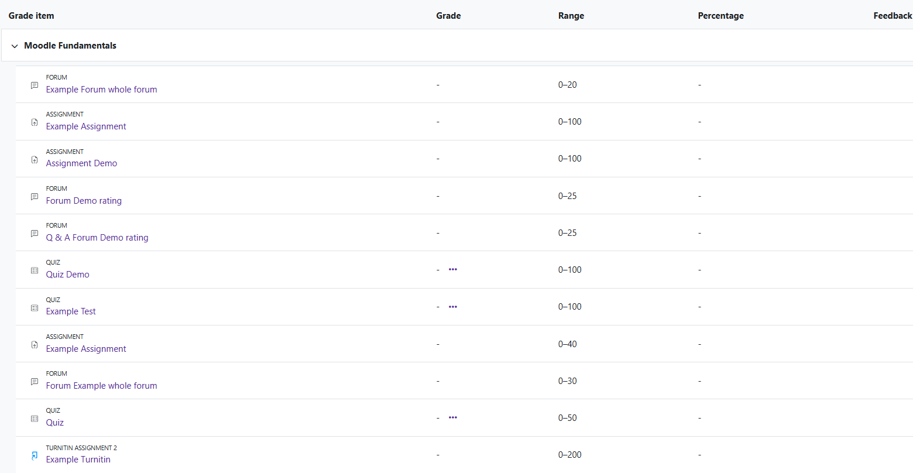

Moodle v. 4.5.7 Updated 03/26

