Adding Questions To A Quiz

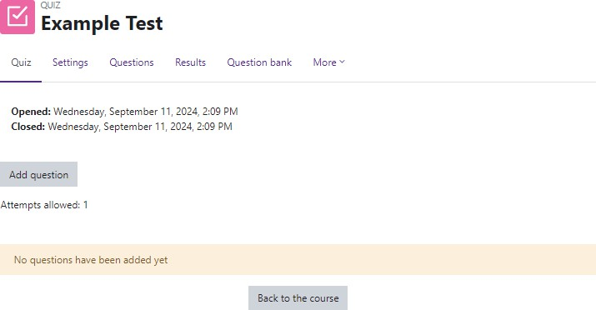
Log in to Moodle and navigate to the course. Turn Edit Mode on.

Locate the quiz.
Click on the quiz link. Click on Add Question.

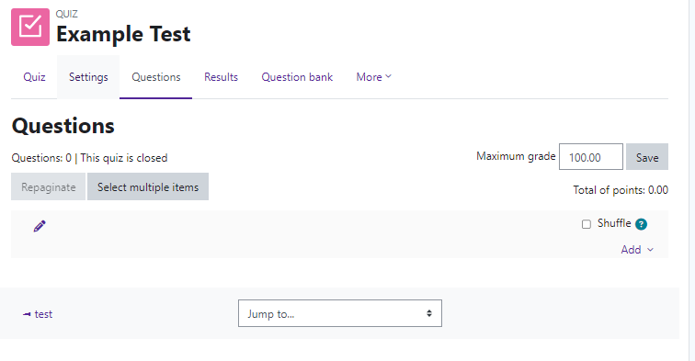
Moodle will load the Editing quiz page.

Questions—this will update as you add questions.

Maximum grade—how many points do you want the quiz to be worth. Make sure to enter this number and Save.

Moodle v. 4.5.7 Updated 03/26

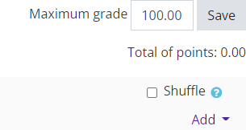

Choose to add a question from bank.

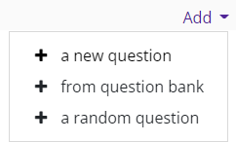
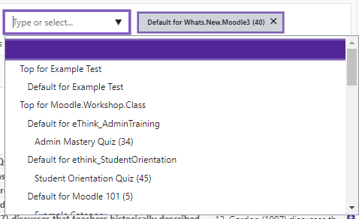
Question Banks
Type or Select- Choose the Question Bank.

Once chose, click Apply Filter.

Moodle will load the questions within that category.
To add questions, click on Add.

Add selected questions to the quiz.

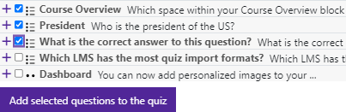
Place a check mark in the select box to the left of each question you want to add to the quiz.
The questions have been added to the quiz.
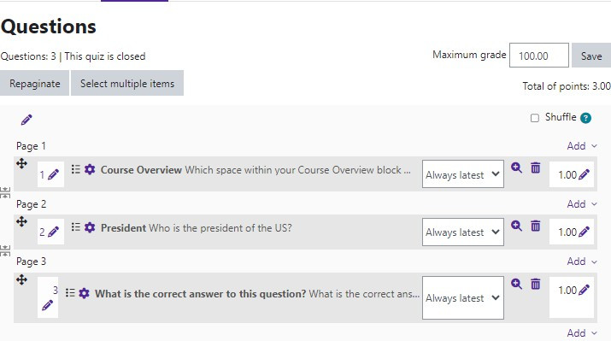

Random questions can be added from different categories.

Click on Add and choose + a random question. Select a category.
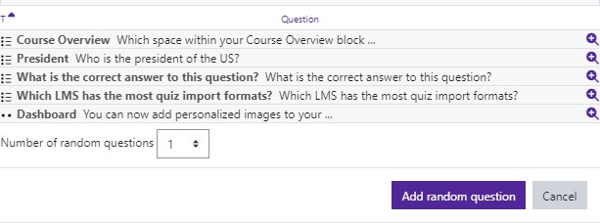
Choose the number of random questions to be added from that category.

Click on Add random question.

Each time the quiz is deployed, Moodle will randomly choose that number of questions from that category. This ensures that every student receives a different quiz.

To add more random questions from other categories, click on Add and select + a random question and repeat the process.

NOTE: Once students take the quiz, changes cannot be made to questions. Deleting or adding questions is not allowed. Make sure to preview the quiz before deploying.

