Open LMS App instructions

Once you have downloaded the OpenLMS app from either the Google Store or Apple App Store and open it, you will be asked to enter the web address for our site.
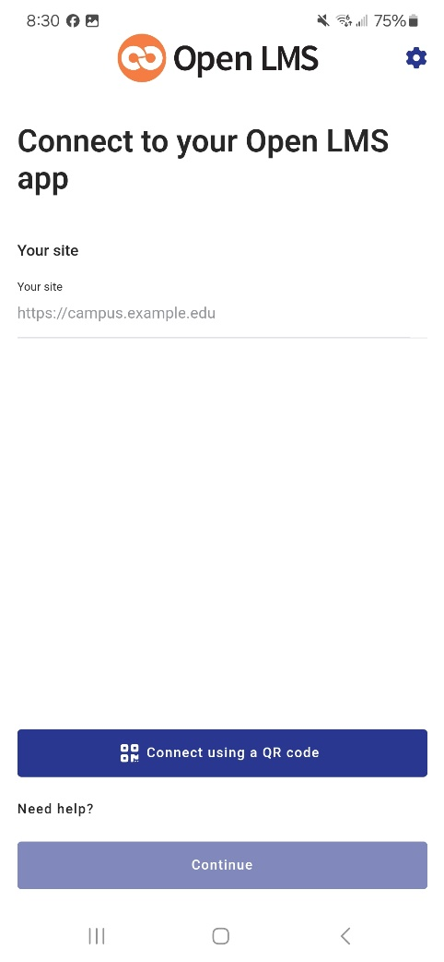

Enter moodle.nsula.edu.

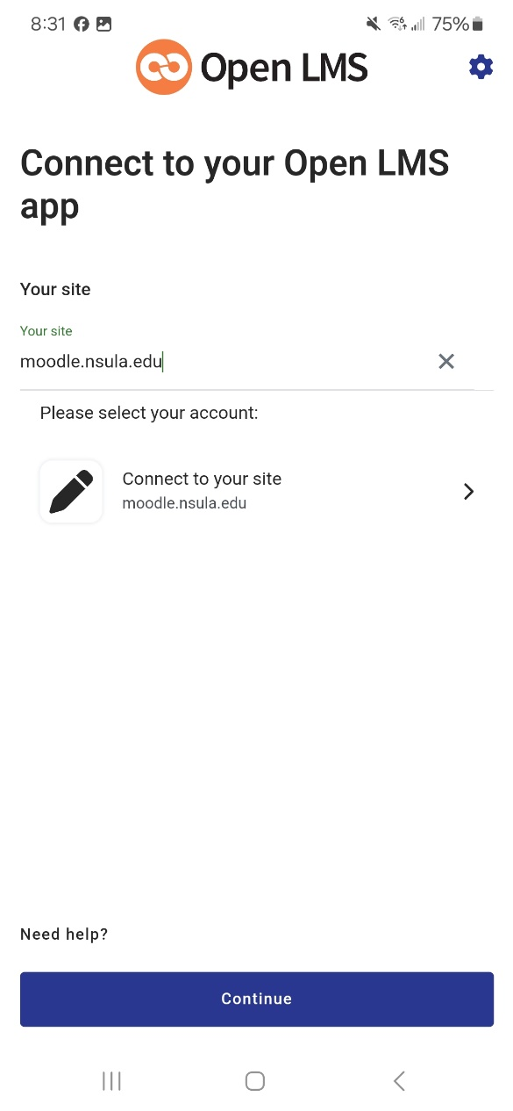

Once entered, click on the “Connect to your site” button in the middle of the screen.

You will then be taken to our myNorthwestern State page. Once there, click “Log in”.
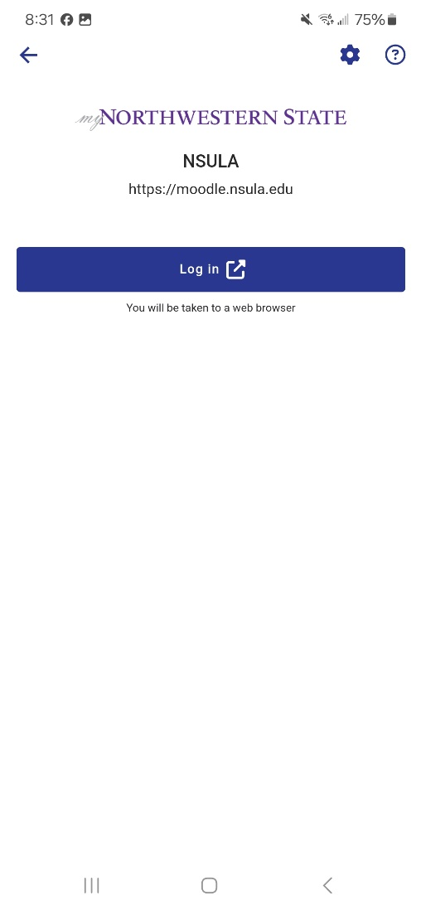

A box should come on your screen asking you for your Username and password. Be sure to put your full email address as the username followed by the password.

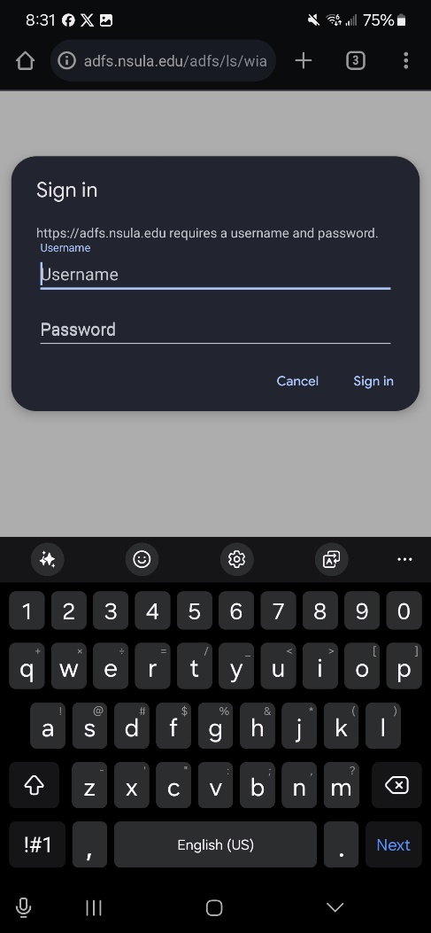

If you entered the information in correctly, your phone should ask you to be taken back to the OpenLMS app.
