Deleting the Quiz Attempt
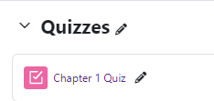
To delete a quiz attempt:
Log in to Moodle and navigate to the course. Locate and click on the quiz link.
Use the quiz name, select Results.
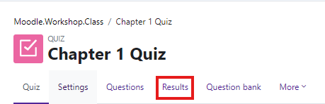

Find the student(s) you want to reset.
Select the student(s) by placing a check mark in the box to the left of their picture. Click on Delete selected attempts.
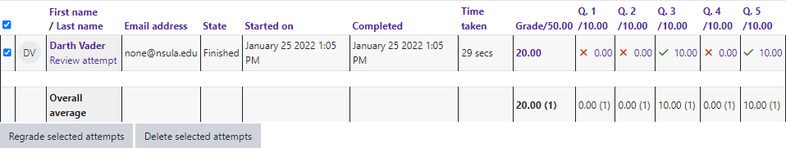

Moodle will remove the attempt.
As long as the quiz is still open, the student(s) will be able to take the quiz.

Moodle v. 4.5.7 Updated 03/26

