Viewing Quiz Results

To view quiz results:
Log in to Moodle and navigate to the course. Locate and click on the quiz link.
Under the test name, select Results.
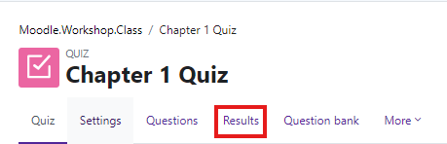

Settings at the top of the report allow the instructor to control what is displayed.
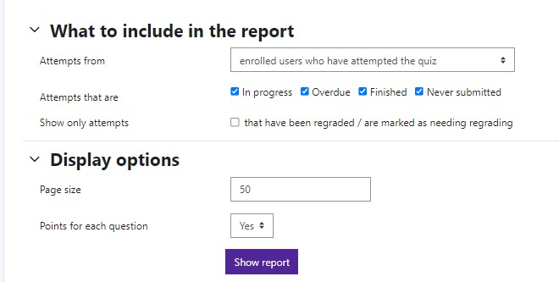
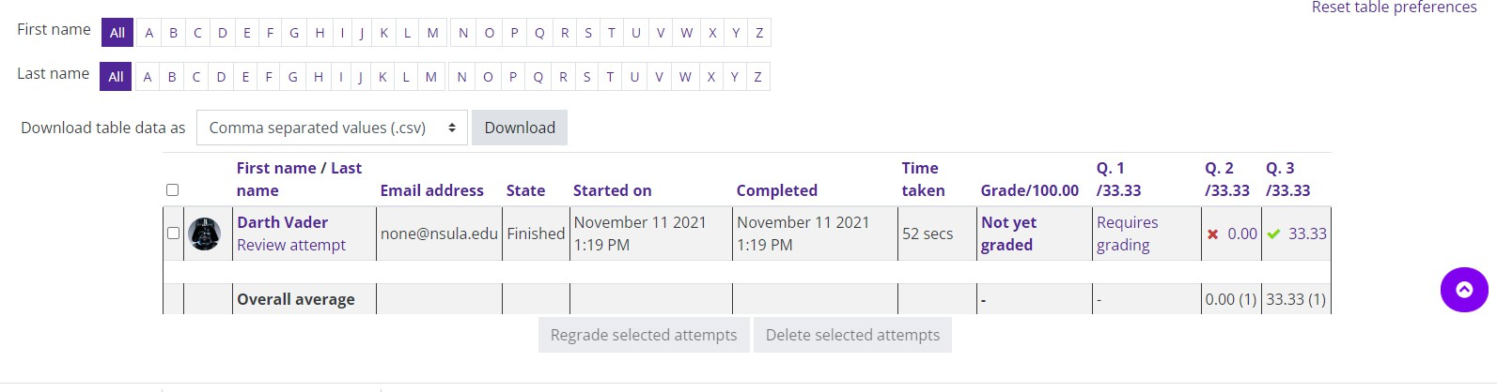
Moodle v. 4.5.7 Updated 3/26

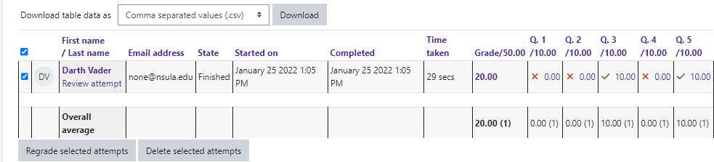
Grade reports show all attempts with the overall grade and the grade for each question. Results can be downloaded.

Report columns include:
- First name / last name
- Email address
- State (finished or in progress)
- Started on—the date and time the quiz was started
- Completed—the date and time completed
- Time taken—the amount of time it took the student to start and submit the quiz
- Grade / x - the number of points students scored; “x” is the maximum number o points. If “Not yet graded” appears in this column, the instructor will need to manually grade this item.
To see the student’s attempt, click on the “Review attempt” link under the student’s name.
