Manually Grading Essay Questions

If you use essay questions in your quiz, you will need to manually grade the student’s response.
Log in to Moodle and navigate to the course.

Under the test name, select Results.


Underneath the dropdown, switch from Grades to Manual grading.
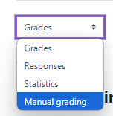
Moodle will load all the questions in the quiz that need to be manually graded.

Click on the “Grade” under the To Grade Column for a question that needs to be graded.

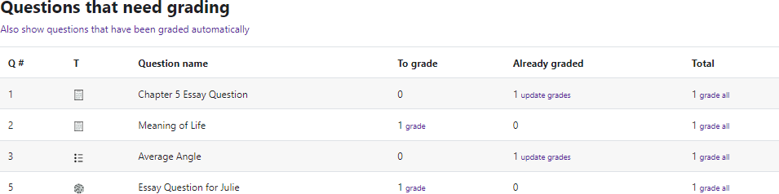
Moodle v. 4.5.7 Updated 03/26

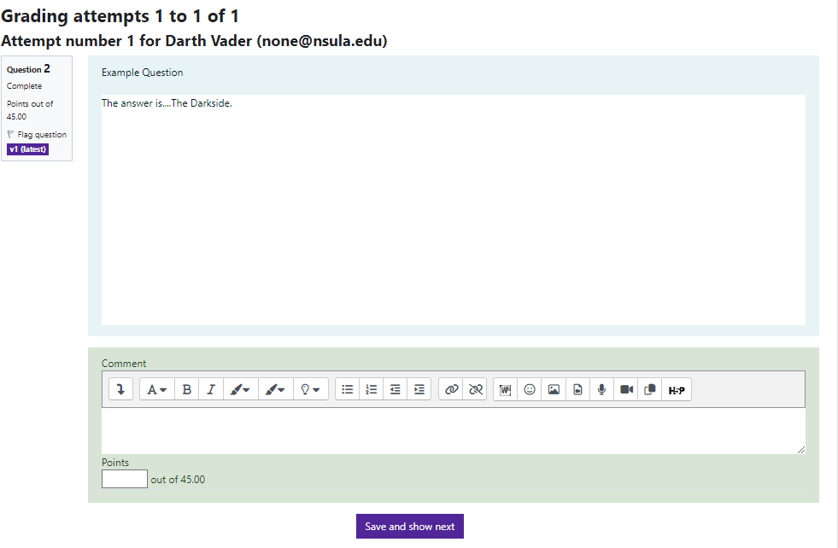

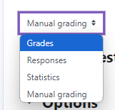
Moodle will load all the responses to the question that needs to be graded manually.
Instructions can leave feedback in the Comment textbox.
The grade for this question should be entered in the box provided. Once complete, click Save and go to the next page.
Once complete, change the dropdown from Manual grading to Grades.

