Uploading Video from Phone to OneDrive
These instructions are for uploading video from your phone to your NSU OneDrive so you can share your video in classes.
Be sure you have the OneDrive app on your phone. The app is free and can be found in the Google Store for Android phones or the App Store for iPhone users. Just be sure you log in with your NSU account.

Adding Video to OneDrive
- Once inside the app, click the Plus button located in the bottom right corner of the screen.
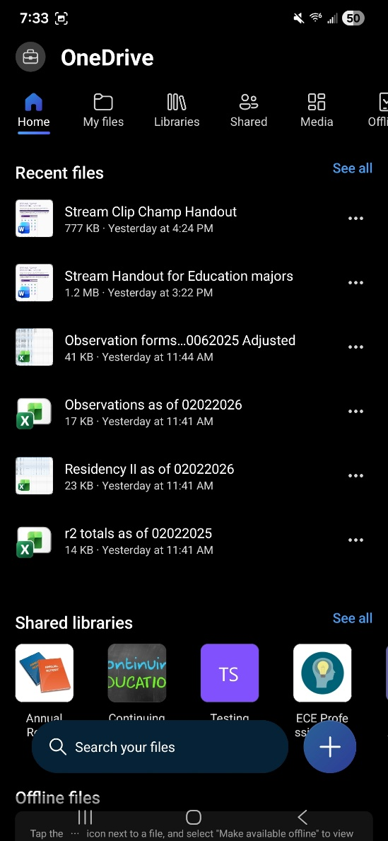

- Click the Upload button located at the bottom of the screen.
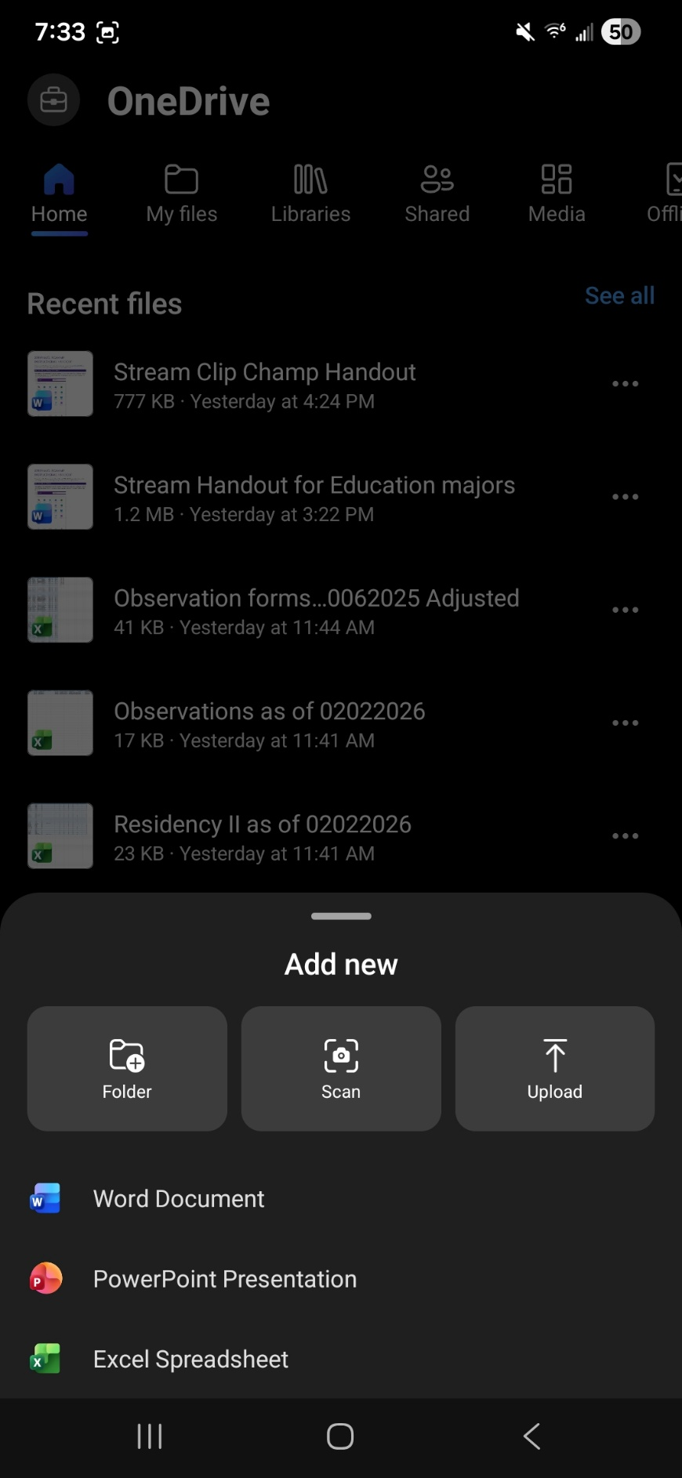

- Select the videos that you need to upload from your phone by pressing the file on your phone. Then, click Select(Android) or the Checkmark(iPhone) at the top right-hand corner of the screen.
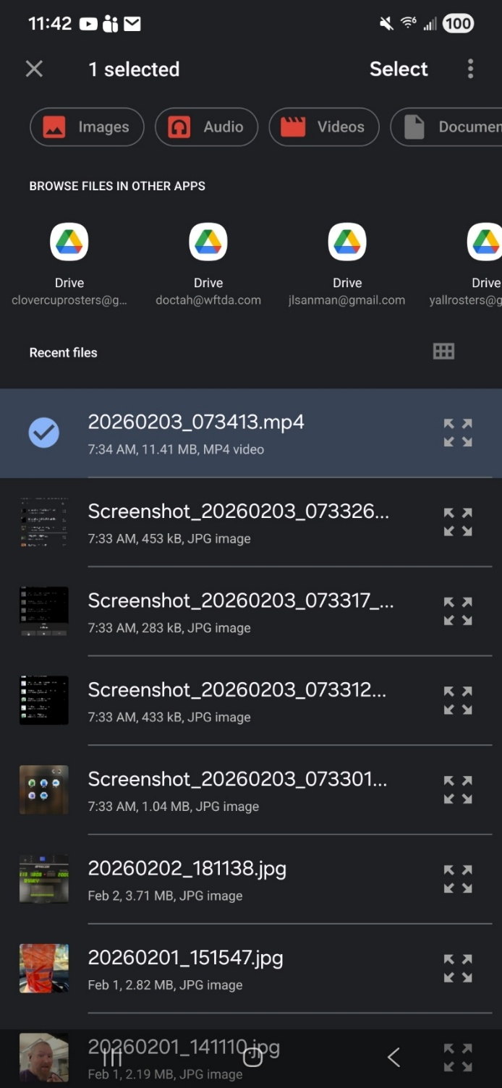

You can then go to your Office 365 (OneDrive) account on your computer to find the video you uploaded. It will be in your MyFiles area. Open from OneDrive online to add captions and share the video to your class.

Add closed captions
- In the Video Settings menu, under Transcript and captions, click Generate.
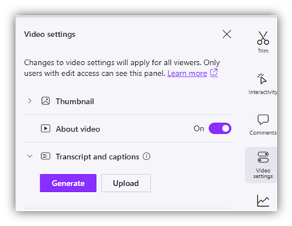
- Once the transcript has been generated, you will see a button on the right labeled Transcript.
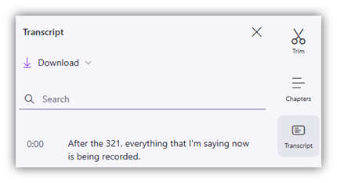
- There, you can read through the transcript and correct any errors.

Post to class
Get the Share link for your class and post as directed by your instructor.
- At the top right corner of the Stream/Clipchamp menu, click Share and Copy link.
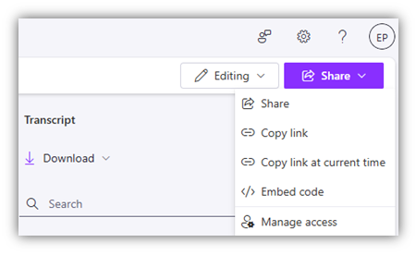
- After you click Copy link, go to Settings to adjust the link properties:
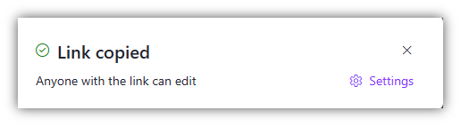
- On the Settings page, be sure to choose Anyone and Can view (instead of Can edit) under More settings. Once you have made your selections, click Apply.
- The link will be copied to your computer clipboard, and you can then paste in the appropriate location within Moodle.

