Post PowerPoint Recording Projects to Class

Create your video with voice over
- Create your Presentation Slides.
- Run the PowerPoint Accessibility checker. Ensure that any color contrast issues are corrected. Once your PowerPoint is converted to video, things like reading order and slide titles will not be relevant.
- Record your voice over and export to video. Save your video to your OneDrive.
- Open the video from OneDrive into Microsoft Stream/Clipchamp (Microsoft is in the process of rebranding Stream to Clipchamp. Right now, you will see both names but they are the same application).

Add closed captions
- In the Video Settings menu, under Transcript and captions, click Generate.
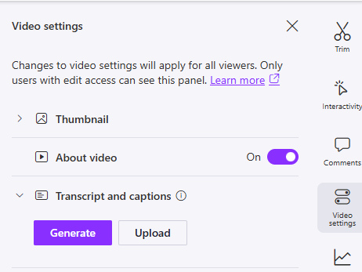
- Once the transcript has been generated, you will see a button on the right labeled Transcript.
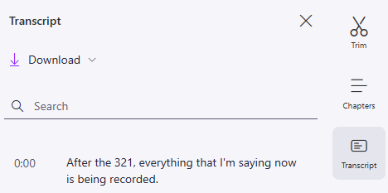
- There, you can read through the transcript and correct any errors.

Post to class
Get the Share link for your class and post as directed by your instructor.
- At the top right corner of the Stream/Clipchamp menu, click Share and Copy link.
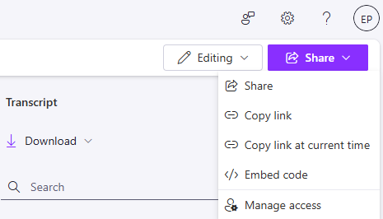
- After you click Copy link, go to Settings to adjust the link properties:
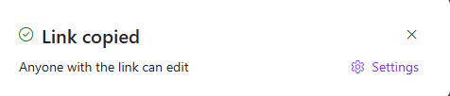
- On the Settings page, be sure to choose Anyone and Can view (instead of Can edit) under More settings. Once you have made your selections, click Apply.
- The link will be copied to your computer clipboard, and you can then paste in the appropriate location within Moodle.

