recording in Stream/ClipChamp
Stream (now Clipchamp) is a video recording and playback service offered through Office365. These instructions are for creating videos in Stream/ClipChamp and sharing the videos.

Navigating to Stream/ClipChamp
Navigating to Stream from Office365: Log into Office365 and click the waffle on the top left. Click the Stream or the ClipChamp icon in this menu. You may have to click “All apps” to find it the first time.
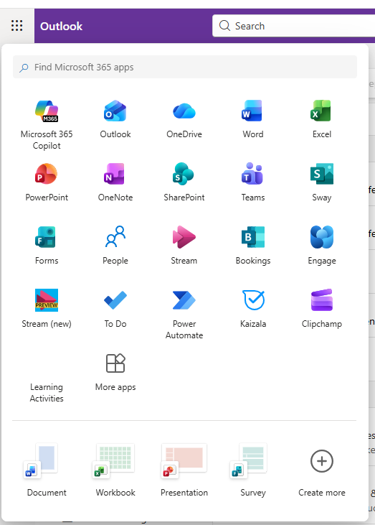

Recording Videos
To record your videos, click on the Screen Recording button if you are recording a presentation or anything on your computer screen, or Camera Recording when you are recording yourself.
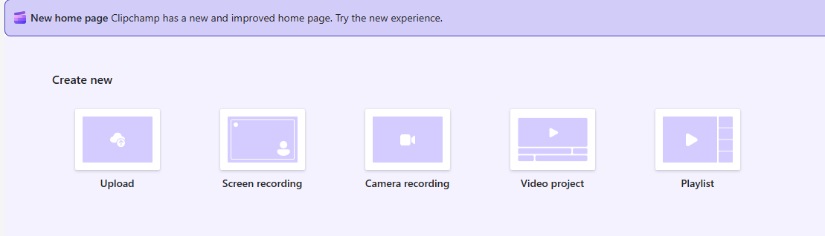

Screen Recording
Click the Start Screen Recording button located at the bottom of the screen.
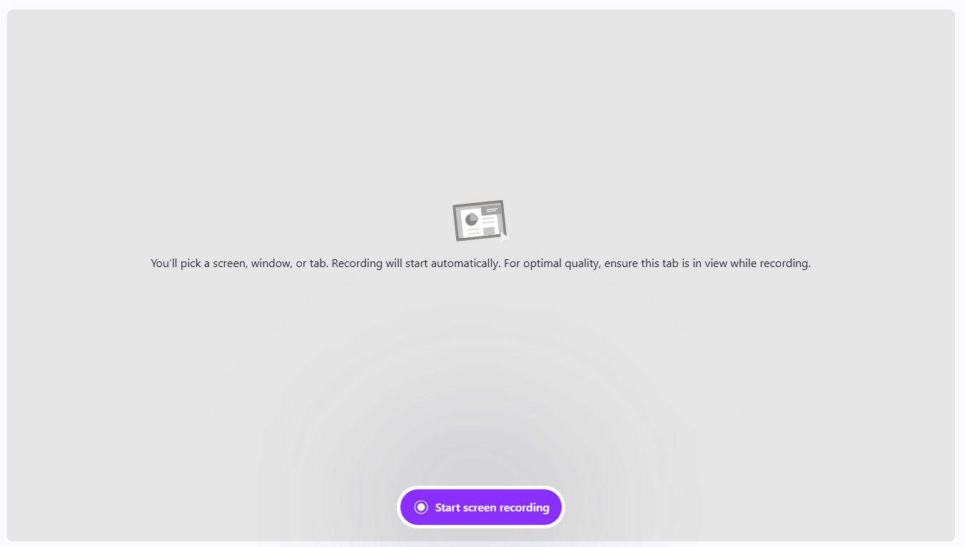

Select the item that you want to share in the presentation. You will choose either a tab of your web browser, an application (Window), or the Entire Screen. At the top of the window, select the option that you want to display. Then, select the specific tab, window, or screen. Then, click Share at the bottom of the screen.
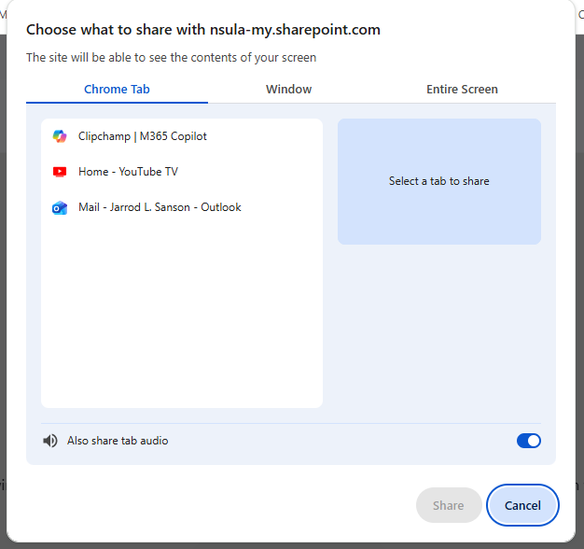
You will see a countdown before the recording begins. Once the recording starts, you will record your presentation, then click the stop button at the bottom to stop the recording. NOTE: Each recording is limited to a maximum of 15 minutes.
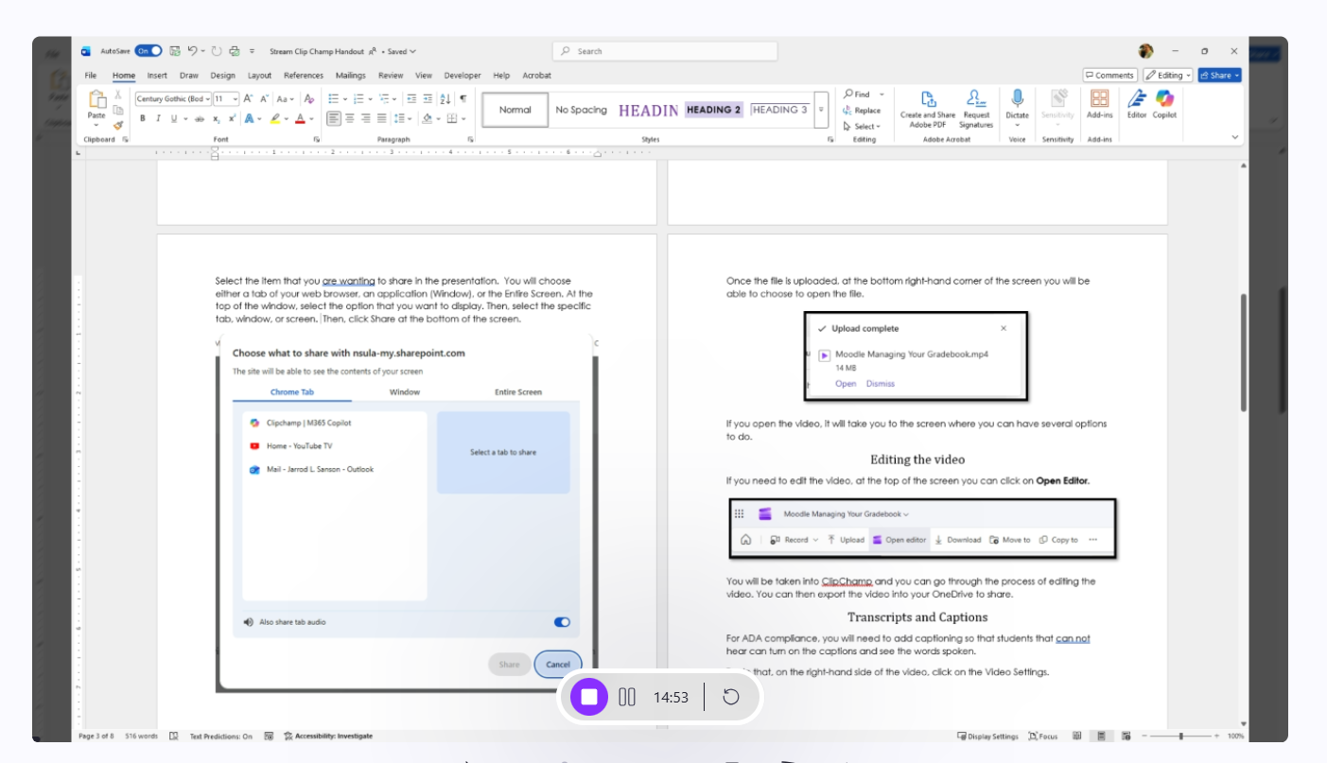
You can then review the recording and edit the recording using the buttons at the bottom of the screen. Once you have reviewed the recording, and made any changes, click the Finish button located in the bottom right of the screen.
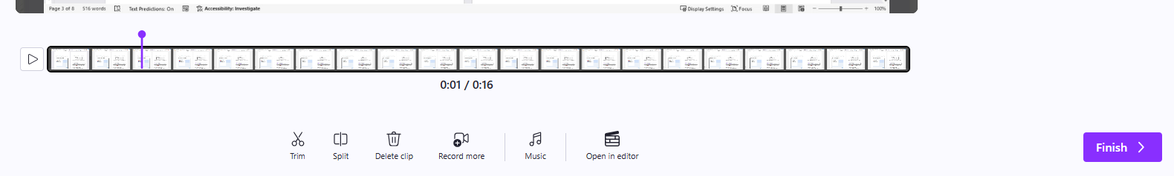
The system will then process the video and take you to the edit menu, where you can then view the recording and add transcripts and captions to the recording.

Camera Recording
For camera recording, there are several similar options. At the bottom of the screen, you can click Camera to select the webcam to use and the Mic button to select the microphone to use. You can click Backdrop to change what background you have. The Script button allows you to have a script displayed so you can read any notes that you have.
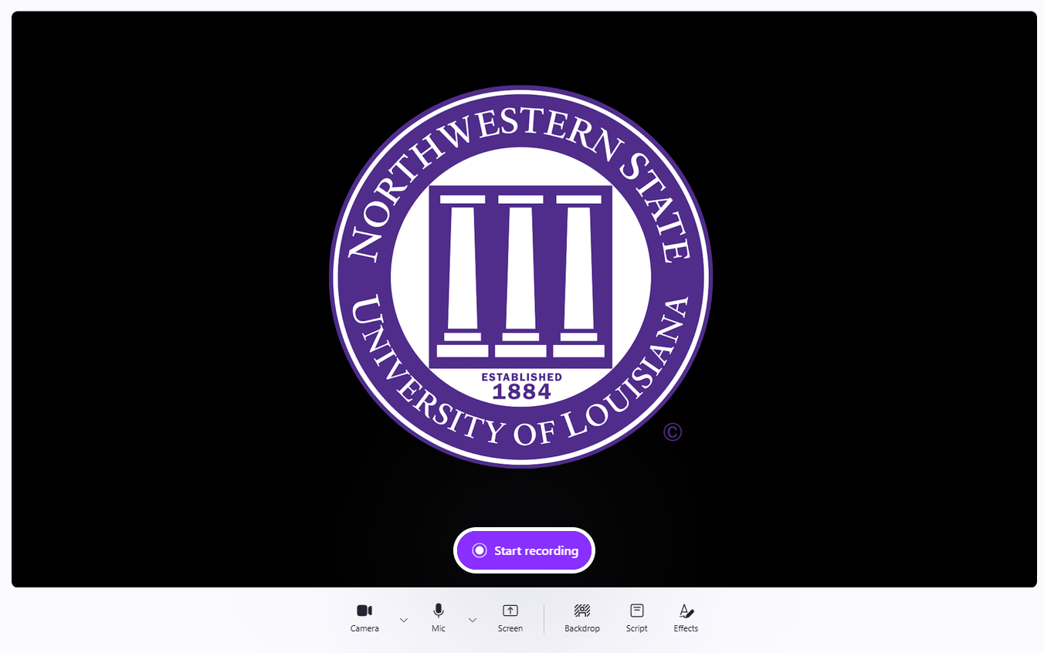

When ready to record, you will click the Start Recording button at the bottom of the screen to start your recording. Once you have finished recording, click the stop button to stop the recording. You can then edit the recording and click Finish to add the transcript and captioning to the recording.

Transcripts and Captions
For ADA compliance, you will need to add captioning.
To do that, on the right-hand side of the video, click on the Video Settings.
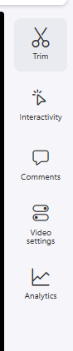
In the Video Settings area, look for the tab called Transcript and captions.
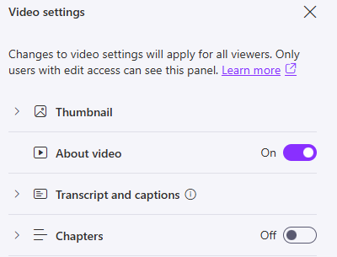
Once expanded, you will click on the Generate button to have ClipChamp start creating the transcript and captions for the video. You will have to choose the language in which the transcript and caption will be.
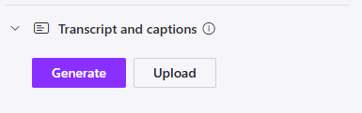
The amount of time it will take to develop the transcript and captions will vary, depending on the length of the video.

Sharing via Link
You can share a direct link to your class by clicking on the Share button located at the top right hand corner of the screen and choose Copy link.
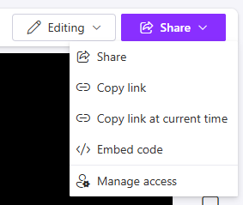
You will need to click on the gear button located next to Copy Link so you can change the settings of the video.
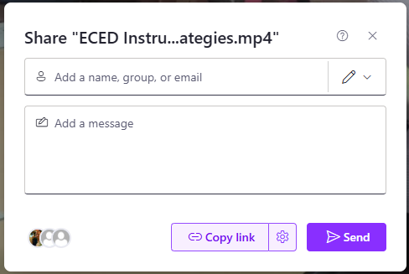

At the bottom of that screen where it says More Settings, you change the option from Can edit to Can view.
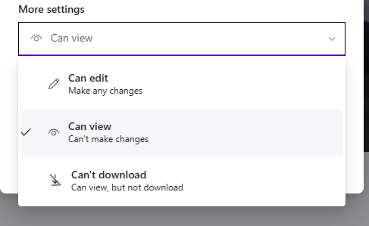
Once you have made the change, you will go to the bottom of the box and click Apply.
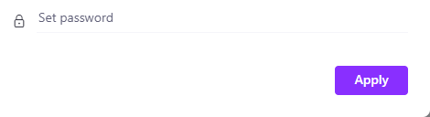
You can now click Copy Link and paste the link to your video into the Moodle class.
