How to Configure a Team for Your Course.

- Once inside Moodle, go to the class that you need a Teams Class for.
- Then, turn your Editing on and look for “Course Blocks” in the top right corner of the screen.
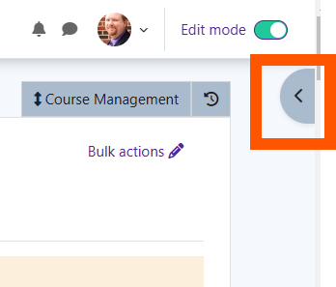
- Click on “Course Blocks” and find the “Add A Block” area.
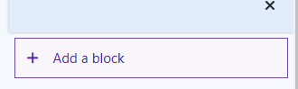
- Click on Add and find Microsoft.
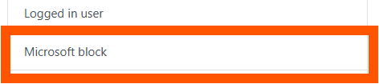
- Once the Microsoft block is added, if you have never used the block before, you will see that you need to connect the block to your Microsoft 365 account. To do that, click on “Log in to Microsoft 365”.

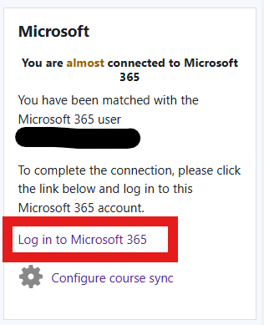
- The screen will change to bring up the Microsoft 365 Features page, and you will need to find “Microsoft 365 Connection Settings”.
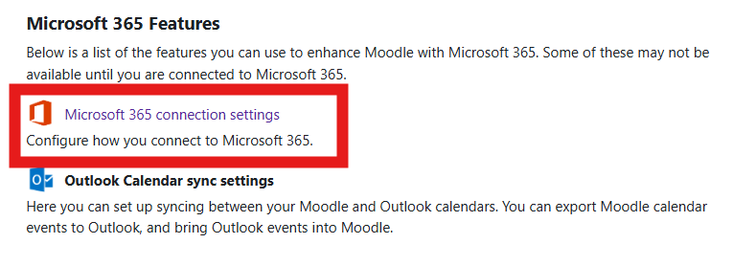
- Then, you will see that you are not connected to Microsoft 365 and you will need to click on “Link your Moodle account to a Microsoft 365 account.
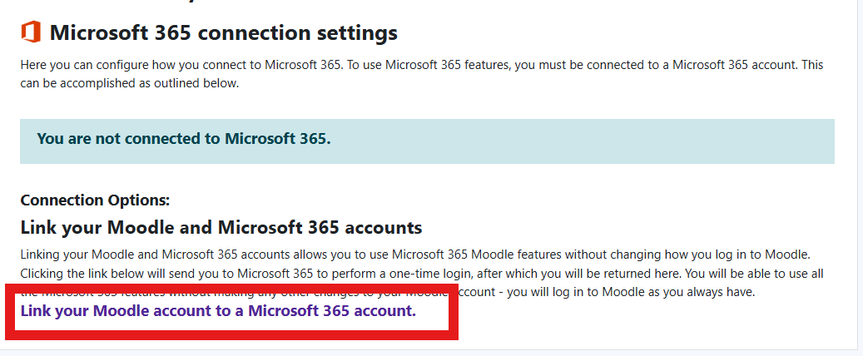
- The system will then connect Moodle to your Microsoft 365 account and let you know that it is linked together.
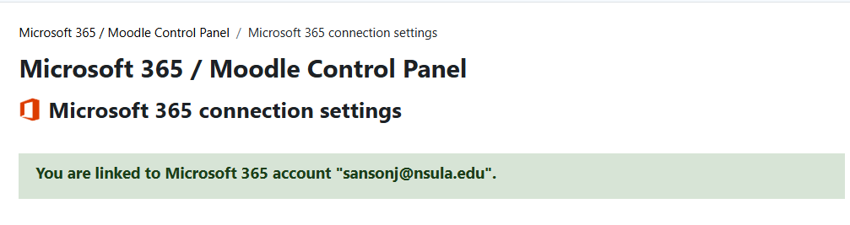
- Once linked, the Microsoft Block will change showing that you are currently connected to Microsoft 365.
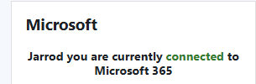

- Next, go to the very bottom of the block, and select “Configure course sync”.
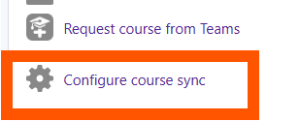
- Then, switch the “Sync option” from “Disabled” to “Enabled”.
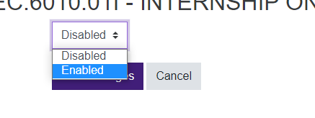
- Once changed, click “Save Changes”.
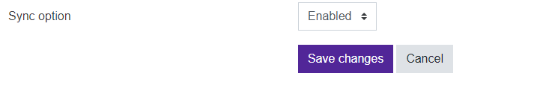
- Once saved, you will be taken back to the course area where you will see that the sync has been saved.
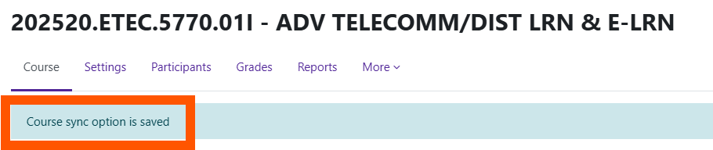

- At that point, you should see a status about if the course is connected to a Team. If it does show that immediately, just wait and check it until it eventually shows that you are connected to a Team.
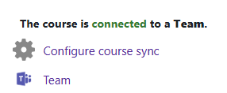

- Switch over to Teams and you should see a Teams block for the class.
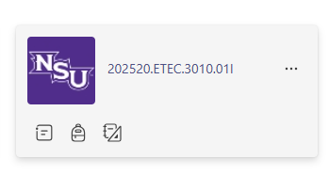
- When you click inside of the Team, you will see a notification to activate the class team to add the students to the Team. Click on the “Activate” button.
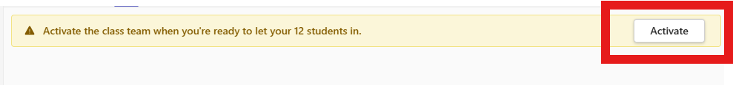

- Once clicked, Teams will give you a notification about what you are about to do and needing to confirm again. Click “Activate” to confirm.
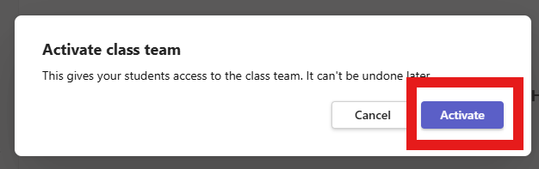

- Team will then let you know it is activated, and you can begin using the Team.
