Creating a Turnitin 3 Assignment

Turnitin
Turnitin is a cloud-based service that checks for originality of a paper.
How it works—Turnitin compares the submitted text to their database and gives an originality or similarity score.

Setting Up a Turnitin Assignment
To add a Turnitin Assignment:
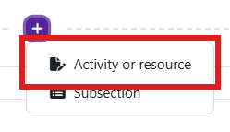
Log in to Moodle and navigate to the course. Turn editing on.
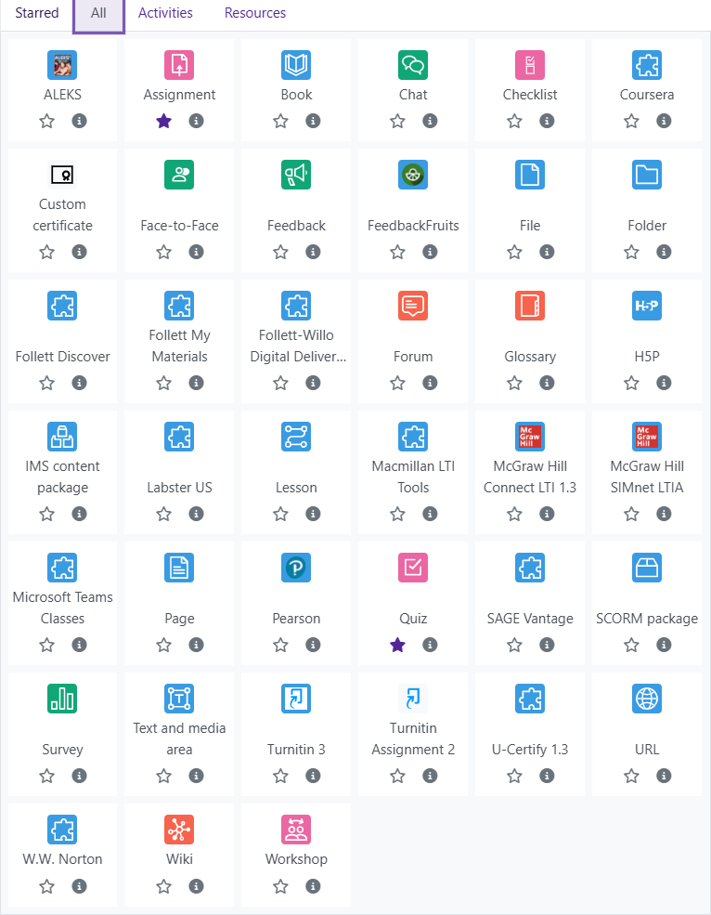
Within a topic, click on the plus and choose add an activity or resources.

The Add an activity or resource picker will open.

Moodle v. 4.5.7 Updated 3/26

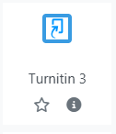
Choose Turnitin 3 .
Notice the icons below Turnitin. The star
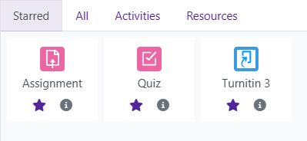
icon will allow instructors to “star” an activi-
ty or resource that is used most frequently.
The activity or resource picker also allows toggling between Starred, All, Activities, and Resources.

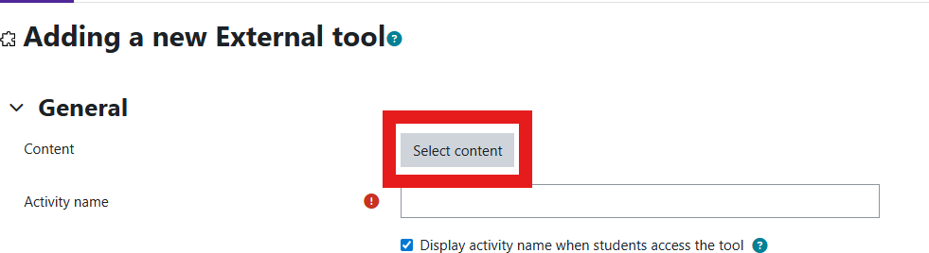
Moodle will open the “Adding a new External Tool” page.

Click on “Select Content”.

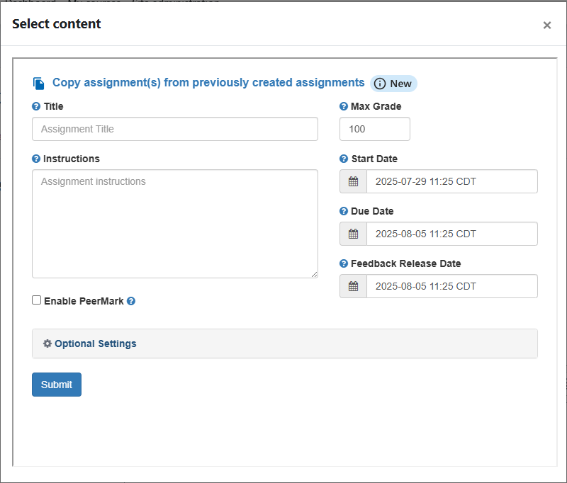
A window will pop up on your screen taking you to the Turnitin system.
You will then supply the title for the assignment and any in- structions that you want to give to the students.
Max Grade- The maximum points the student earns on the assignment. This is also posted in the Gradebook Setup area. Start Date—the earliest date students can submit.

Due Date—the deadline. If you have enabled late submissions any late submissions will appear in red.

Feedback Release Date—the date that marks and feedback are returned to students. This is the date when students will actu- ally see their grade in the Moodle Gradebook.

Then, you will click on the Optional Settings area to changing
any of the other settings for the assignment.

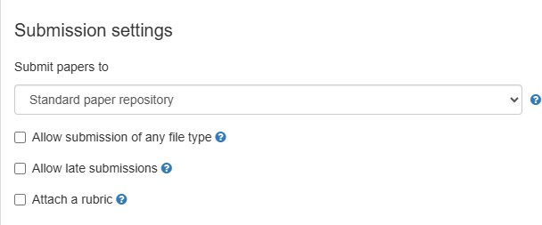
Submission Settings

Submit Paper To– Select if you want to paper stored as part of Turnitin’s paper repository.

Allow Submission of Any File Type– if
checked, the system will allow a student to upload a file type beyond a DOC, DOCX,
HTML, TXT, RTF, PDF, ODT, Google Doc, or
PPTX file type.

Allow Late Submissions—if checked, you allow students to submit after the due date has passed.

Attach a rubric-if checked, you will select a pre-formatted rubric or click Launch Rubric Manager and create a rubric for the assign- ment.

Similarity Report Settings

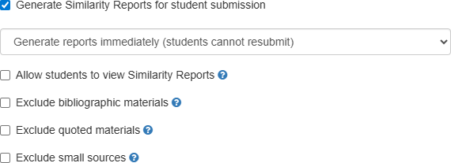
Generate Similarity Reports for Student Sub- mission-if checked, you will select when the report will be generated.

Attach students to view Similarity Reports-if checked, this will allow students to see the report.

Exclude Bibliographic Materials-if checked, you will exclude bibliography information from the similarity report.

Exclude Quoted Materials-if checked, you will exclude quoted material from the re- port.

Exclude Small Sources– if checked, you will determine the number of words or percent- age from a source will need to be used to count in the similarity report.

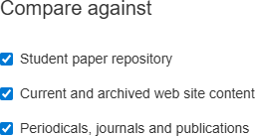
Comparing Against Settings

You will check which items to compare the stu- dent’s submitted work against:

- Turnitin’s Repository
- Web site content
- Periodicals, journals, and publications.

If you are making students enter information onto a template and upload that template into Turnitin, you can upload a blank version of the template and Turnitin will not count that information as part of the simi- larity report.
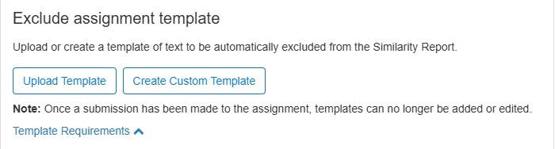


Once all of the settings have been prepared, click Submit.
You will then be taken back into Moodle where you can scroll down to the bottom and click Save and Return to Course to save the assignment.

