Grading a Turnitin Assignment
Turnitin is a cloud-based service that checks for originality of a paper.
How it works—Turnitin compares the submitted text to their database and gives an originality or similarity score.
Since you have built the assignment, let’s go through the process of how to grade a Turnitin assignment.

Accessing the Turnitin Assignment for Grading
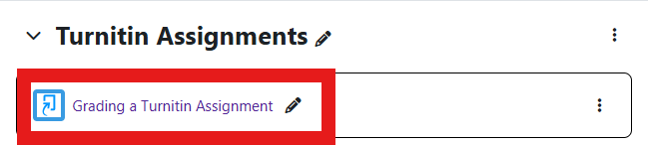
To access the assignment:
Log in to Moodle and navigate to the course that has the assignment.
Within the topic that holds the assignment, click on the name of the Turnitin Assignment.

You will be taken to the Assignment Inbox where you can see the list of students, the name of the file up- loaded, when the file was uploaded, if the student has viewed the feedback and grade, what grade you en- tered, the percentage on the Similarity Report, and if there are any flags with the file.

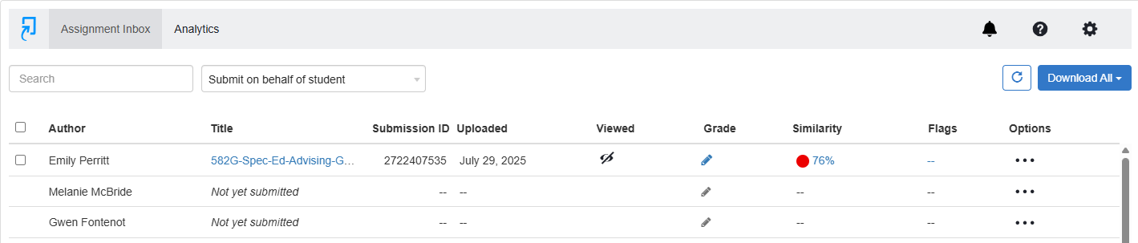

Moodle v. 4.5.7 Updated 3/26

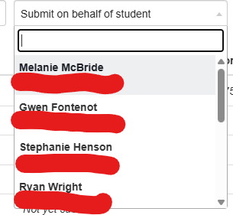
Uploading on a Student’s Behalf:
If you ever need to upload a student’s work for them, you can click on the drop down that says “Submit on behalf of student”.
Then, choose the student whose work you are trying to upload.

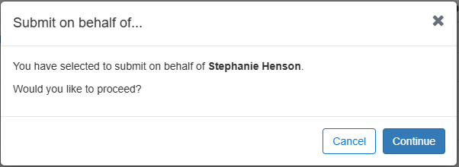
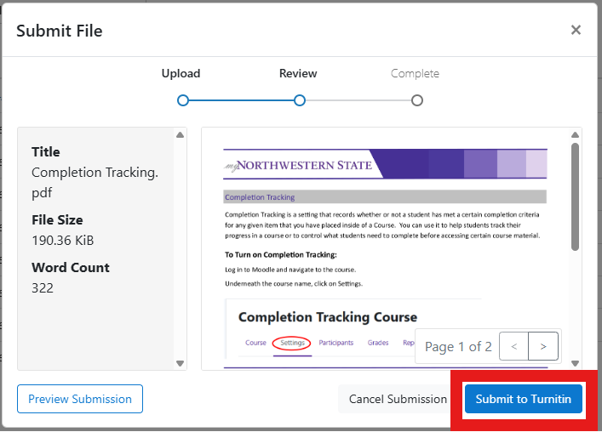
Once the student is selected, you will be asked if you want to proceed with uploading for that student. To proceed, click Continue.

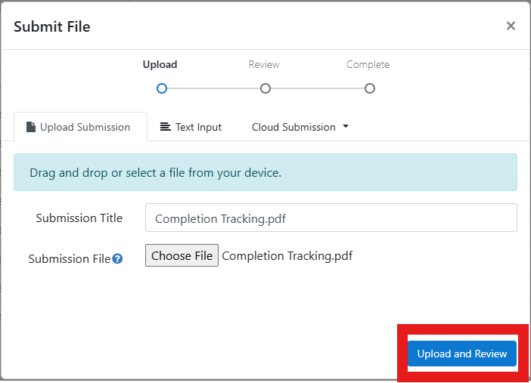
You will then click on the “Choose File” button to browse and find the file that needs to be upload- ed for the student. Once uploaded, you will click “Upload and Review”.
You will see a preview of the file that was uploaded. If everything is correct, you will click “Submit to Turnitin”.

Upon submission, you will be taken back to the Submission Inbox showing that the upload was successful.
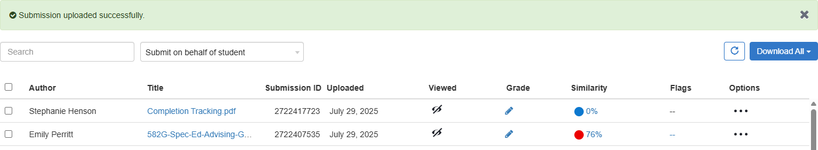

Grading an Assignment

To grade a student’s work and to see the details of the similarity report, on the row of the student, click on the pencil located in the Grade column.
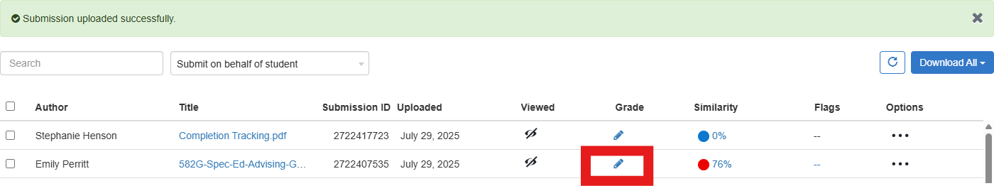

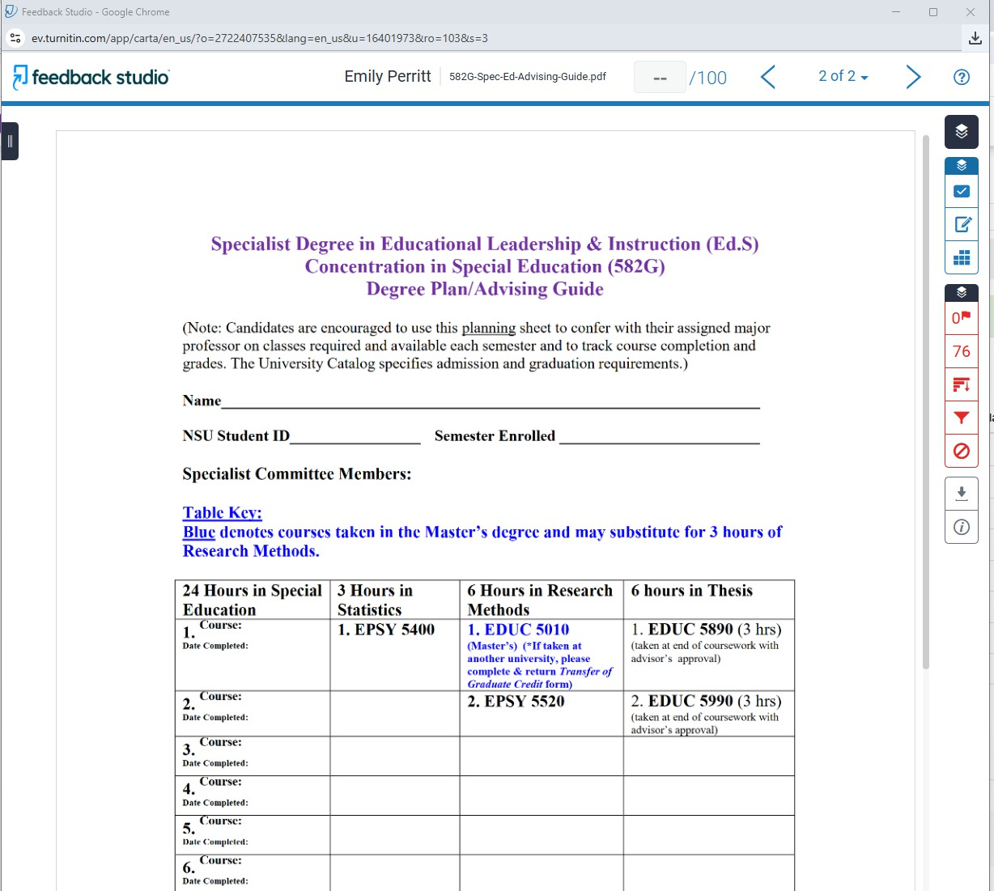
A pop-up window will come up on your
screen taking you to the Feedback Studio where you can review the file uploaded and assign the grade for the student’s work.

The top of the window provides you with the student’s name, the file name of the item uploaded, and a place to enter the grade out of the points possible for the assignment.


On the right hand side of the screen, the blue section, provides you with buttons where you can enter comments and notes to the student.

The Rubric/Form allows you to use a rubric that was attached to the assignment.
The QuickMarks button allows you to select from a list of pre- formatted comments.
The Feedback Summary button allows you to either do a voice comment or type cus- tomized comments.


The red section allows you to view if there are any flags and the sources that Turnitin was able to match the text in the document.

The Match Overview button shows the similarity score and highlights pieces of the document that matched, along with providing the source that the information matched to.

The Filter button allows you to ex- clude quotes, bibliography, and sources that are less than a certain amount of words or percentage of the source.

The Flags button shows if there is any hidden text or replaced characters that Turnitin’s algorithms deem in- consistent than a normal submission.

The All Sources button allows you to review all of the sources that Turnitin was able to match the text to.

The Excluded Sources button allows you to exclude specific sources from being part of the similarity report.

After reviewing the document, you can enter the grade at the top of the screen.
Once entered, you can close the Feedback Studio window.

When you go back to the Assignment Inbox area, you will see the grade that you have entered for that student.
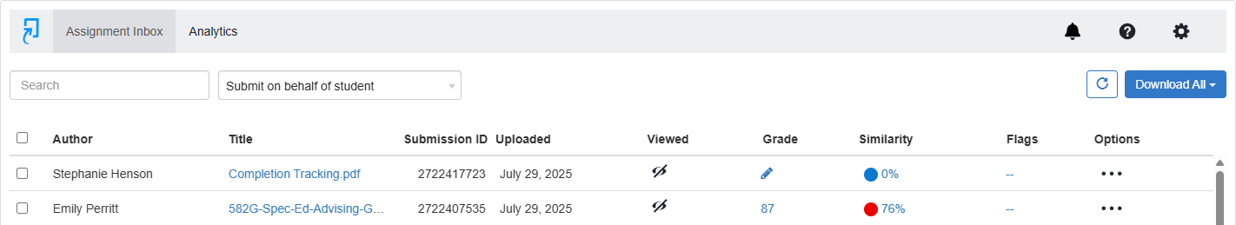

Once you have graded all of the students, you can click on the Analytics button to see a breakdown regard- ing similarity scores, what variety of sources information was found from, and, if you use any of the
QuickMarks, what were the common errors notated.
