Changing the Gradebook Aggregation—Weighted/Natural
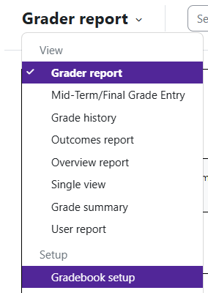

Log in to Moodle and navigate to the course.
Click on Grades.

Under the drop drop on the left hand side, change from Grader Report to Gradebook Setup.

Once in Gradebook Setup, the Status column will let you know what type of aggregation you have for the course and if “Exclude Empty Grades” is turned on. “Natural” means total points divided by total points possible.
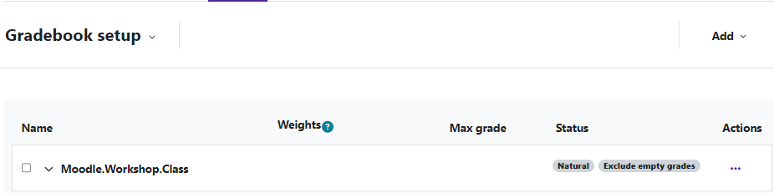
“Exclude Empty Grades” means if no grade is entered for a student, Moodle will not count the grade item towards the student’s Course Total.

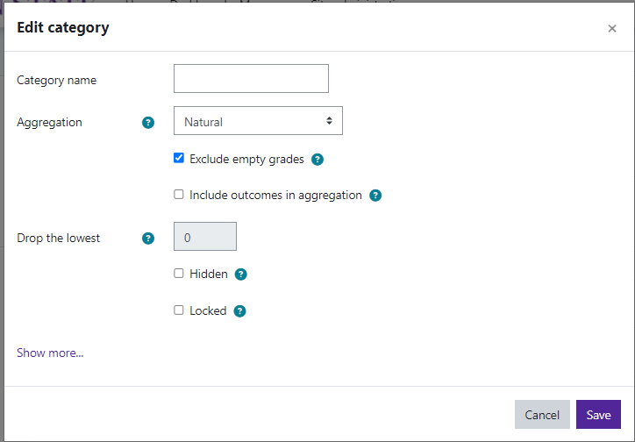
If change is need, click the three dots, and choose
“Edit Category”.
To change the aggregation, use the Aggregation drop down menu and select Weighted Mean of Grades.
Save changes.
A weighted gradebook will have a course total of 100.

Moodle v. 4.5.7 Updated 03/26

Weighted Mean of Grades—Setting Weights
After changing the aggregation to weighted mean of grades, you will need to set the weights for grade items and/or grade categories.
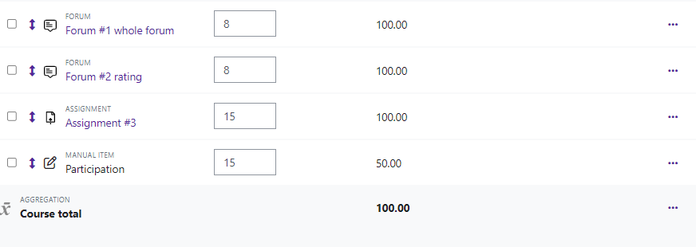
Type in the amount you want the grade item and/or category. Save changes.

