Adding Manual Grade Items
When an activity is added on the front page of the course through the “add an activity or resource “ link, if there are points associated with it, Moodle automatically creates a grade column in the gradebook. Also, when you grade the activity through the front page, the grades are transferred into the gradebook. Howev- er, sometimes there might be an addition to the gradebook, such as points for participation or attendance, you would like to add.

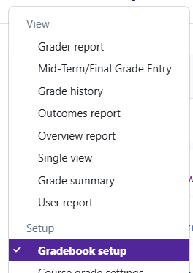
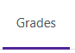
Log in to Moodle and navigate to the course. Click on Grades.

Click on the drop down located at the top left corner, choose Gradebook Setup.
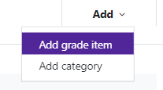

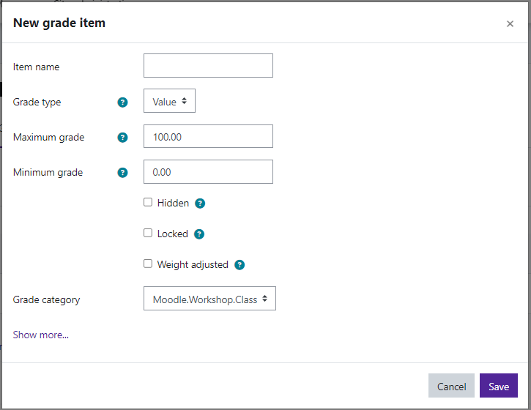
At the top right of the Gradebook table, choose Add and then Add Grade Item.

Item name—give the grade item a name. Decide on the grade type:
Value—a numerical value with a maximum and a minimum Scale—an item in a list
Text—feedback only
Only value and scale grade types may be aggregated.
If you choose Scale, the Scale drop down menu will become available. You can choose a scale that has been previously cre- ated.
If you choose Value, the Maximum and Minimum grade op-
tions will open and you can set the maximum number of points this item is worth.

Moodle v. 4.5.7 Updated 03/26

Hidden—if selected, grades are hidden from students. A hidden until date may be set if desired, to release grades after grading is complete.
Locked—if selected, grades can no longer be automatically updated by the related activity.
Weighted adjusted—Uncheck this to reset a grade item weight to its automatically calculated value. Check- ing this will prevent the weight being automatically adjusted.
Grade Category—if you created categories in your gradebook, you can choose the category in which you want your new grade item to appear.

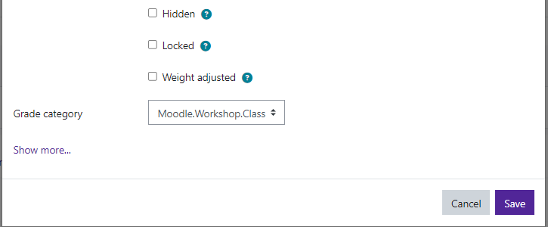
Once you have changed all of the settings needed, click Save. The grade item will now show in your grader report.


To enter grades for a manual grade item:
- From the front page of the course, click on Grades.

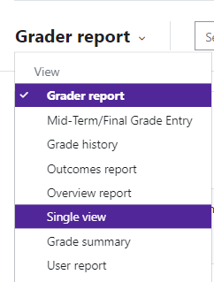
- Use the Grader report drop down menu and select Single View.


- Change the “View By” from “Users” to “Grade Items”.

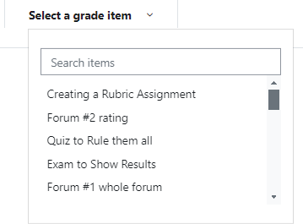
- Under “Select a grade item”, use the drop down menu and select the grade item you created.

Note: Make sure Edit Mode is turned On.
- Type in the grade.
- Save changes.

