Adding Grade Categories

Adding Grade Categories to the Gradebook.
To customize your Gradebook Setup, you can add grade items and grade categories. Categories are like fold- ers. Grade Items can be placed in Categories in the Gradebook Setup. Grade Items are covered in the “Adding Manual Grade Items” information sheet.
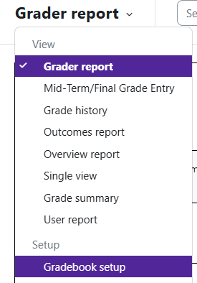
NOTE: Do not make a category for a single activity. If you have more than one activity that you would like to group together, then a category would be appropriate.

Log in to Moodle and navigate to the course. Click on Grades.

Under the dropdown located at the top left corner, click on Gradebook setup.

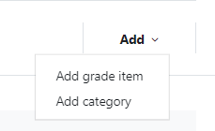
On the Gradebook Setup page, in the top right corner, you can click Add and then choose to add a category or grade item.

Grade Items and Categories—What is the Difference?
Grades can be organized into grade categories. A grade category has its own aggregated grade which is calculated from its grade items. There is no limit to the level of nesting of categories. However, each grade item
may belong to only one category. All grade items and categories belong to at least one, permanent category—the course category—which is designat- ed by the course name in the grader report.

Moodle v. 4.5.7 Updated 03/26

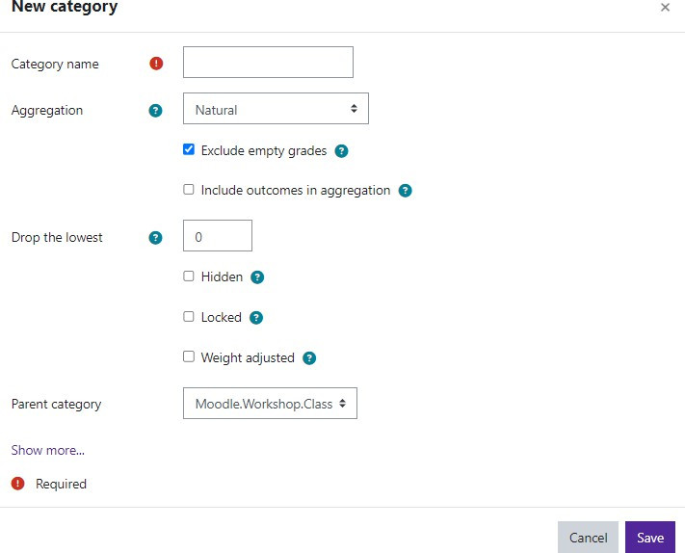
Give the Category a name.
Aggregation—this determines how grades in a category are combined. We recommend weighted mean or grades or natural (sum of grades).
Exclude empty grades—determines whether empty grades are not in- cluded in the aggregation or are counted as minimal grades.
Include outcomes in aggregation—if enabled, outcomes are included in the aggregation. This may result in an unexpected category total.
Drop the lowest—this setting ena- bles a specified number of the low- est grades to be excluded from the
aggregation. Note: All items in the category must be of equal value for you to be able to drop the lowest one.
If you are just wanting to add a simple category, these are the only settings you need to enter. Make
sure to save your changes.
NOTE: Do not make a category for a single activity. If you have more than one activity that you would like to group together, then a category would be appropriate.
The new category has been added.
