Gradebook Reports

Log in to Moodle and navigate to the course.
Click on “Grades” in the navigation area on the top of
the screen.
The Grader Report page will open.
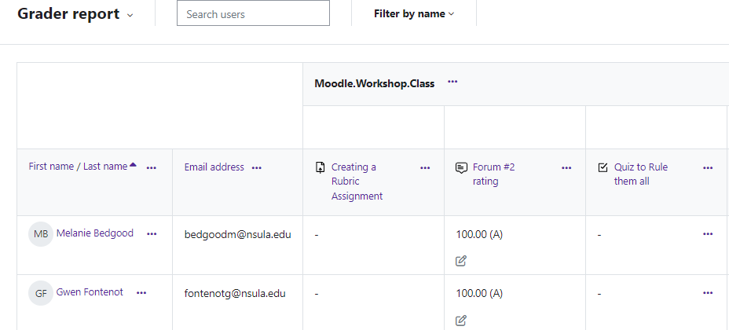

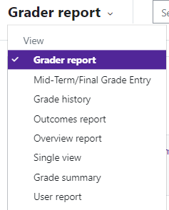
Moodle provides: Grader report, Overview report and User report. Use the dropdown menu to select the report you need.
Grader Report
The grader report collects items that have been graded from various parts of Moodle that are assessed, and allows you to view and change them as well as sort them out into categories and calculate totals in various ways. When you add an assessed item in a Moodle course, the gradebook automatically creates space for the grades it will produce and also adds the grades themselves as they are generated, either by the system or you.

Moodle v. 4.5.7 Updated 03/26

Grader Report
Along the top of the grader report are several columns: first the course, then the category (if you cre- ated categories), then the columns for each graded activity. Any activities which were left
“uncategorized” will appear in the general category which is named after the course by default.
When you create an activity on the front page of the course that has a point value, Moodle will auto- matically build a column in the grader report for that item.
When you assign an activity a grade through the activity itself, Moodle will transfer the grades from the activity into the grader report.
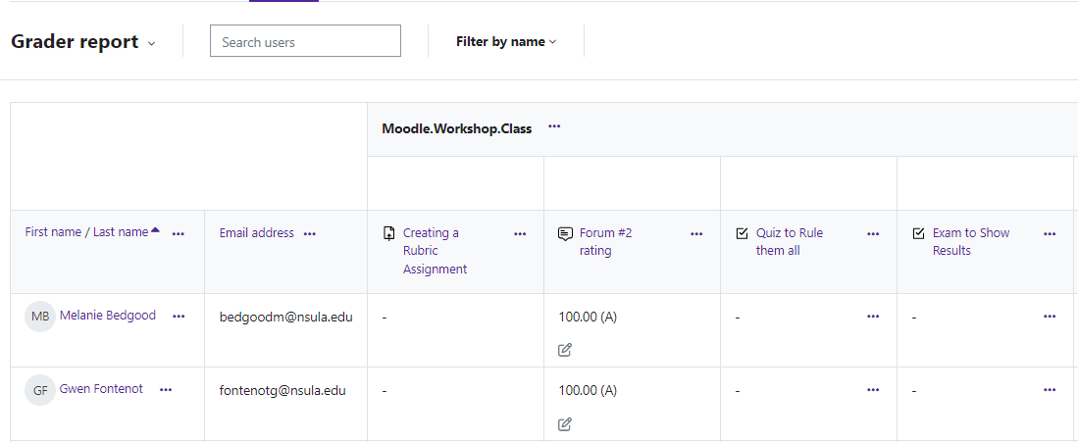

Overview Report
An overview report of all grades of a selected student can be viewed from within any course.
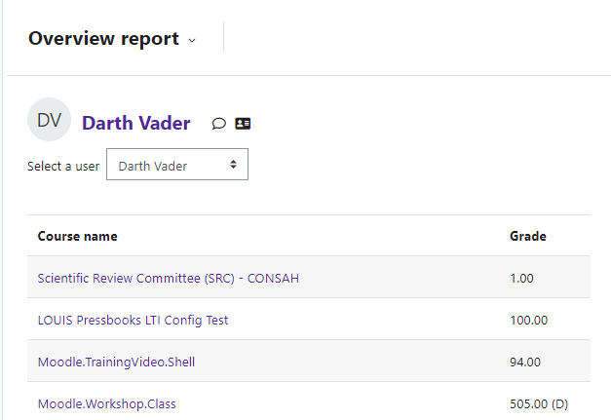

User Report
The user report shows student’s grades in the course. This is what the student will see. It includes:
- A breakdown of the grades for each grade item in the course.
- The optional teacher-given feedback for each grade.
- The overall grade for the course.
NOTE: if you have hidden items in your gradebook, students will not be able to see them in the User
report.
