Customizing the Gradebook—Grader Report

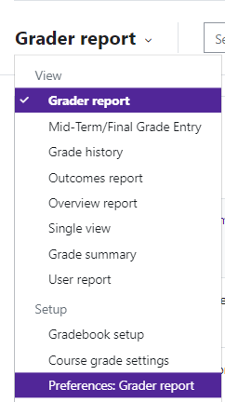
Log in to Moodle and navigate to the course. Click on Grades.

Use the Grader Report drop down menu and select Preferences: Grader report.

Grader Report Options Available

Show/hide toggles | Show column averages—adds a row that shows the average for each grade.  Show user profile images—the users image can be displayed or not.  Show ranges—adds a row for displaying categories and grade items.

Special rows | Grades selected for column averages—excludes or includes cells with no grades in the averages.  Show number of grades in averages—includes the quantity of grades that were used  in brackets next to the average.
General | Quick grading—enables the teacher to edit multiple grades at one time. This prevents the grade from being edited through the activity.  Show only active enrollments-only show students that are active in the course (see Participants area of course)  Aggregation position—displays the category and course total first or last in the gradebook.
Moodle v. 4.5.7 Updated 03/26

