Exporting a Gradebook from Moodle
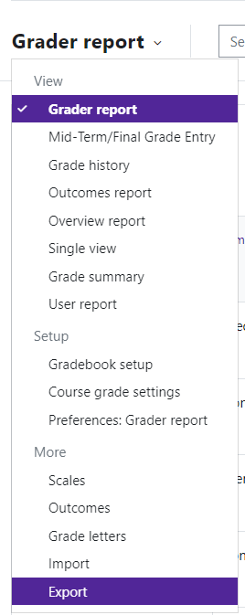

At the end of each semester, it is recommended that instructors export a copy of the gradebook and save
for future reference.
Log in to Moodle and navigate to the course.
Click on Grades.
Use the Grader report drop down menu and choose Export at the bottom of the list.
Where you see “Export as”, choose the file type that you would like to download. We recommend “Excel spread- sheet”.
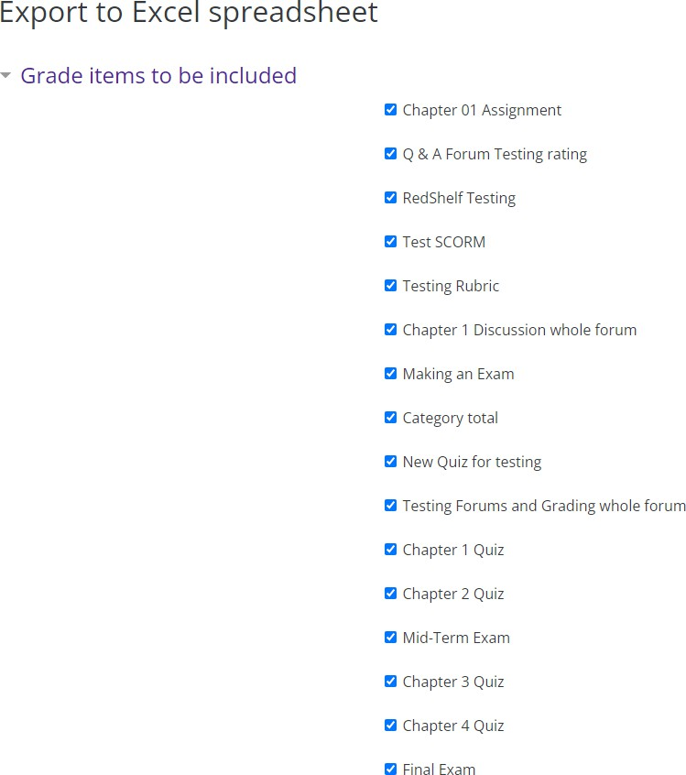
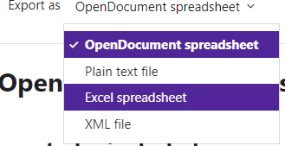
Moodle will provide options to allow you to customize your download.
Grade Items to be included—select or unselect the
items you would like to include in the download.

Export format options
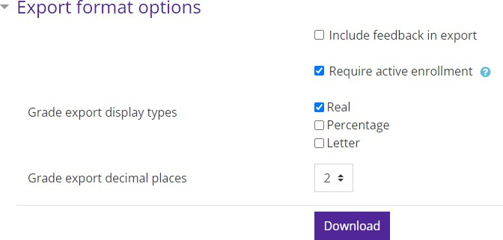
If you would like to include feedback in your report, place a check in the box next to “Include Feedback in Report.”
When you have finished customizing the report, click
Download.

Moodle v. 4.5.7 Updated 3/26

