Suitable Basics for Students
The Suitable app is an easy-to-use student engagement platform available on Apple iOS and Google Android. It helps university students track their co-curricular activities, build valuable professional skills, and earn rewards along the way. With features like experiential learning records and customizable milestones, Suitable also connects students to opportunities that support their growth and prepare them for their future careers.
Joining Suitable from a Mobile Device
To join Suitable on your smartphone or tablet, download the Suitable app (available on Apple iOS and Google Android) from your device’s app store, or scan the appropriate QR code below.
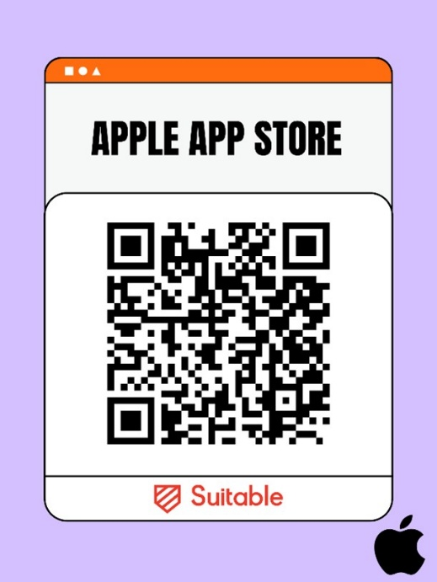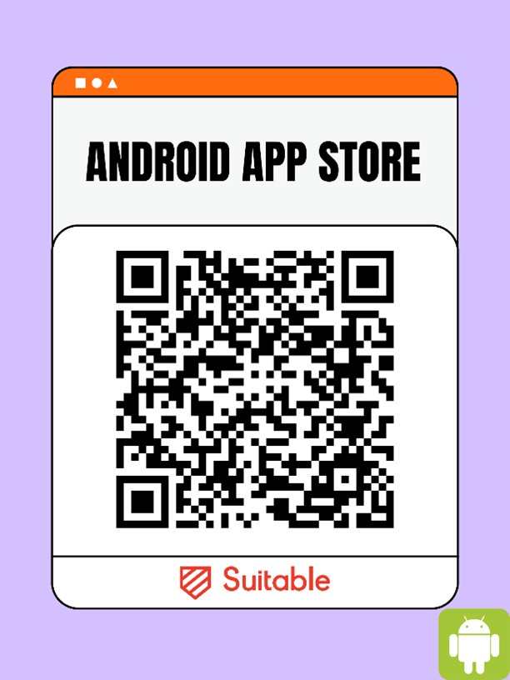
Once installed, open the app.
When prompted, enter your NSULA student email address and click Continue. Next, select Sign In to the right of the NSU name/logo and follow the steps below:
- Log in using your NSULA credentials.
- Complete the Multifactor Authentication (MFA) process to verify your identity.

If you experience any issues logging into Suitable, please feel free to contact Trevor O’Bannon for assistance.
- 📞 (318) 357-5438
- ✉️ obannont@nsula.edu

