Respondus LockDown Browser and Respondus Monitor

What is Respondus LockDown Browser?
Respondus LockDown Browser is a custom browser that locks down the testing environment within Moodle.
If enabled, Respondus LockDown Browser will prevent the following:
- Printing
- Copying
- Opening another browser
- Access other applications
- Right click

What is Respondus Monitor?
Respondus Monitor is a webcam feature for LockDown Browser that records students during online, non-
proctored quizzes. When this feature is enabled for a quiz, students are required to use a webcam and a microphone with LockDown Browser. After the quiz is completed, an instructor can review details of the assessment and the
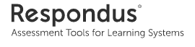
recorded videos.

Adding Respondus LockDown Browser Block
To add the “Respondus LockDown Browser” block to the course page:
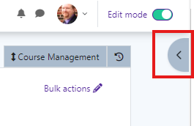
- Turn editing on.
- Click on the arrow located at the right hand side of the screen. This will expand the Course Block area.
- Click on Add a block.
- A box will come on your screen . Click Respondus Lockdown Browser among the choices.
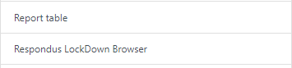

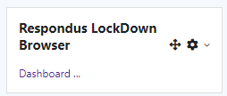
Moodle will add the Respondus LockDown Browser block to the course blocks area.

Respondus LockDown Browser Settings
To add Respondus LockDown Browser to a quiz, click on Dashboard in the Respondus LockDown Browser block.
A list of deployed quizzes will be displayed.
  - Quizzes labeled with Required will require students to use LockDown Browser.
  - Quizzes labeled with Not Required do not require stu- dents to use LockDown Browser.
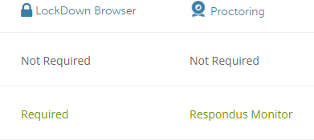

To change the settings, select Settings from the context menu to the left of the quiz title and select the desired op- tion.

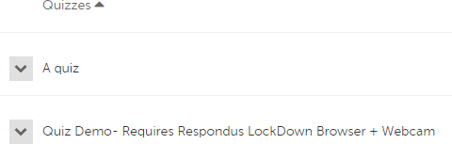

Preparing a Quiz Continued
Several optional Advanced Settings are available:

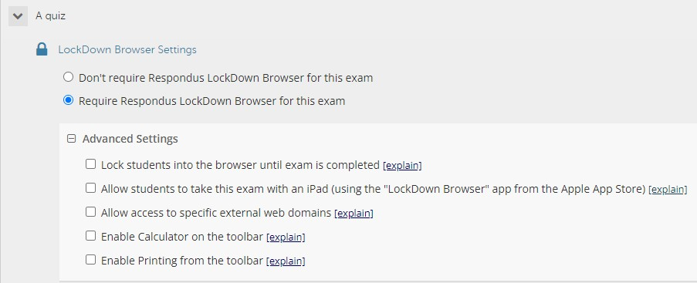

  - Lock students into the browser until exam is completed. This is sometimes used in testing centers where a proc- tor can enter a password to exit the exam an exam early.
  - Allow students to take the exam with an iPad, using the free LockDown app. This is used when students use iPads.*
  - Allow students to access a list of specified web domains during the test.
  - Enable Calculator or Print functions in the LockDown Browser toolbar.
Click Save and Close to apply settings.

* iPad Settings
The iPad Edition of “LockDown Browser” is available from the Apple App Store. This app enables a student to use an iPad to take exams that require Respondus LockDown Browser.
The instructor must first select a setting that permits the use of iPads for the exam.

Using Respondus Monitor
Respondus LockDown Browser must be used along with
Monitor.
Set the exam to require the use of LockDown Browser.
Select Require Respondus Monitor for this exam under Proc- toring.

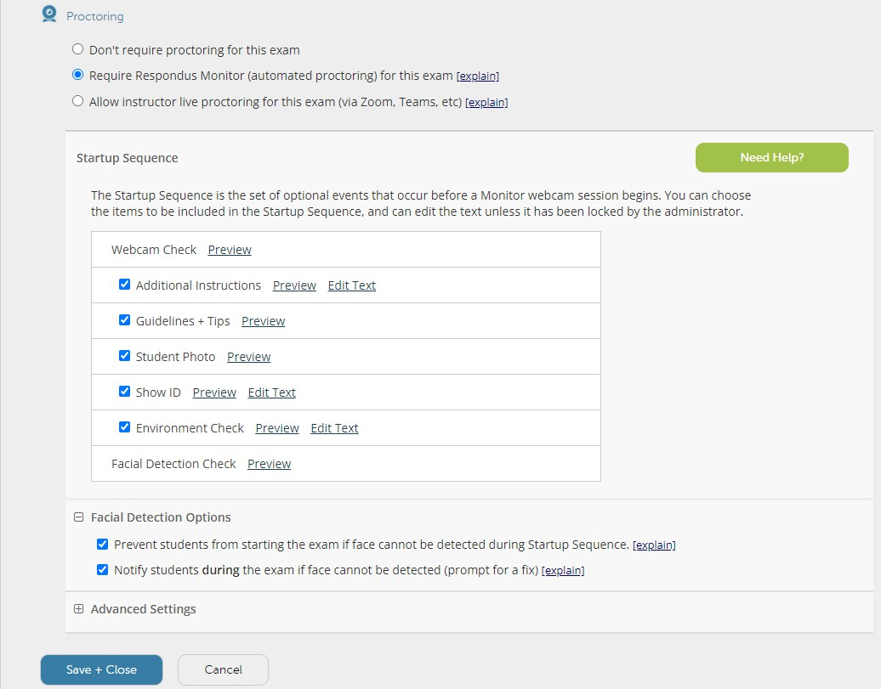

Select the items to be included in the Startup Sequence. This includes the steps a student must complete prior to the start of the exam. Most settings are optional.
Save and Close.

Student Experience
Students will need to access their class through their normal web browser (Mozilla Firefox or Google Chrome). Any links for quizzes or exams that require the lockdown browser will launch the browser automatically. The exam must also be
available for Respondus to load properly.
- Log into Moodle with a regular browser, select the course and navigate to the quiz.
- If LockDown Browser has not previously been installed, the student will be prompted to download and install the browser.
- Return to quiz and open to launch LockDown Browser.
If the student is required to use a Monitor, a Startup Se- quence will guide them through a webcam check and other items required by the instructor.
Make sure students have downloaded and installed the NSU version of Respondus Lockdown Browser from the Student Help Desk website under the expandable Moodle section. This version is available for Windows or Mac computers.
For Chromebooks, the link to download the Chrome browser extension for Respondus will be available from the launch page on one of your exams that requires the lockdown browser.

