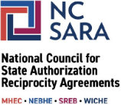
March 10, 2026
Northwestern State University of Louisiana
300 Sam Sibley Dr.
Natchitoches, Louisiana 71497
United States
On behalf of the National Council for State Authorization Reciprocity Agreements (NC-SARA), we are pleased to welcome Northwestern State University of Louisiana as an institutional participant in SARA for the current participation period 4/20/2026-4/20/2027. We are happy that you are part of the SARA community, and we look forward to working with you!
Your institution will be listed on our website as a SARA-participating institution. The attached Institution Welcome Kit walks you through important information such as:
- Who to contact
- The SARA Policy Manual and Administrative Forms
- Completing required annual data reporting
- Paying annual participation fees and billing
- Renewal details
- About SARA and NC-SARA
- And so much more
While the Institution Welcome Kit is a quick guide resource, the SARA Policy Manual contains all applicable SARA policies for participating institutions. Institutions are responsible for becoming familiar with SARA policy.
NC-SARA Website Listing and Use of SARA Institution Seal of Participation
Your institution will be listed on our website as a SARA participating institution.
Institutions are encouraged to use the State Authorization Reciprocity Agreements (SARA) Institution Seal of Participation as a simple way to inform students of participation in SARA. The seal is available in two versions: one with a light background and the other with a dark background. The institution seal may be downloaded at https://nc-sara.org/seal-of-participation.
Because the seal is an official symbol of SARA, the following language must always be used with the SARA Institution Seal of Participation:
(Name of institution) participates in the State Authorization Reciprocity Agreements.
There are several additional guidelines for using the seal that can be found at https://nc-sara.org/seal-of-participation.
If you have questions for your home state, your State Portal Entity (SPE) contact information can be found on the State Portal Entity Contact page of the NC-SARA website. If you have questions for NC-SARA staff please reach out to info@nc-sara.org.
Thank you for joining us in this work, and best wishes for your continued success.
Sincerely,
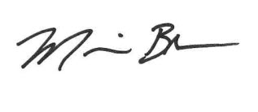
Dr. Marianne Boeke
President, NC-SARA

