NSU Wireless Network Setup (Apple iOS)

Step 1
From your device’s Home screen, tap the Settings icon.
Select Wi-Fi from the Settings menu.
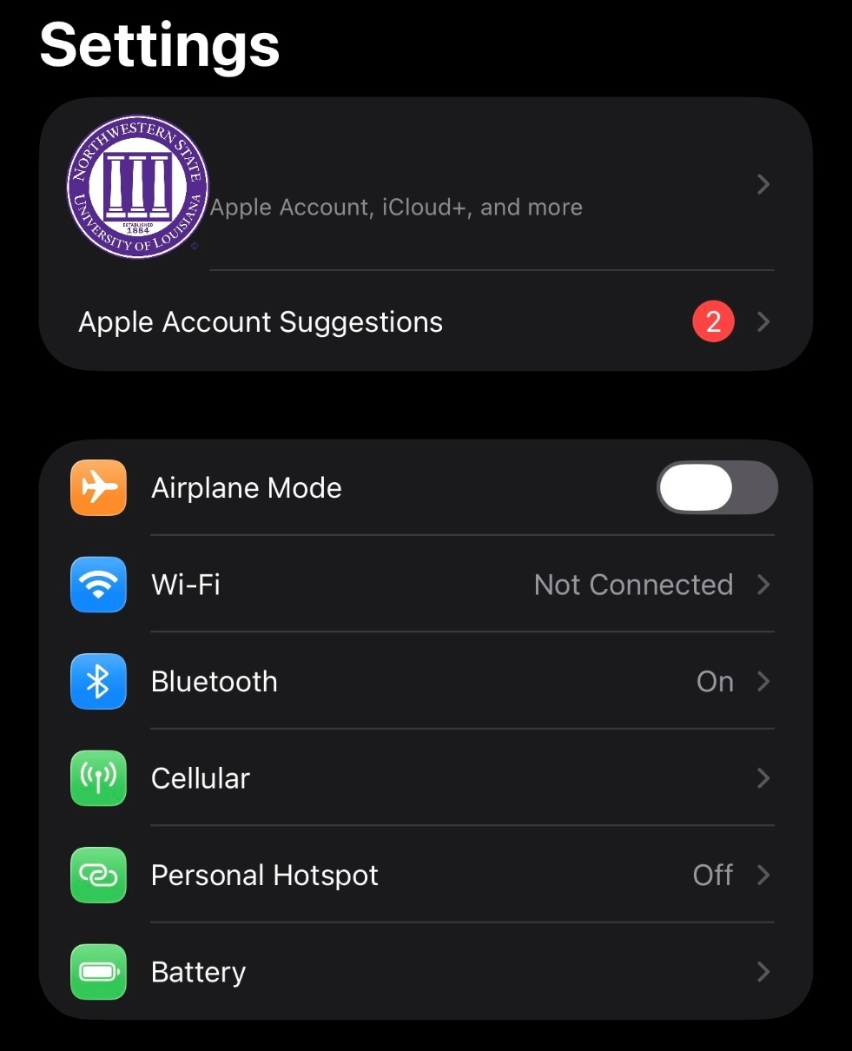

Step 2
From the list of available networks, tap student. Enter your VIC username and password in the fields provided. Then tap Check to connect.
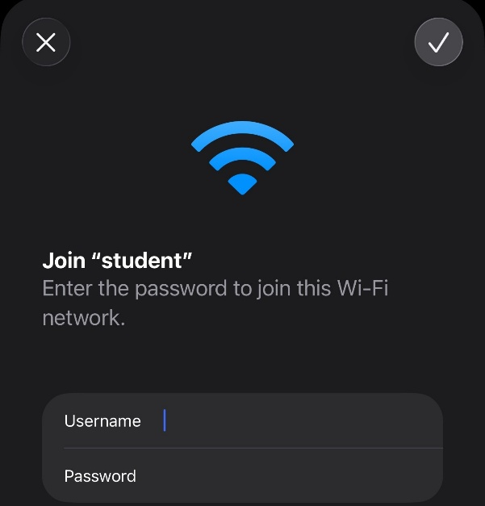

Step 3
Finally, tap Trust to accept the certificate.
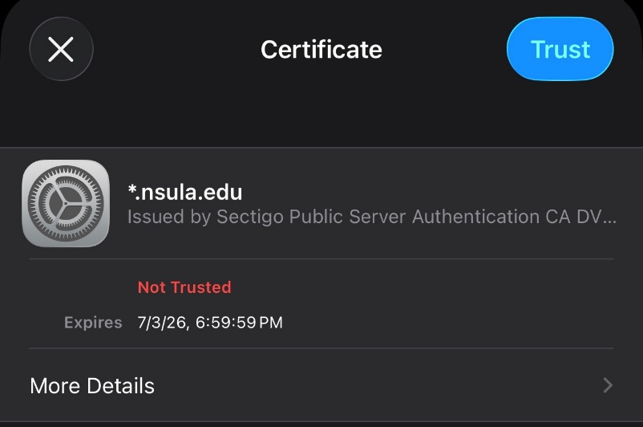

Once authentication is complete, your device will indicate that you are successfully connected to the student network.

