NSU Wireless Network Setup (Google Android)
Step 1
Open your Wi-Fi settings and select the student network. Then configure the following options:
- EAP method: PEAP
- Phase 2 authentication: MSCHAPV2
- CA certificate: Use system certificates
- Online Certificate Status: Request certificate status
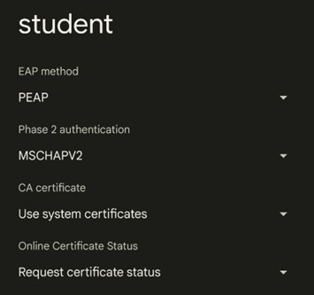

Step 2
Then configure the following options:
- Domain: nsula.edu
- Identity: VIC Username
- Password: VIC Password
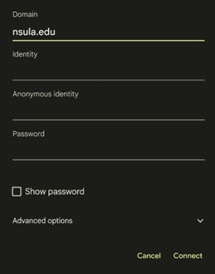
Step 3
Leave all other settings unchanged, then tap Connect.
Once authentication is complete, your device should indicate that you are successfully connected to the student network.

