NSU Wireless Network Setup (ChromeOS)
Step 1
If you have never connected to an NSU wireless network on this computer before, please skip to Step 4.
If you have previously connected:
Click the Network icon in the bottom-right corner of your taskbar.


Then select the Settings (gear) icon.

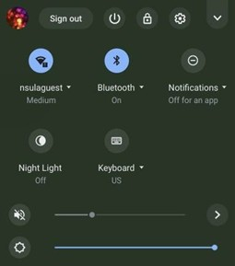

Step 2
Select Wi-Fi from the menu.

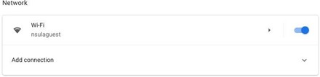

Step 3
You will need to remove (forget) any previously saved NSU wireless networks:
- Locate nsula, student, and NSU Open
- Click the arrow next to each network
- Select Forget

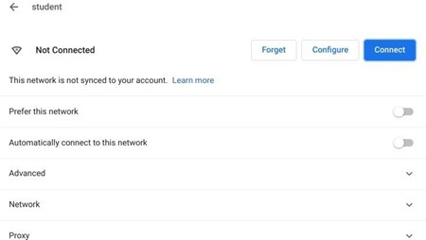

After forgetting all NSU networks, restart your computer before proceeding.

Step 4
Click the Network icon in the bottom-right corner of your taskbar.

Then select the Settings (gear) icon.

Step 5
Select Wi-Fi from the menu.

Step 6
Choose the student network to begin setup.

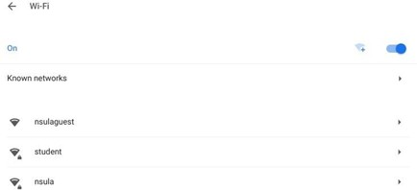

Step 7
When prompted:
- Enter your VIC username (username@nsula.edu) in the Identity field
- Enter your VIC password in the Password field
- Leave the Anonymous Identity field blank
Click Connect.

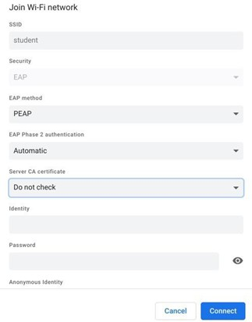

Once authentication is complete, your device will display “Connected” next to the student network.

