NSU Wireless Network Setup (Microsoft Windows 11)
Step 1
Click the Search bar at the bottom of your screen.

Type Control Panel and select it from the results.
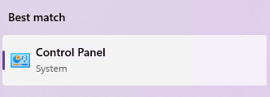
In Control Panel:
- Click Network and Internet
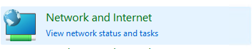
- Select Network and Sharing Center

Step 2
Click Set up a new connection or network.
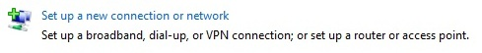

Step 3
Select Manually connect to a wireless network, then click Next.

Step 4
Enter the following information:
- Network name: student
- Security type: WPA2-Enterprise
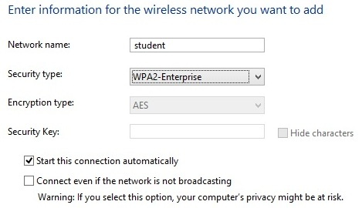
Click Next to continue.

Step 5
Click Change connection settings.
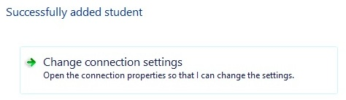

Step 6
Select the Security tab at the top.
Next to Microsoft: Protected EAP (PEAP), click Settings.
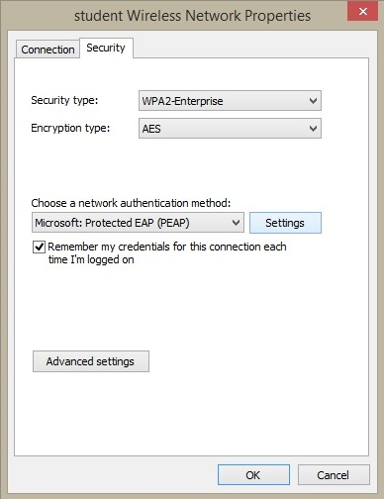

Step 7
Uncheck Verify the server’s identity by validating the certificate.
Then click Configure next to Secured password (EAP-MSCHAP v2).
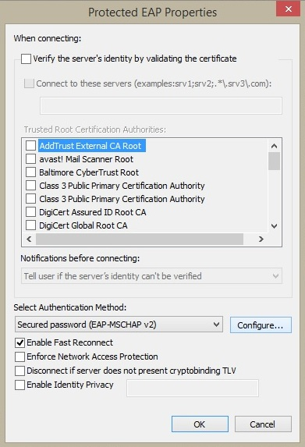

Step 8
If selected, uncheck Automatically use my Windows logon name and password (and domain if any).
Click OK until you return to the Security window.
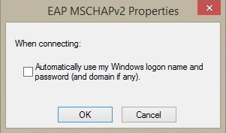

Step 9
Click the Advanced settings button.
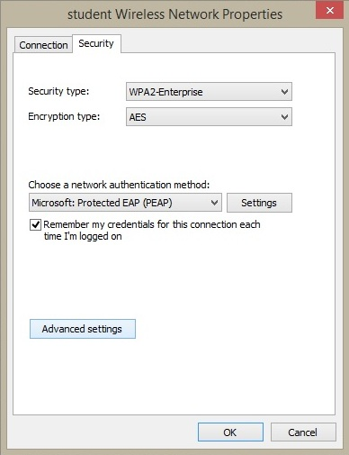

Step 10
Check Specify authentication mode and select User authentication from the dropdown menu.
Click Save credentials.
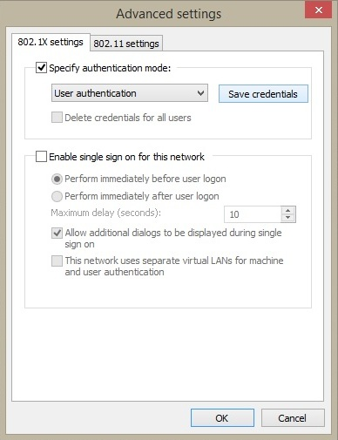

Step 11
Enter your VIC username and password, then click OK until all windows are closed.
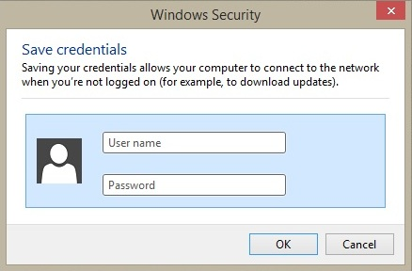
Once authentication is complete, your device will display “Internet Access” next to the student network.

