Logging Into Moodle
To log in to Moodle, go to NSULA Moodle.
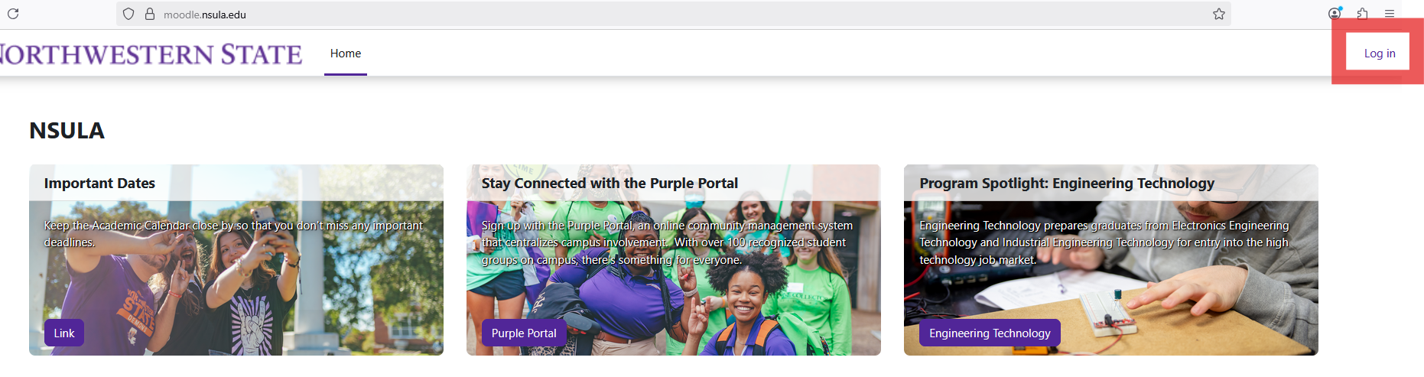
Click on the Log in button located at the top right-hand corner of the page.

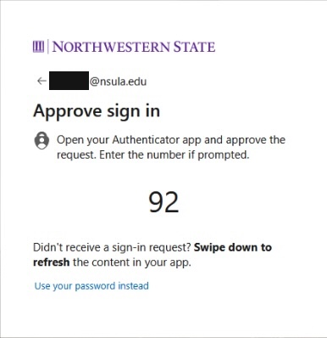
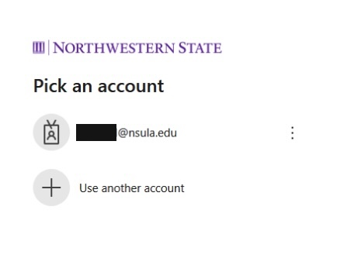
Sign in using your NSU email address.
If asked to verify using the Microsoft Authentication app, you will either select “Use your password instead” or enter the number shown on your phone screen. **Follow instructions on screen.

My Courses provides a list of courses. To view courses for the current semester, use the filter below Course Overview and choose “In progress.”
To enter a course, click on the course name.
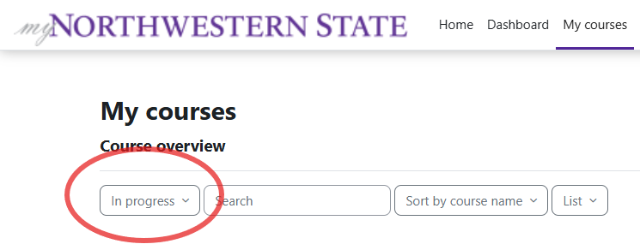
Moodle v. 4.5.7 Updated 03/26

