Changing Profile Settings
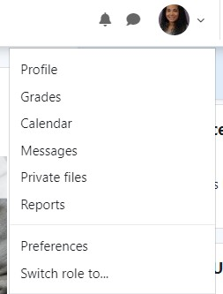
Log in to Moodle.
Locate your name in the right hand corner of the screen. Click on the down arrow next to your name.
Select Profile.

Under User Details, click on Edit Profile.
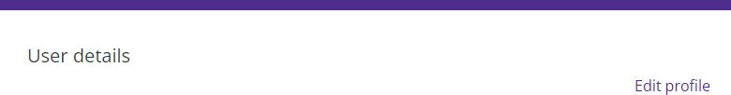

General Settings
First name and Last Name—you will not be able to change this information.
City/town and Select a country—customize your profile by changing this information. Time zone—please leave the time zone to Server’s local time.
Description—you can choose to enter information about yourself here.
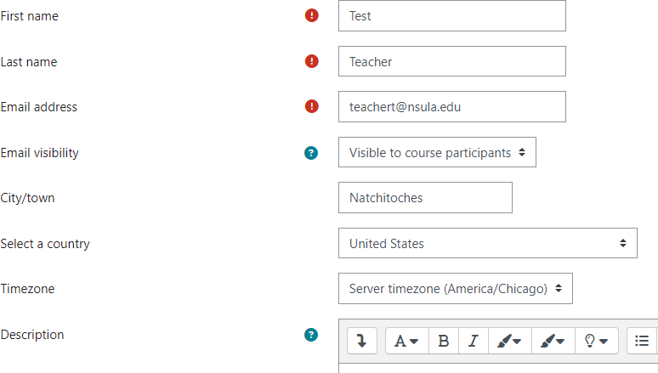
Moodle v. 4.5.7 Updated 09/24

User Picture—you can add a picture of yourself by using the drag and drop feature or by clicking on the Add icon.
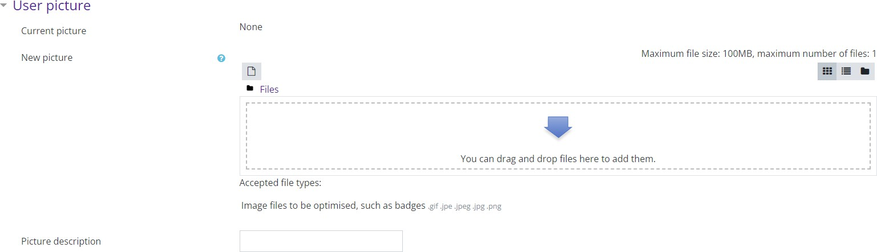

Extended Profile Information—Customize your profile further by adding:
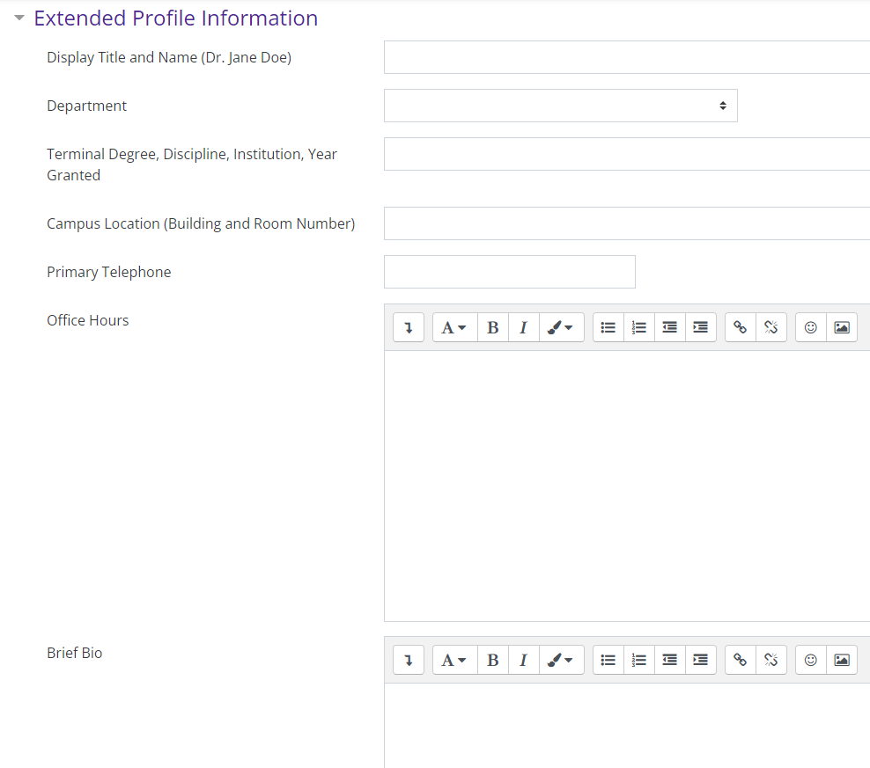
- Display Name
- Department
- Terminal Degree, Discipline, Institution, Year Granted
- Campus Location
- Primary Telephone
- Office Hours
- Brief Bio

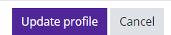
Make sure to click on the Update Profile button to save changes.

