Viewing Participant List
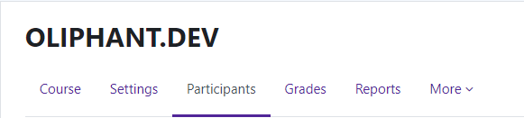
The Participant list enables teachers to view and filter course participants.
Log in to Moodle and navigate to your course.
The Participant list is located in the navigation panel right
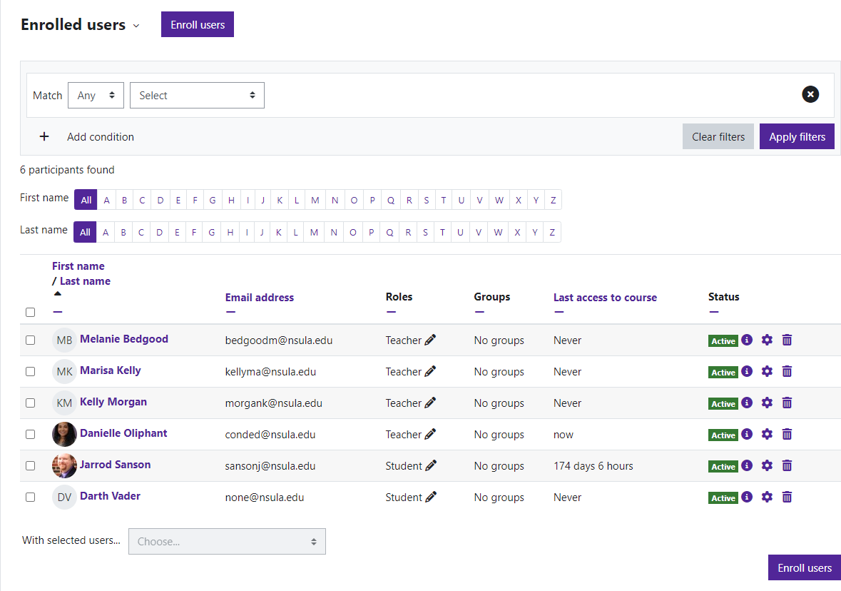
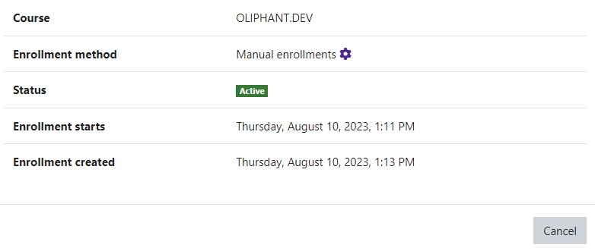
under the course name.

Clicking on the “I” under status will open an Enrollment details window with the student’s information.

Moodle v. 4.5.7 Updated 09/24

