Changing Course Format—New Courses
The course format determines the layout of the course page. When a new course shell is added, the course format is set to the “Topics” format with 18 topics or blocks.
There are 3 formats that are most commonly used:
- Topics format (default) - the course page is organized
into topic sections
- Weekly format—the course page is organized into weekly sections with the first week starting on the course start date.
- Collapsed topics format—similar to topics format, all topics can be toggled on an off to reduce clutter in courses that have large number of topics or lots of content. Viewers can expand topics to see content.

Changing the Course Format
To change the course format:
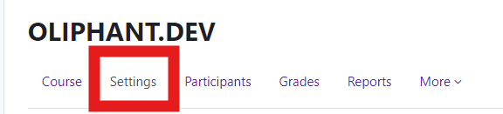
Log in to Moodle and navigate to the course. Under your course name, click on “settings”.

Under Edit course settings., scroll down to “Course For- mat.”

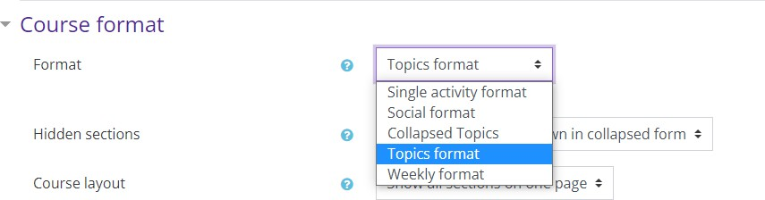
Use the drop down menu to select the pre- ferred format.

Adding Additional Topics
The default setting for topics is 18. Additional topics/ blocks can be added to the course page.
To change the number of sections on the course page: Log in to Moodle and navigate to the course.
Turn editing on.
Locate the “Add topics” button.  Click on the button.
Moodle will add the additional topics to the course page.
Weekly Format

Types of Course Formats

Topics Format



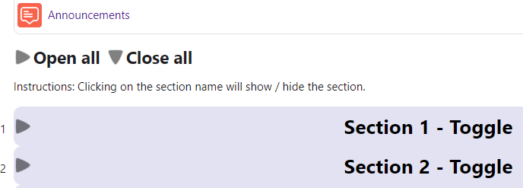
Collapsed Topics Format
Moodle v. 4.5.7 Updated 03/2026

