Creating a Text and Media Resource
The text and media resource enables text and multimedia to be inserted into the course page in between links to other resources and activities. Text and media is versatile and can help to improve the appearance of a course if used thoughtfully.
To add Text and media:
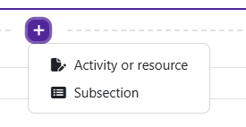
Log in to Moodle and navigate to the course. Turn editing on.

Within a topic, click on the add an activity or resource.

The Add an activity or resource picker will open.
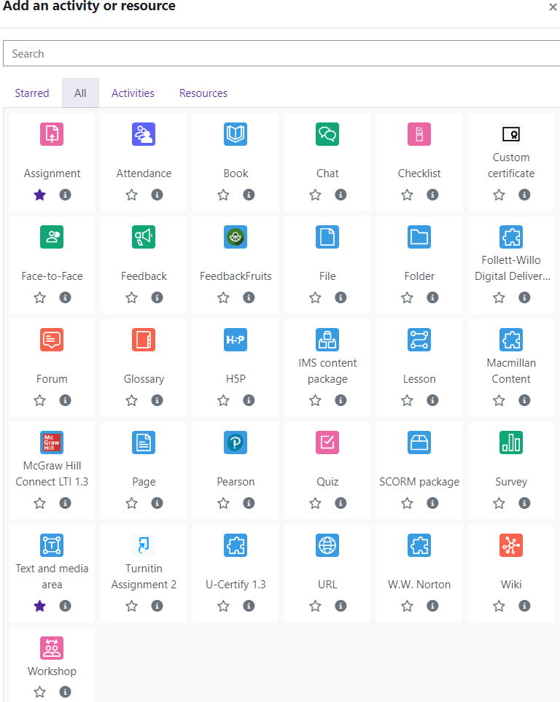
Moodle v. 4.5.7 Updated 03/26

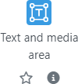
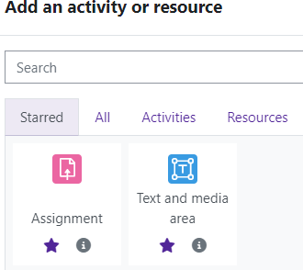
Notice the icons below Text and media. The star icon will allow instructors to “star” an activity or resource that is used most frequently.
The activity or resource picker also allows tog- gling between Starred, All, Activities, and Re- sources.

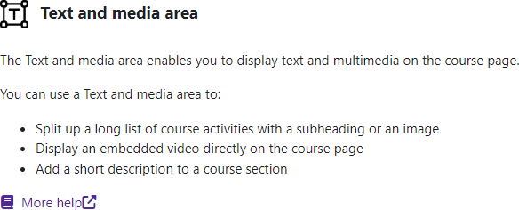
Clicking on the “I” —information icon—will open a window that gives more information about the activity or resource.

For additional help, click on “More help” to navigate to the Moodle Docs site.

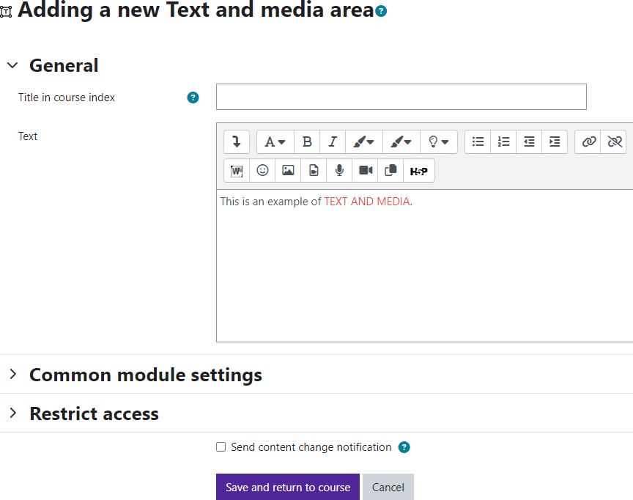
Choose Text and media.
Moodle will open the “Adding a new Text and media
area” page.
Add the Text and Media text. (If you don’t add a title the system will generate one, but it doesn’t show the title in your Moodle shell).
You can customize font by using the editing tools. Text and multimedia can be inserted as well.
Save and return to course.

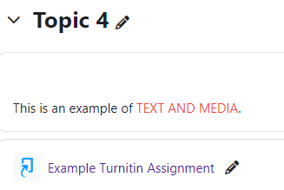

Moodle will return to the front page of the course and display the Label.

