Creating a File Resource
The file module enables a teacher to provide a file as a course resource. To add a File:
Log in to Moodle and navigate to the course.
Turn editing on.

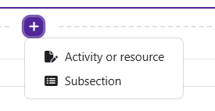
Within a topic, click on the add an activity or resource.

The Add an activity or resource picker will open.
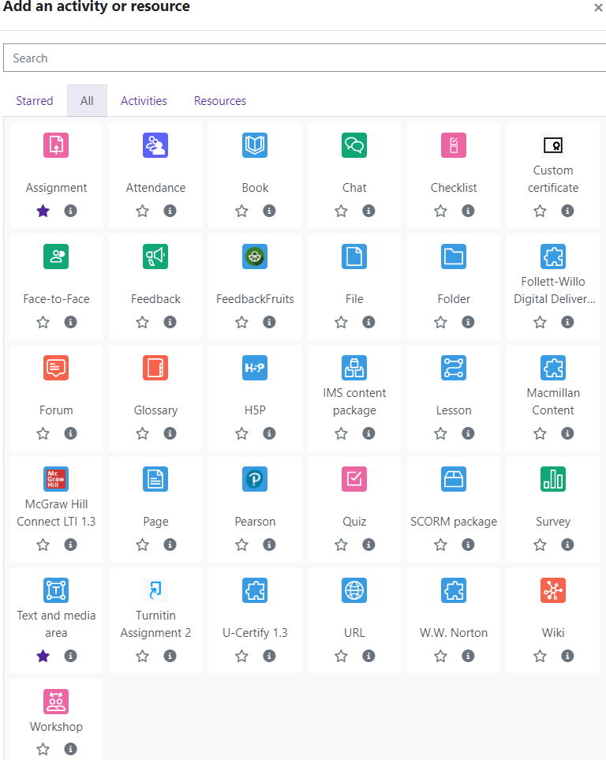
Moodle v. 4.5.7 Updated 03/2026

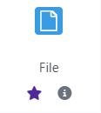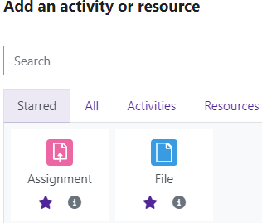
Notice the icons below File. The star icon will al- low instructors to “star” an activity or resource that is used most frequently.
The activity or resource picker also allows toggling between Starred, All, Activities, and Resources.
Clicking on the “I” —information icon—will open a window that gives more information about the activity or resource.

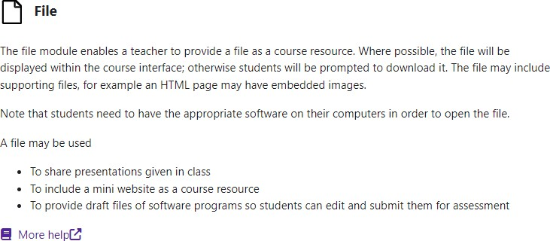

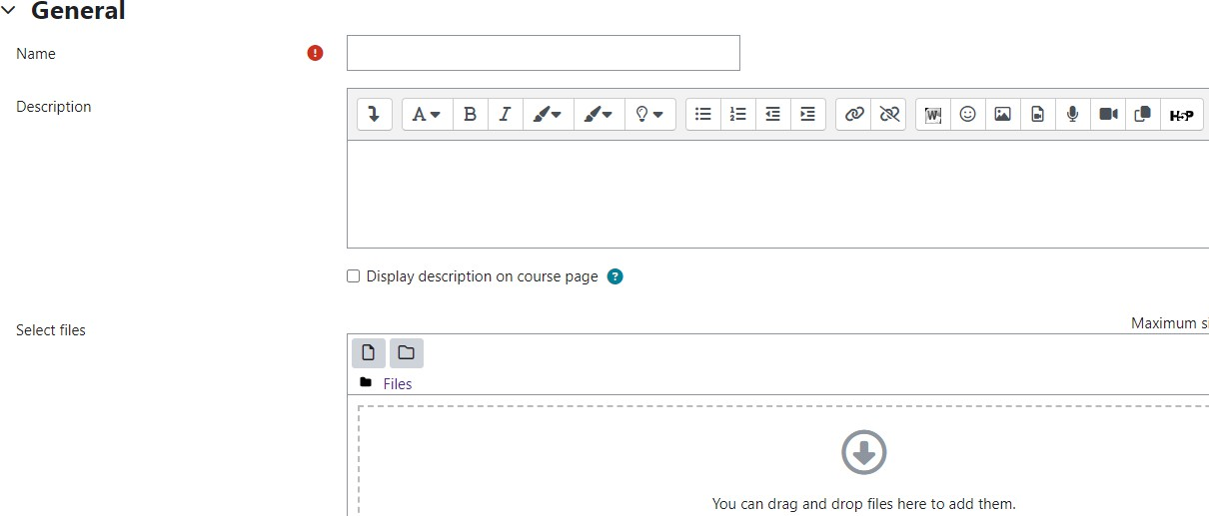
well.
Choose File.
Moodle will open the “Adding a new File” page.
Add the file name and description if desired.
You can customize font by using the editing
tools. Text and multimedia can be inserted as
For additional help, click on “More help” to navigate to the Moodle Docs site.

There are 2 ways to add the actual file.
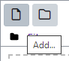
Drag and drop your file from the desktop. Find your file on your computer. Click and hold the left mouse key on the file. Drag the file into the text box with the gray arrow. Release the mouse button. The rile will now appear in the text box.
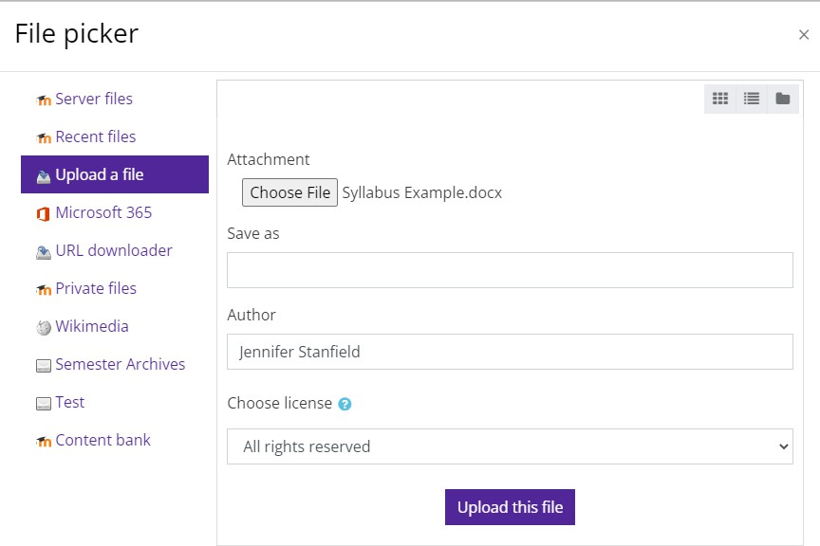
Use the Add option. Click on the “Add” under “Select Files.”
The File Picker window will open. With “Upload a file”
selected, click on “Choose File.” The “Open” window will appear. You can navigate to the file you wish to add.
Select the file and click the “Open” button. You should see the file next to Attachment. Click on “Upload this file.”

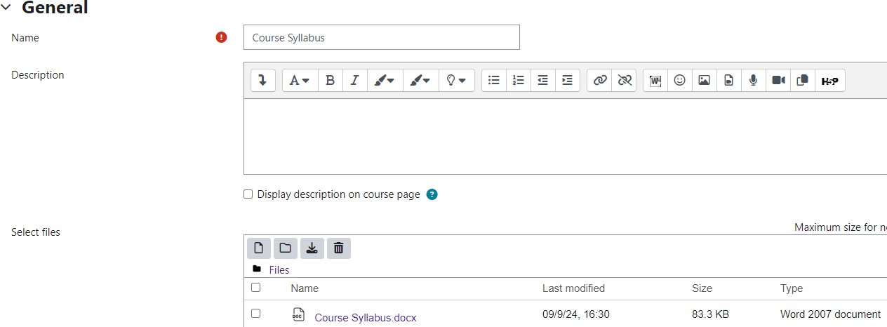
The file will now appear in the text box.

Save and return to course.
You should now see the file on the front page of the course.


