Creating a Folder Resource
The folder resource enables a teacher to display a number of related files inside a single folder, reducing scrolling on the course page.
Only files can be placed in folders.
To add a Folder:
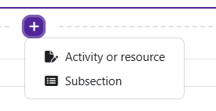
Log in to Moodle and navigate to the course. Turn editing on.

Within a topic, click on the add an activity or resource.

The Add an activity or resource picker will open.
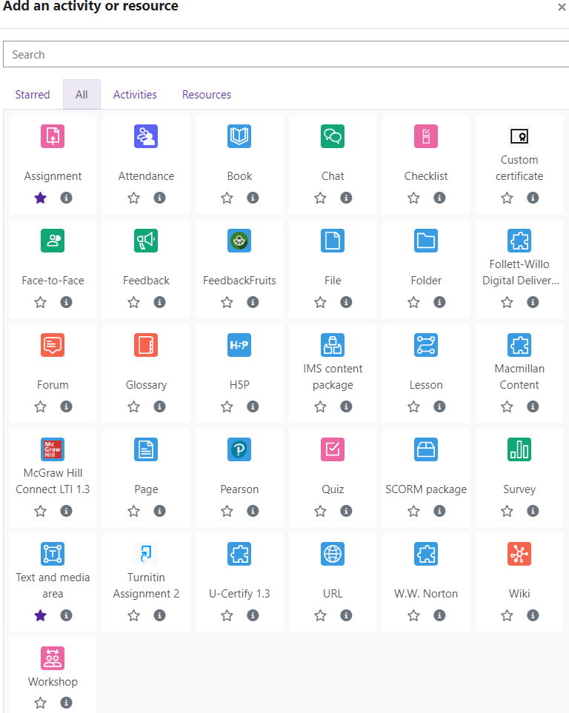
Moodle v. 4.5.7 Updated 09/24

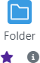
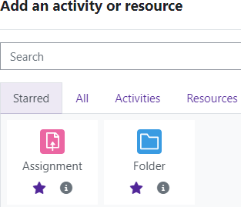
Notice the icons below Folder. The star icon will allow instructors to “star” an activity or resource that is used most frequently.
The activity or resource picker also allows toggling between Starred, All, Activities, and Resources.

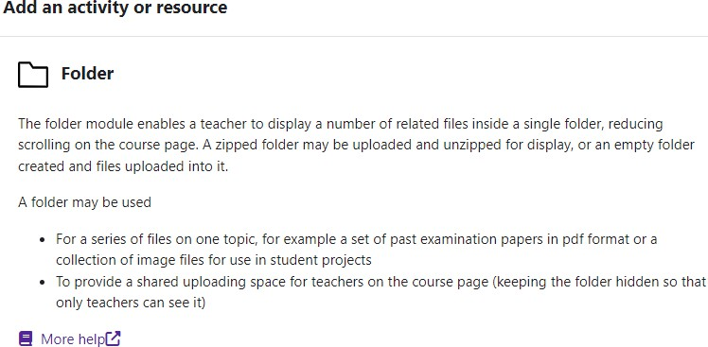
Clicking on the “I” —information icon—will open a window that gives more information about the activity or resource.

For additional help, click on “More help” to navigate to the Moodle Docs site.

Choose Folder.
Moodle will open the “Adding a new Folder” page.

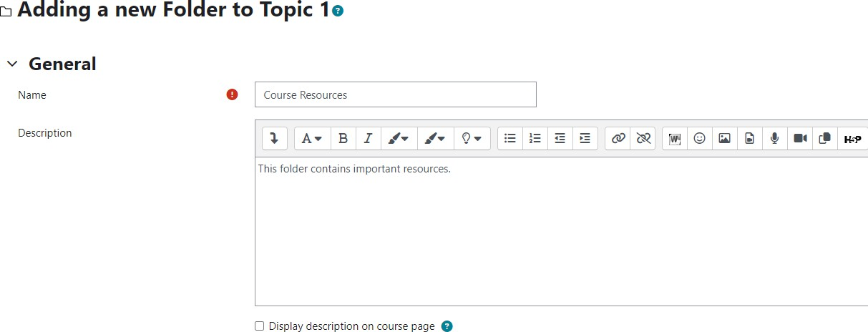
Add the Name of the Folder. Include a description if desired.
If you would like for the description to show on the front page of your course directly under the name, check the “Display description on course” box.

There are two ways to add files.
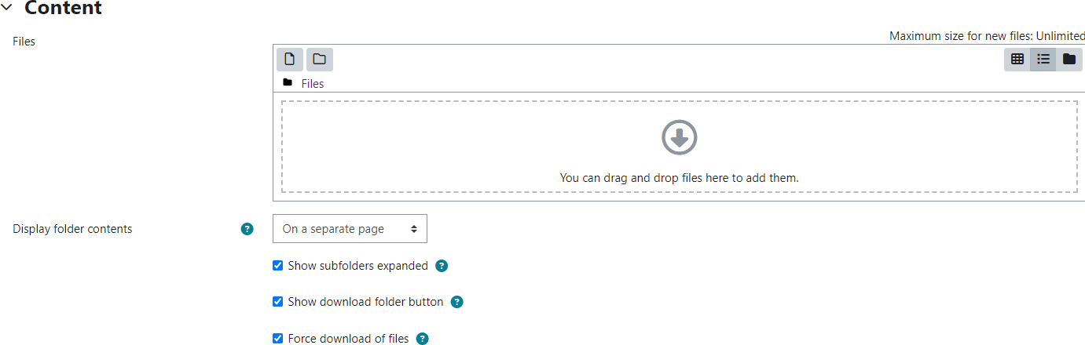
Drag and drop your file from the desktop.
Find your file on your computer. Click and hold the left mouse key on the file. Drag the file into the text box with the gray arrow.
Release the mouse button. The file will now appear in the text box.

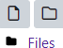
Use the Add option.
Click on the “Add” under “Select files.”
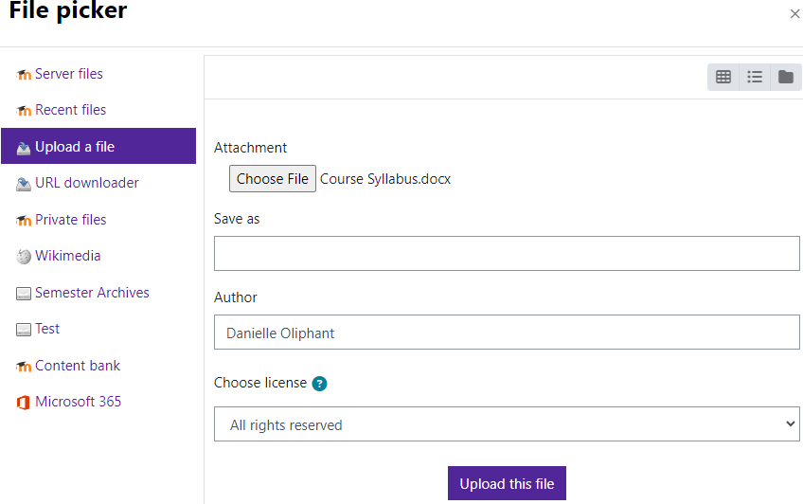
The File Picker window will open. Click on “Choose
File.” The “Open” window will appear. You can navi- gate to the file you wish to add. Select the file and
click the “Open” button. You should see the file next to Attachment. Click on the “Upload this file” button. The file will now appear in the text box.
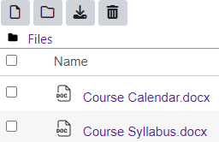

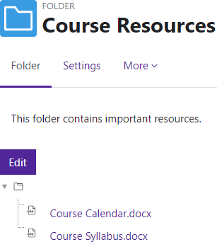
Save and return to course.
Your files are now located within the folder.


Students can download all contents of the folder by clicking on “Download folder.” Moodle will download a zipped file.

