Creating a URL Resource
The URL resource enables a teacher to provide a web link as a course resource. Anything that is freely avail- able online, such as documents or images can be linked to. The URL of a particular web page may be copied and pasted or a teacher can use the file picker and choose a link from a repository.
To add a URL:
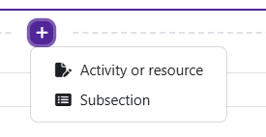
Log in to Moodle and navigate to the course. Turn editing on.

Within a topic, click on the add an activity or resource.

The Add an activity or resource picker will open.
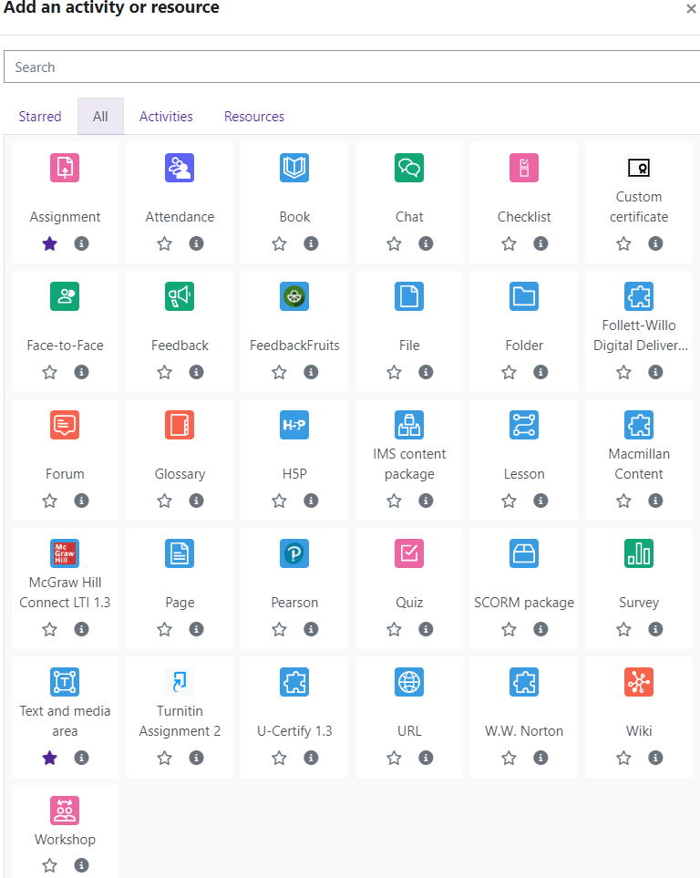
Moodle v. 4.5.7 Updated 03/26


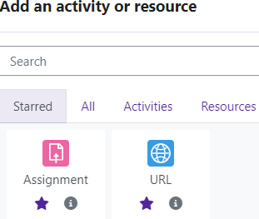
Notice the icons below URL. The star icon will allow instructors to “star” an activity or resource that is used most frequently.
The activity or resource picker also allows toggling between Starred, All, Activities, and Resources.

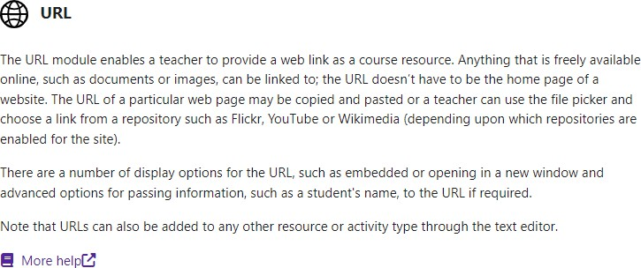
Clicking on the “I” —information icon—will open a window that gives more information about the activity or resource.

For additional help, click on “More help” to navigate to the Moodle Docs site. Choose URL.

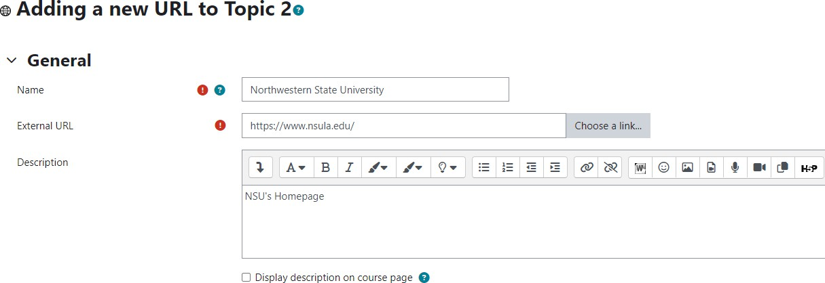
Moodle will open the “Adding
a new URL” page.

Add the name of the URL
Enter the web address of the URL in the External URL text box.
If a description of the URL is added, it can be displayed on the front page of the course by clicking the “Display description on course page” box.


Save and return to course.

