Creating an Assignment
The assignment activity resource enables a teacher to communicate tasks, collect work and provide grades and feedback. Students can upload files such as word-processed documents, spreadsheets, images, or audio and video clips. Teachers may require students to type text directly into the text editor.
To add an Assignment:
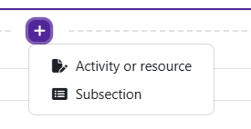
Log in to Moodle and navigate to the course. Turn editing on.

Within a topic, click on Add an activity or resource.

The Add an activity or resource picker will open.
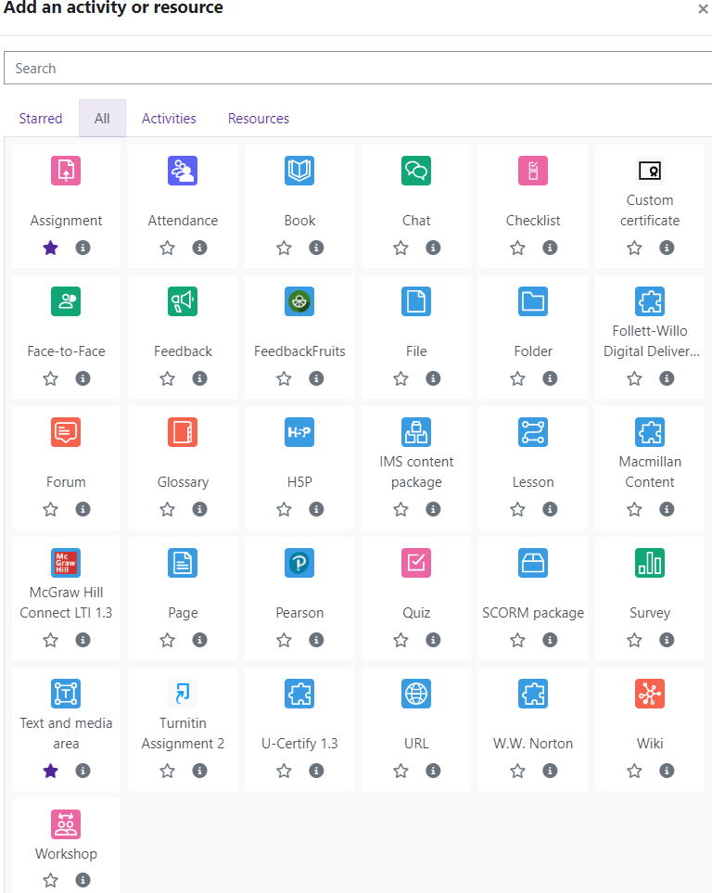
Moodle v. 4.5.7 Updated 09/24

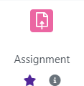
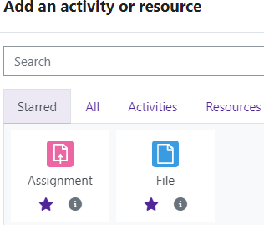
Notice the icons below Assignment. The star icon will allow instructors to “star” an activity or resource that is used most frequently.
The activity or resource picker also allows toggling between Starred, All, Activities, and Resources.

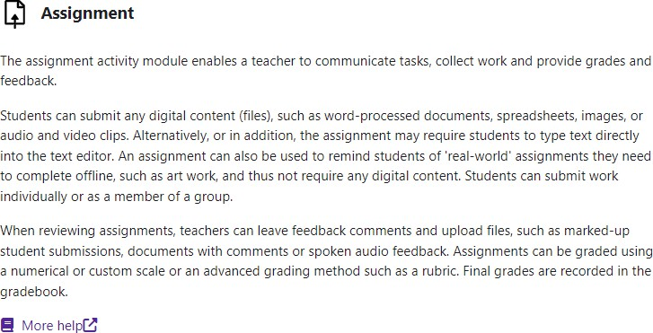
Clicking on the “I” —information icon—will open a window that gives more information about the activity or resource.

For additional help, click on More help to navigate to the Moodle Docs site.

Choose Assignment.
Moodle will open the “Adding a new Assignment” page. Add the Assignment name.
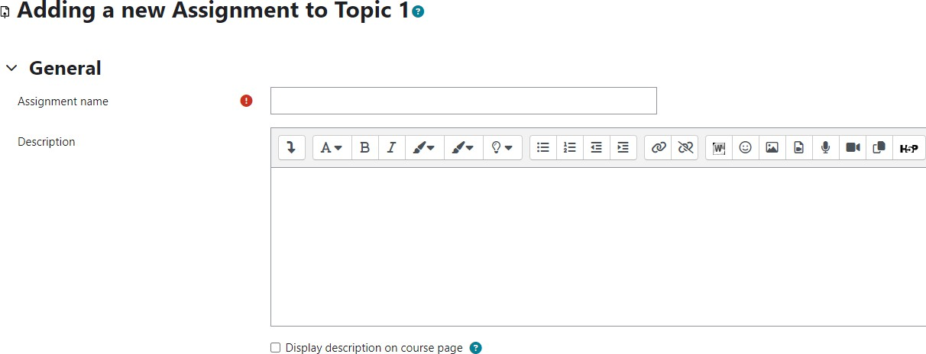
Add a Description if desired. Text can be customized using the editing toolbar.

Select Display description on course page if desired.

Files can be added by dragging and dropping files into the “Additional Files” box or by using the Add button.
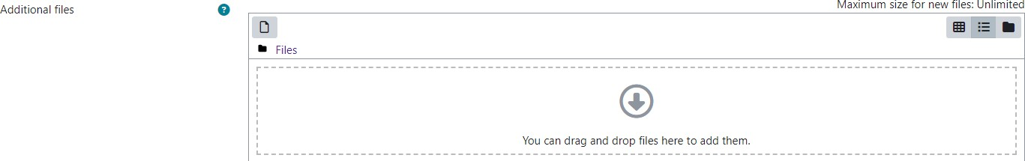

Additional files can be added by dragging and dropping files into the “Additional Files” box or by using the Add button.

Availability options

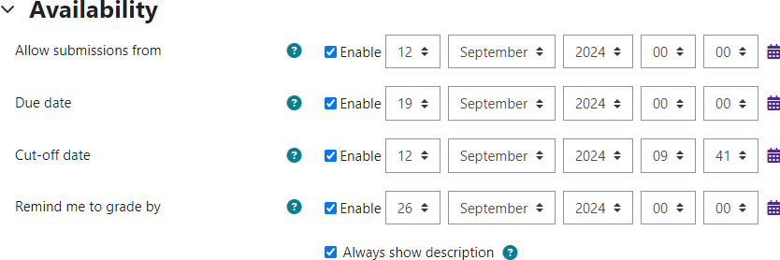

Always show description: If disabled, the Assignment Description will only become visible to students at the “Allow submissions from” date.

Submission types

Allow submissions from:
If enabled, students will not be able to submit before this date.

Due date:
This is when the assignment is due. Submissions will still be allowed after this date but will be marked late.

Cut-off date:
If set, the assignment will not accept submissions after this date without an extension.

Remind me to grade by:
The expected date that marking of the submission should be completed by. This date is used to prioritize dashboard notifications for teachers.

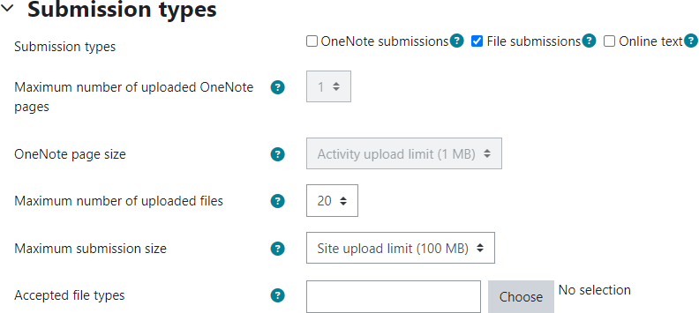
OneNote submissions
If enabled, students are able to upload one or more OneNote pages as their submission.

Online text
If enabled, students are able to type rich text
directly into an editor field for their submission.

File submissions
If enabled, students are able to upload one or more files as their submission.

Submission options

Maximum # of uploaded OneNote pages
If enabled, each student will be able to upload up to this number of OneNote pages for their submission.

OneNote page size
Sets the maximum submission size of OneNote pages.

Maximum # of uploaded files
If file submissions are enabled, each student
will be able to upload up to this number of files for their submission.

Maximum submission size
Files uploaded by students maybe up to this size.

Accepted files
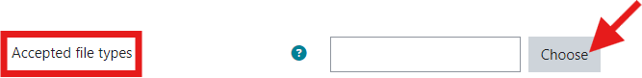
Instructors can specify the file type that students can submit to the assignment activity. If you click Choose, you'll be
presented with a list of file types. You can pick and choose what you are willing to accept as submissions. Those file
types will display for the student when they are trying to upload to your assignment. If a file type is not selected, all file types will be accepted.

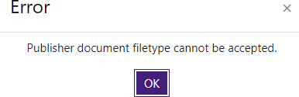
If students do not submit an acceptable file type, they will be prompted to try again.

Feedback types

Feedback comments
If enabled, grader can leave feedback com- ments for each submission.

Annotate PDF
If enabled, the teacher will be able to create annotated PDF files when grading the assign- ments. This allows the teacher to add com- ments, drawing and stamps directly on top of the students work. The annotating is done in the browser and no extra software is required.

Offline grading worksheet
If enabled, Moodle allows you to grade assignment sub- missions without being connected to the Internet. Grades are entered into a customized grading spreadsheet and uploaded as a .csv file into Moodle. NOTE: this is not
available for assignments that use Rubrics.

Feedback files
If enabled, the teacher will be able to upload files with feedback when grading the assignments. These files may be, but are not limited to marked up student submissions, documents with comments or spoken audio feedback.

Feedback OneNotes
If enabled, the teacher will be able to upload OneNote pages with feedback when marking the assignments. Teachers may choose to annotate the student’s OneNote submission or upload a completely new OneNote page.

Comment inline
If enabled, the submission text will be copied into the
feedback comment field during grading, making it easier to comment inline (using a different color, perhaps) or to edit the original text.

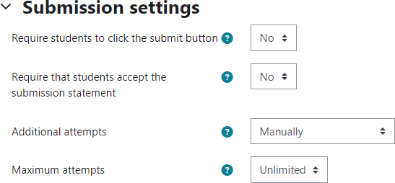
Submission Settings

Require students click submit button
Leave this set to “NO.”

Require that students accept the submission statement
Leave this set at “NO.”

Additional attempts
This setting determines how student submission attempts are reopened.
- Never—The student submission cannot be reopened.
- Manually—The student submission can be reopened by a teacher.
- Automatically until pass—The student submission is automatically reopened until the student achieves the grade to pass value set in the Gradebook.

Maximum attempts
The maximum number of submission attempts that can be made by a student.

Group Submission Settings
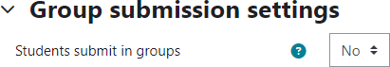
If enabled, students will be divided into groups based on the default set of groups or a custom grouping. A group submission will be shared among group members and all members of the group will see others’ changes to the submission.

Notifications

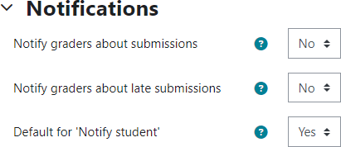
Notify graders about submissions
If enabled, teachers receive a message (email) whenever a student submits an assignment.

Notify graders about late submissions
If enabled, teachers receive a message whenever a stu- dent submits an assignment late.

Default setting for “Notify students”
Set the default value for the “Notify students” checkbox on the grading form.

Grade

Grade
Select the type of grading used for this activity.
- None—No grade will be reported.
- Scale— Choose the scale from the drop-down menu.
- Point—Enter the maximum grade for this activity.

Grading method
Choose advanced grading method that should be used for calculating grades. Choices are simple direct, grading guide and rubric.

Grade category
This setting controls the category in which this activity’s grades are placed in the gradebook.

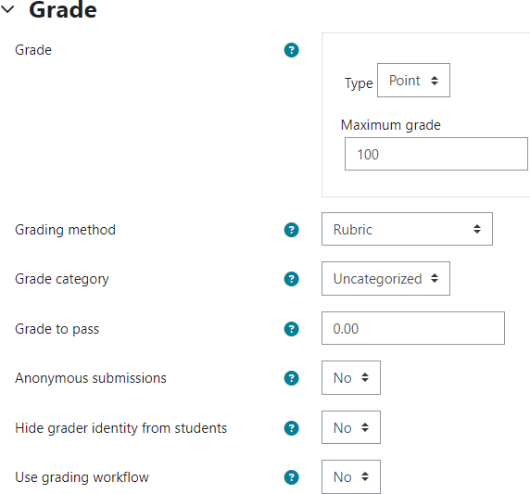
Grade to pass
This setting determines the minimum grade required to pass. The value is used in activity and course completion, and in the gradebook, where pass grades are highlighted in green and fail grades in red.

Blind grading
Hides the identity of students to graders.

Hide grader identity from students
If enabled, the identity of any user who grades an assignment sub- mission is not shown so students can’t see who marked their work.

Use grading workflow
If enabled, grades will go through a series of workflow stages before being released to students. This allows for grades to be released to all students at the same time.

Restrict Access
This setting is used to restrict access to the as- signment based upon date, grade, the group or grouping the student is in or even user profile fields. The Restrict set button allows for more complex criteria requiring nested conditions.

Do not use this function to set the availability of the assignment.

Instructors can choose one or more re- strictions.
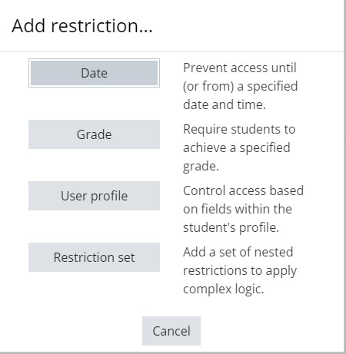

Save and return to course.

The new assignment can be found on the front page of the course along with the Open date and Due date.

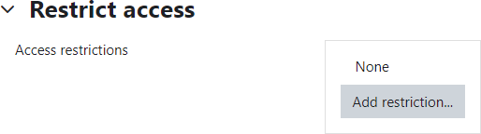

Restrictions Available

Date
Prevent access until (or from) a specified date and time.

Grade
Require students to achieve a specific grade.

User profile
Control access based on fields within student’s profile.

Restriction set
Add a set of nested restrictions to apply complex logic.
Set the restrictions needed.

