Restrict Access
Restrict Access enables instructors to restrict the availability of any activity, resource, or course section according to conditions such as a date, grade obtained, group, or other activity.

Add a Restriction
Log in to Moodle and navigate to the course.
Next to the activity, click on the three dots and choose “Edit Settings.”
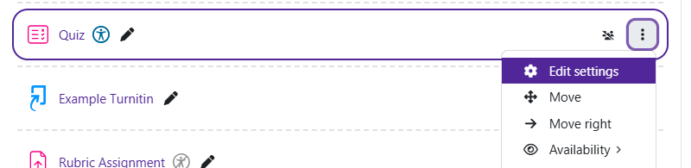

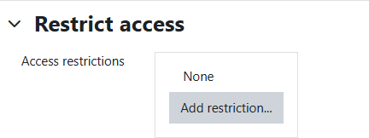
Once there, scroll to the bottom of the area and find Restrict Access. Once found, click on the section and beside “Access restrictions,” click on “Add restriction…”

A pop-up will come on your screen with options for restricting.
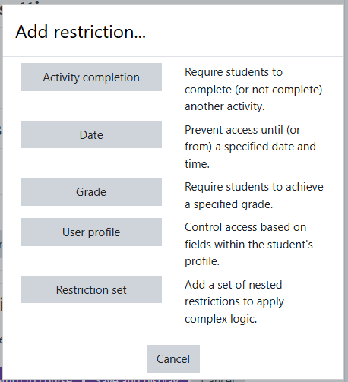
- Activity completion– Require students to complete another activity before having access to this activity.
- Date– Prevents access until a specific date.
- Grade– Require students to achieve a certain grade on an item to access.
- User Profile– Restrict access to a specific person(s).
- Restriction set– Create a set of rules to be applied for access. You will click on the option for your situation.

Moodle v. 4.5.7 Updated 3/2026

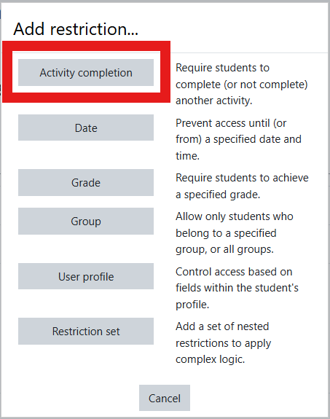
Restricting Access via Activity Completion:
Note: You must have Completion Tracking turned on, and have set activities up with completion tracking for this to be used.
After clicking “Add Restriction,” choose “Activity Completion.”

Next, select the activity that needs to be completed prior to receiving access to this new activity. Click on “Choose…” to select the activity that needs to be completed.

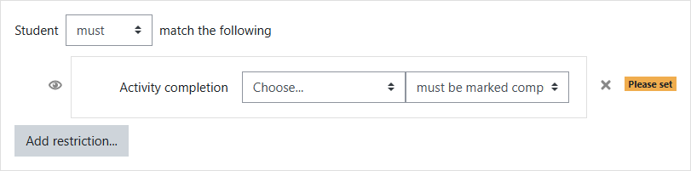

Once the access is set, scroll to the bottom and click “Save and return to course” to save the changes.

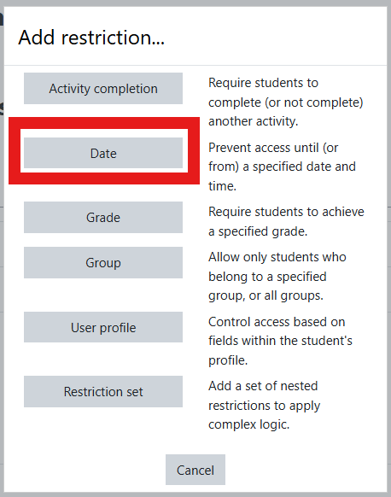
Restricting Access via Date:
You can also set dates for accessibility of items. After clicking “Add Restriction,” choose “Date.”

Select the desired dates of availability.

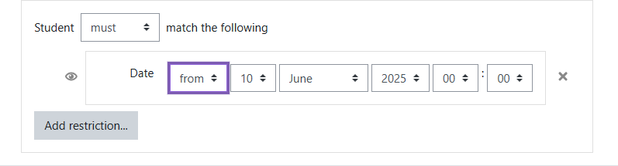

If you would like to an end date for availability of the item, click “Add restrict…” again, choose “Date,” and
then change “from” to “until” and set the date the item will become unavailable to your students.
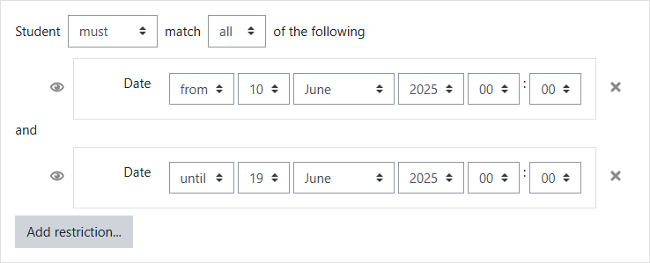
Once the access is set, scroll to the bottom and click “Save and return to course” to save the changes.

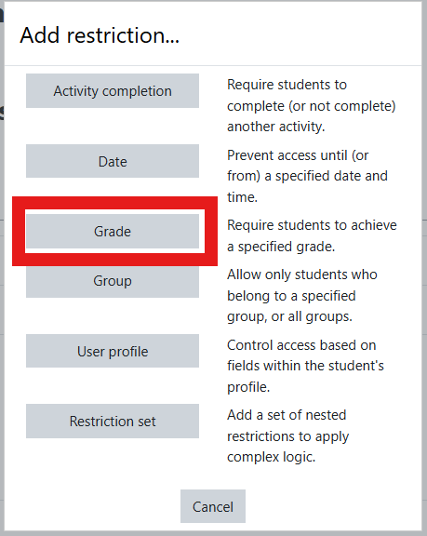
Restricting Access via Grade:
You can set an item to be accessible based upon the grade re- ceived on something else.
To do so, after clicking “Add Restriction,” choose “Grade.”

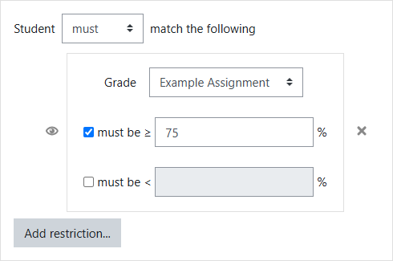
Beside “Grade,” select the item the student must receive a grade upon to access the restricted item.
If you require the student to receive a grade higher than a certain percentage, click the checkbox be- side “Must be >=“ and type in the percentage.
If you require that the student have a grade lower than a certain percentage, click the checkbox be- side “Must be <=“ and type in the percentage.

Once the access is set, scroll to the bottom and click “Save and return to course” to save the changes.

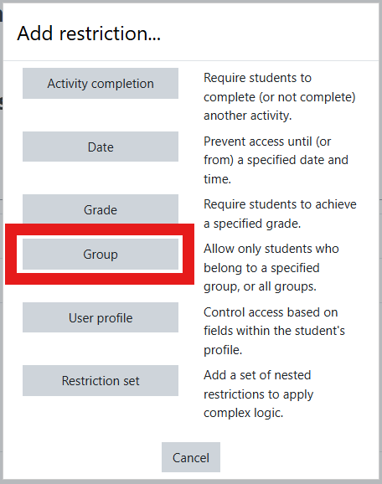
Restricting Access via Group:
Note: You will need to have created groups and assigned students to those groups for this to work.
To restrict to a certain group, after clicking “Add Restriction,” choose “Group.”

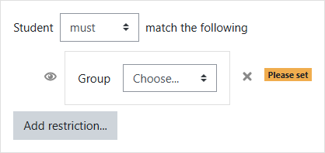
Beside “Group,” click “Choose…” and select the group that needs access to that item.
If more than one group needs access to that item, click “Add restriction…” again, choose “Group,” and choose the next group that needs the access.

Once the access is set, scroll to the bottom and click “Save and return to course” to save the changes.

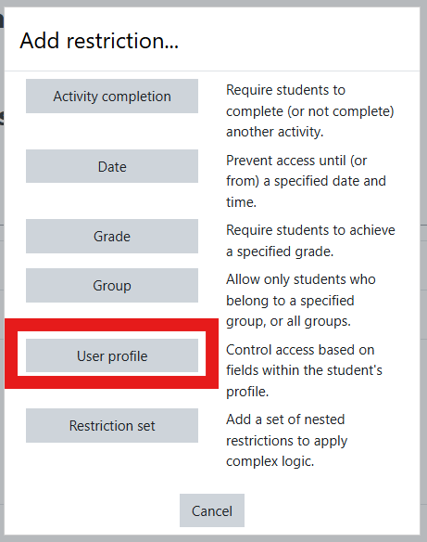
Restricting Access via User Profile:
You can restrict access to an item to a specific person(s).
To restrict access to a person, after clicking “Add Restriction,” choose “User Profile.”

The Access Restriction area will change. Beside “User profile field,” you will click “Choose…,” and select the identifier you want to use to find the specific student. For example, if the student is the only person with a particular last name, then select “Last name.” If they have a unique first name, select “First name.”
Then, in the blank box at the end, type in the information of that student. For example, if you use “Last Name,” type in that student’s last name.
If more than one student needs access to that item, after setting up access for one student, you will need to click “Add restriction…” again, choose “User Profile,” and choose the next student that needs the access.
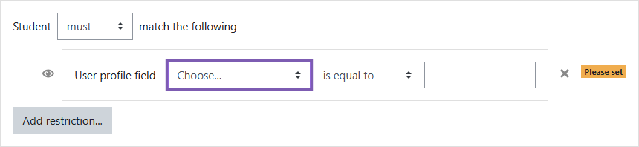

Once the access is set, scroll to the bottom and click “Save and return to course” to save the changes.

