Completion Tracking
Completion Tracking is a setting that records whether or not a student has met a certain completion criteria for any given item that you have placed inside of a Course. You can use it to help students track their progress in a course or to control what students need to complete before accessing certain course material.

To Turn on Completion Tracking:
Log in to Moodle and navigate to the course. Underneath the course name, click on Settings.
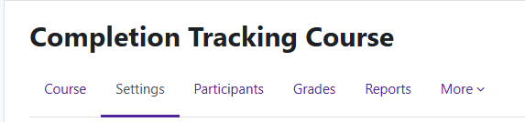

Once there, scroll to the bottom of the area and find Completion Tracking. Once found, click on the section and beside “Enable completion tracking”, click the drop down and choose “Yes”.
Once you say yes to enabling completion tracking, you will be given an option to show the activity completion conditions to your students. If you say yes to showing the conditions, students will know what is required to achieve completion on the item.
After setting the options, click “Save and display”.
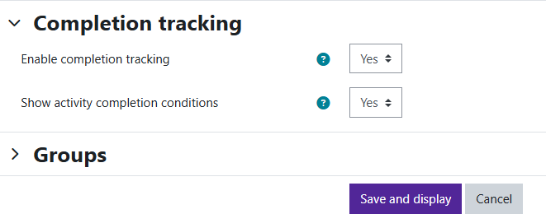
Moodle v. 4.5.7 Updated 3/2026

Setting Completion Tracking on an Activity:
Now that Completion Tracking is turned on for the course, you will need to set the conditions that will determine completion on each item.
To set the conditions, click on the three dots beside the activity and select “Edit Settings.”
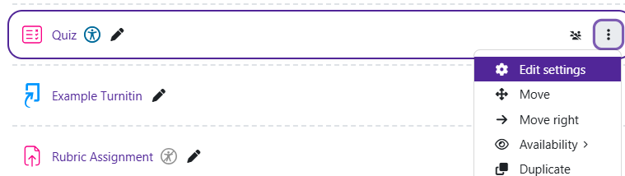
Once in Settings, scroll down to the bottom and find the section called “Completion Conditions” and
expand it.
You can choose between two options:
- Students must manually mark the activity as done– If selected, student will be able to mark if they have completed the activity or not.
- Add requirements– If selected, you will set what will need to be done to have the activity marked completed. You will select from further options that will be provided.
After setting up the completion conditions, you will click “Save and return to course.” Condition
possibilities include viewing the activity, submitting into the activity, receiving a grade, etc.
