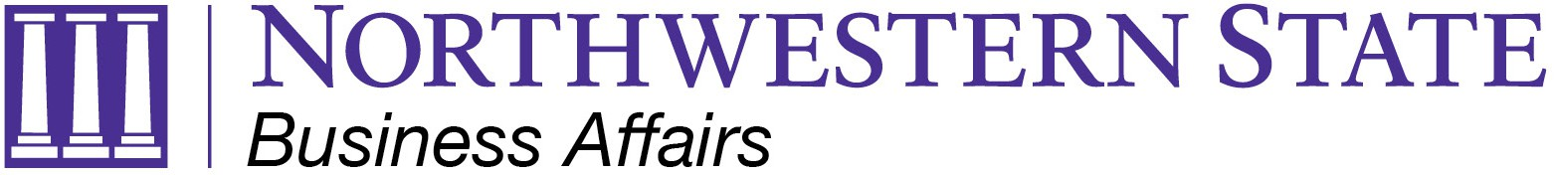

TO: NSU Employees
FROM: Business Affairs/Travel
Re: Travel Update Memo
Date: August 5, 2026

New Mileage Rate
Effective July 1, 2026, mileage reimbursement will be paid at the rate of $0.76 per mile for a max of 200 miles.

Travel Trainings NOW Available
To register for one of the scheduled Travel Procedures training sessions, click the link below to select the date and time that works best for you. More sessions will be added as needed. https://www.signupgenius.com/go/70A0E4AA4AC2AABFA7-65012915-2627

If your department would like a customized Travel Policy and Procedures training tailored to your faculty and staff’s travel needs, please email travel@nsula.edu to schedule a session.

New Policy Format
The NSU Travel Policy has been broken down into three documents to better meet the needs of our travelers:
- NSU T-Card Policy which addresses card usage, requirements, and protocols.
- NSU Travel Policy which addresses the allowable expenses and requirements for travel.
- NSU Travel Procedures which provides procedural guidance, documentation requirements, and processing instructions for official university travel New Travel Forms

New Travel Forms
New forms are available on our website for the following:
- Request for Authorized Travel
- Travel Expense Account Form
- Request for Use of CBA (Hotel)
- Request for Use of CBA (Air)

Reminders
- U.S. General Services Administration (GSA) rates for Lodging, Meals, and Incidentals are updated October 1st every year.
- Airfare must be purchased through Christopherson Business Travel using a T-Card or CBA.

