Submitting the Intent to Attend on VIC
Step 1: Login to VIC
Log in to your NSULA student account at vic.nsula.edu. Once logged in, locate the Intent to Attend alert card located at the top of the page. Click the Click here to answer link located in the bottom-right corner of the card to initiate process.
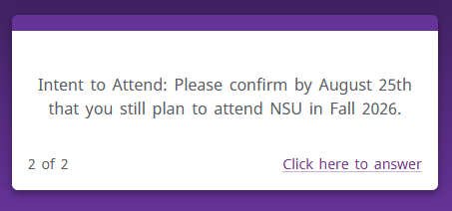

Step 2: Select Attendance Option
Select the appropriate option on whether or not you plan to attend Northwestern State University and click Submit.
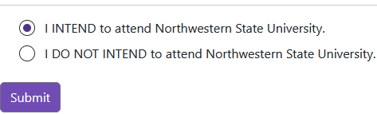
The following page will display your submitted selection and the date submitted in blue at the top of the page.

Step 3: Select Payment Options
Within the Fee Payment Deadline and Instructions, indicate your payment methods and click the corresponding link.
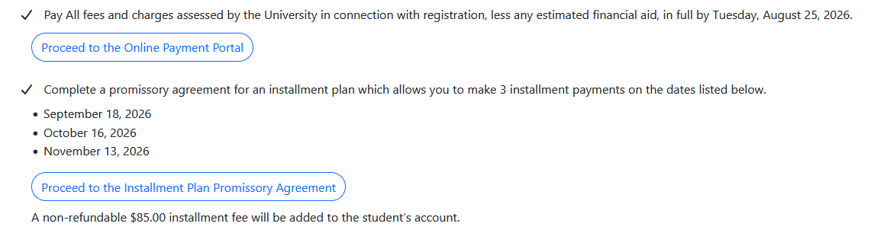
Selecting Proceed to the Online Payment Portal will redirect to you account balance for payment by clicking Make a payment. Please note that if you have pending Financial Aid availble you can close out of the tab and no further actions are necessary.
Selecting Proceed to the Installment Plan Promissory Agreement will provide a payment breakdown with the addition of the $85.00 installment fee. View and verify the charges and select that that you agree to finalize.

Step 4: Intent to Attend Alert Card
Once all steps are completed, the Intent to Attend alert card located at the top of the VIC dashboard will disappear after approximately 1 hour.

