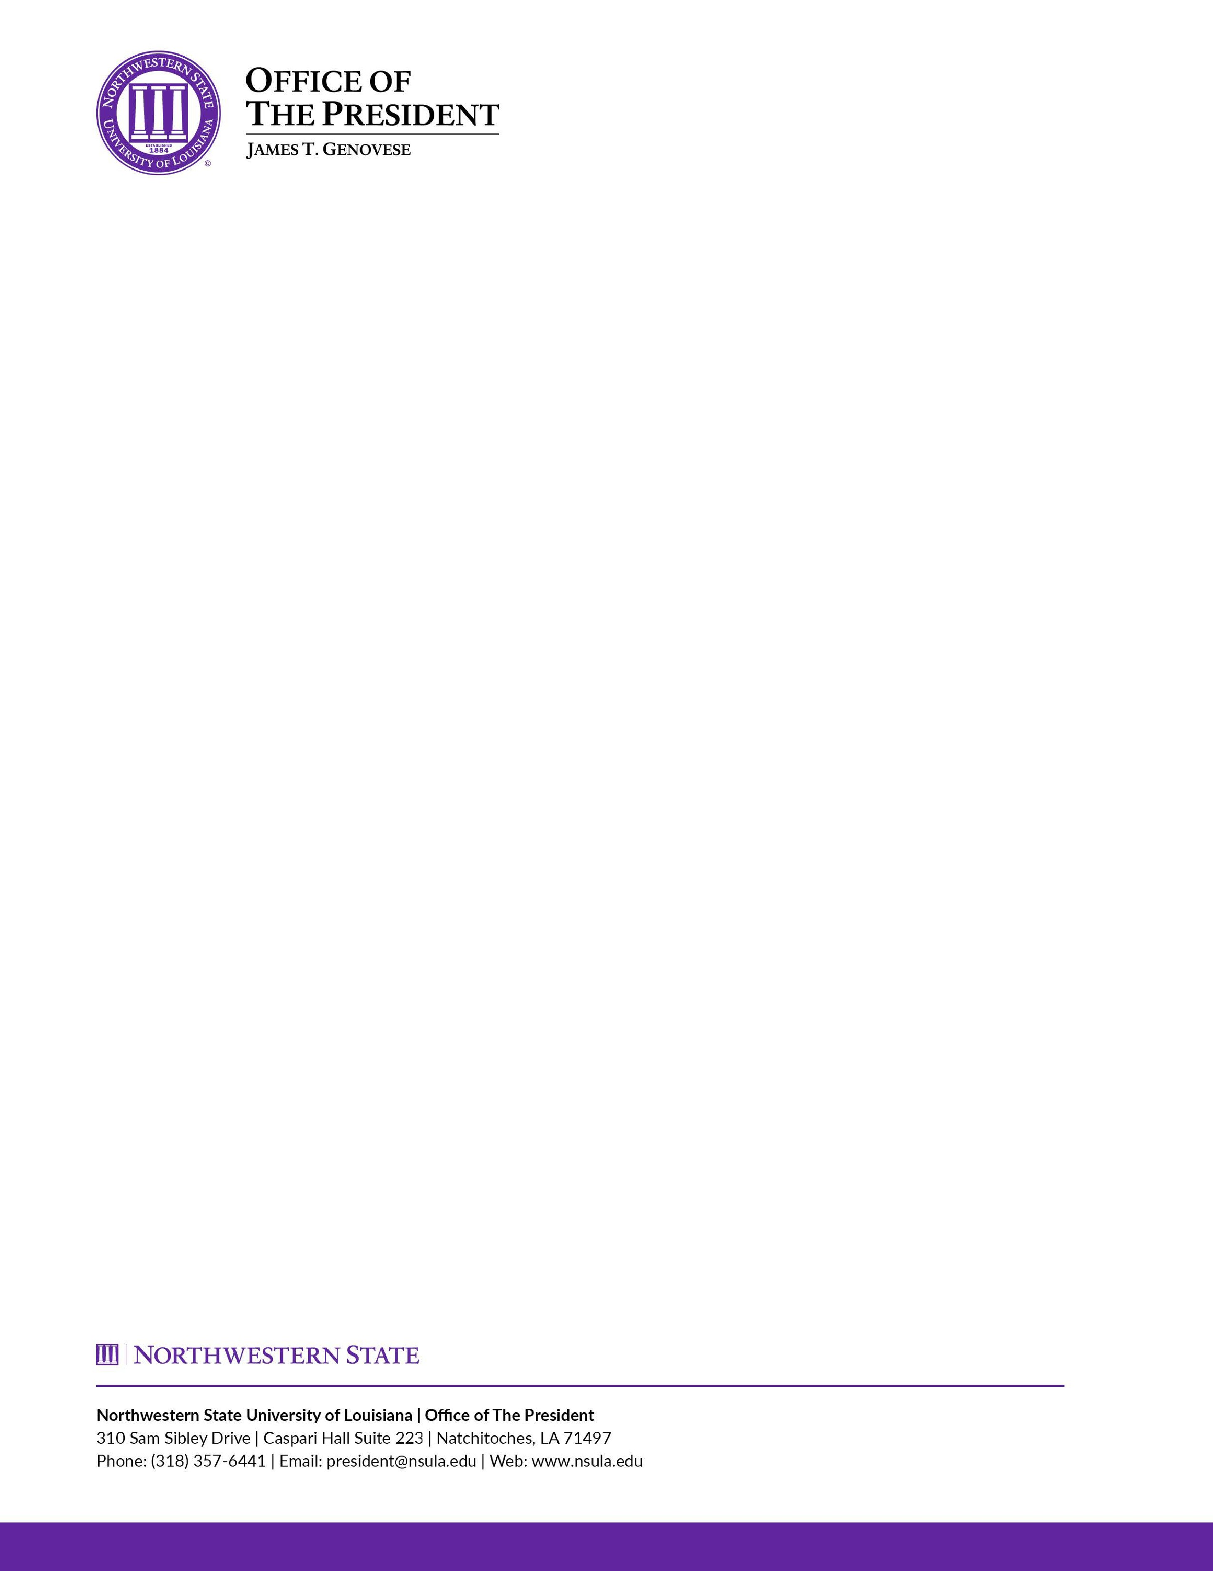

Organ Donor Leave Policy

Effective: 8/1/2026

1.

Policy Statement
The approved adoption of Civil Service Rule 11.37 provides the framework for leave for state classified employees
who donate all or part of a liver, pancreas, kidney, intestine, lung, or bone marrow. This rule provides state
employees with 30 calendar days

of leave following the donation.

This policy will be applicable to all employees of
Northwestern State University.

2.

Applicability

(
a) An eligible employee serving with job appointment, probationary, or permanent status shall be granted time off
without loss of pay, annual leave, compensatory leave, or sick leave, for a period not to exceed 30 calendar days,
to donate all or part of a

liver, pancreas, kidney, intestine, lung, or bone marrow. The 30
-
calendar
-
day period shall
commence on the day immediately following the organ donation surgery.

(
b) Eligibility

To be eligible for organ donor leave, in the twelve months immediately preceding the date of organ donation
surgery, the employee must:

1.

Have been continuously employed by the State; and

2.

Have actually worked for at least 1250 hours.

(
c) Compensation

1.

A full
-
time active employee shall be compensated at the rate of 100% of their base pay during the 30
-
calendar
-
day
period.

2.

A part
-
time active employee shall be compensated at the rate of 100% of their base pay during the 30
-
calendar
-
day period based upon the employee’s average number of hours worked in the six months immediately preceding
the commencement of the organ donor leave.

(
d) Limitations

1.

An employee utilizing organ donor leave shall follow their agency’s customary leave practices. That is, as
practicable, advance notice of leave needs shall be provided and leave approved prior to use.

2.

An employee utilizing organ donor leave under circumstances also qualifying under the Family and Medical Leave
Act (“FMLA”) shall use FMLA leave concurrently with organ donor leave.

3.

Organ donor leave shall not be donated to another employee or leave pool.

4.

Use of organ donor leave in accordance with this rule and agency policy shall not have a negative impact on the
employment relationship. Specifically, an employee shall not be dismissed, separated, demoted, suspended, or
discriminated against in any manner

for requesting or utilizing organ donor leave in accordance with this rule or
agency policy.

5.

An employee not utilizing organ donor leave in accordance with this rule and/or agency policy may be disciplined,
including the possibility of separation or dismissal.

6.

Organ donor leave shall not extend the employment relationship.

Establishing Eligibility for Organ Donor Leave:

- Prior to granting organ donor leave, a requesting employee must submit a completed Organ Donor Leave Request Form to the Office of Human Resources.

- In addition to the request form, an Appointing Authority and/or Human Resources may require the employee to provide documentation from a licensed healthcare provider or transplant facility verifying the employee’s status as an organ donor and the anticipated medical procedure. Any supporting documentation must be sufficient to establish the employee’s eligibility for organ donor leave and may be subject to verification. The employee is responsible for providing all required documentation in a timely manner. Approval of organ donor leave is contingent upon receipt of satisfactory documentation and verification of eligibility requirements.


_______________________________
Appointing Authority

