Accepting Financial Aid Awards on VIC
Step 1: Login to VIC
Log in to your NSU student account at vic.nsula.edu.
Once logged in, click View All Cards in the upper-right corner of the screen to display all available cards.

Step 2: Find Financial Aid Quicklinks Card
On the left side of the page, click the Find Cards search bar and type Financial Aid.
From the search results, select NSU Financial Aid Quicklinks.
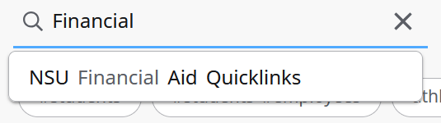

Step 3: Select View Status & Accept your Awards
Within the NSU Financial Aid Quicklinks card, click View Status & Accept your Awards to access your financial aid information.
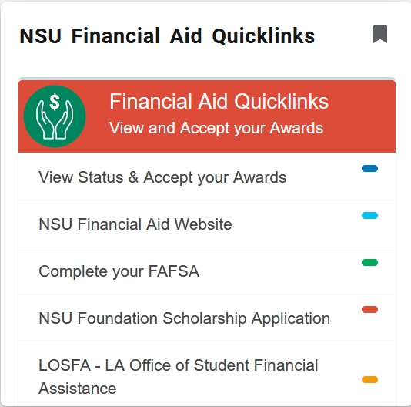

Step 4: Locate Awards to Accept
From the Financial Aid menu, select Offer to view your available financial aid awards.
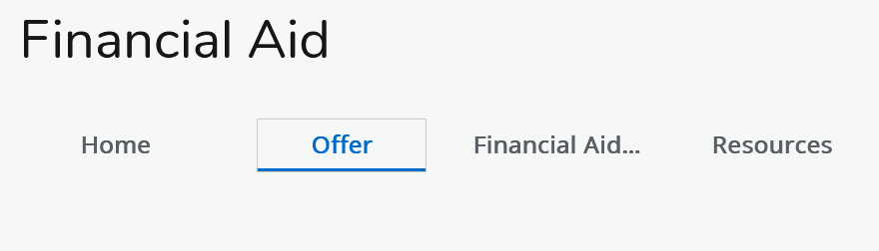

Step 5: Accept or Decline Financial Aid
Under the Take Action column, use the dropdown menu next to each financial aid award to select Accept or Decline.
This may include grants and scholarships as well as student loans, depending on your financial aid package.

Step 6: Submit Cost of Attendance
Scroll toward the bottom of the page and click Submit. The button will be highlighted in blue when action is required.
Submitting this information confirms your Cost of Attendance estimates and your selected financial aid awards.


Step 7: Terms and Conditions
After clicking Submit, a Terms and Conditions popup will appear in the center of the page.
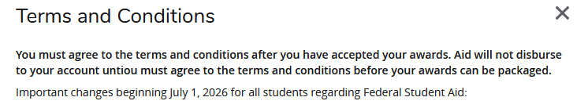

Scroll to the bottom of the Terms and Conditions and check I acknowledge these terms and conditions.
Click Accept Award to complete the process.
