Creating Your NSULA Passkey
A passkey provides a secure and convenient way to access your NSULA account using your device's face recognition, fingerprint, PIN, or other supported security method.
Step 1: Login to VIC
Log in to your NSULA student account at vic.nsula.edu.
After signing in, the Let’s keep your account secure prompt will appear. Click Next to begin setting up your NSULA Passkey.
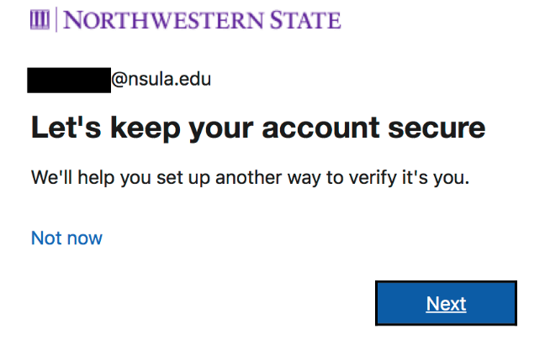
Step 2: Sign in Faster
The Sign in faster with your face, fingerprint, or PIN screen will appear. Click Next to continue.
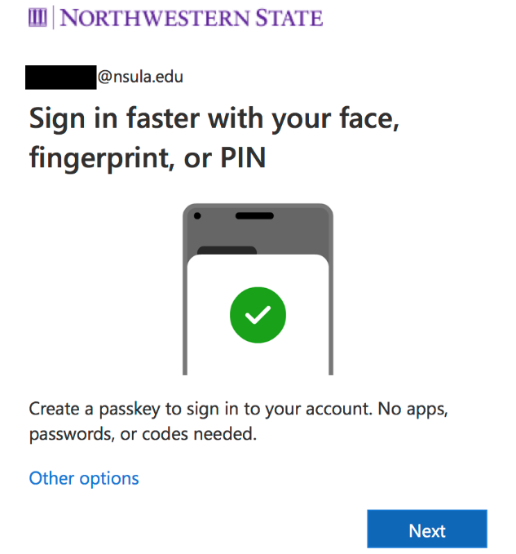

Step 3: Set Up You Passkey
The NSULA Passkey setup process will begin. Click Next to complete your passkey creation following the on-screen instructions.
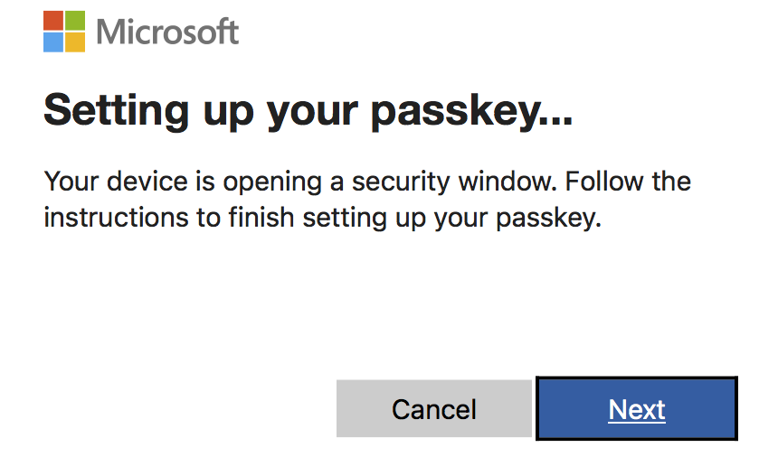

Step 4: Name Your Passkey
Your @nsula.edu username will appear at the top of the prompt, along with a field to enter a name for your Passkey.
We recommend using NSULA Passkey as the name so it can be easily identified in the future.
After entering the name, click Next.
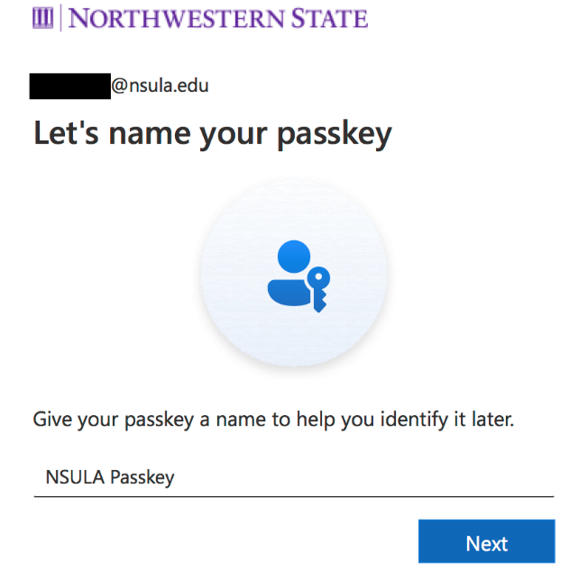

Step 4: Passkey Created
Once the setup is successfully completed, a Passkey Created confirmation will appear.
Click Done to finish the setup.
Your NSULA Passkey is now ready to use when signing in to supported NSULA services.

